WELLNESS
Home Life

Hello from your Wellbeing team, February 2022
A thought;
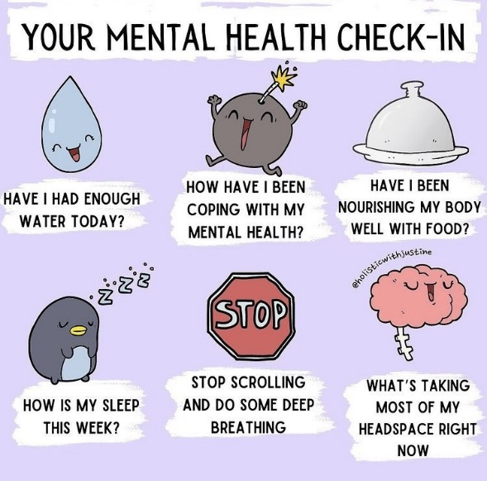

Why labelling feelings is so important

Helping children put their feelings into words can help them better navigate strong, negative emotional experiences. We tend to keep it simple when talking about feelings with young children and may often stick to the basics, such as angry, happy and sad. Once our children have mastered that, we can move on to a bigger variety of emotionally descriptive words. We can increase our child’s understanding of a bigger expanse of feelings by broadening the terms we use.

Brave Cheerful Worried Joyful Frightened Calm
Excited Confused Frustrated
Curious Friendly Shy Ignored Lonely Interested
Proud Embarrassed Jealous Angry Bored
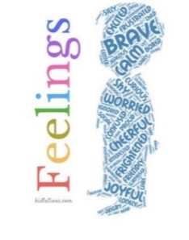
Surprised Silly Uncomfortable
Stubborn Safe Relieved Peaceful
Overwhelmed Loving Cranky

This week is ‘Children’s Mental Health Week’; it is to raise awareness of the importance of our children’s mental health and to support children in expressing themselves. Our schools will be focusing on this week when we return from our February break. Through the week of 21st – 25th February, we will be discussing in school all about how children can express their feelings and support each other. Also, we will be having a ‘Dress to Express’ day on Friday the 25th of February, where the children are invited to wear their favourite colour or a unique outfit to express how they are feeling.
If you would like to contact us for any help or support, please do not hesitate to email on wellbeing@woodton.norfolk.sch.uk.
Top tip;
When your child is struggling, whether this is a meltdown, feeling sad, crying etc, sit and ask them to describe how they are feeling. Ask them to put their feelings into words. This is a known calming strategy and can help them cope with future emotions.
Time to Talk; we understand how children may need that extra support at times, an adult or friend to talk to. Across both schools, we now have a ‘Time to Talk’ session on Tuesdays supported by Mrs Taylor. Children are welcome to talk about their wellbeing, and support and help can be offered. As well as Mental Health champions across both schools, we also have Domestic Abuse Champions who are here to support at all times.
Mental Health Champions: Mrs K Taylor & Mrs S Brooks
Domestic Abuse Champions: Mrs K Taylor & Mrs V Woods
Is your child showing signs of Anxiety?
Here’s what to watch out for…
- Finding it hard to concentrate
- Not sleeping, or waking in the night with bad dreams
- Not eating properly
- Quickly getting angry or irritable, and being out of control during outbursts
- Constantly worrying or having negative thoughts
- Feeling tense and fidgety
- Unexplained crying
- Being clingy
- Complaining of tummy aches and feeling unwell
- Nail biting, knee jigging, thumb sucking

Separation anxiety is common in younger children, whereas older children and teenagers tend to worry more about school or have social anxiety.
If you feel, your child may be experiencing anxiety, sit with them and ask them to describe how they are feeling, reassure them that it’s okay to feel like this and work together with how to ease their anxiety.

The BBC and childline have put together some helpful advice support for anxiety and stress
https://www.bbc.co.uk/bitesize/articles/zfnhxbk
https://www.childline.org.uk/toolbox/calm-zone/

Signposting:
There are a range of services available to support children, young people and adults with anxiety across Norfolk & Waveney, and nationally.
Kooth – www.kooth.com
Kooth is an online counselling service for children and young people aged between 11 and 25. They can also further support via their website.
Childline – www.childline.org.uk
The childline website offers a variety of support including information, games, online counselling, Calm zone and a support took box. Children can also call for support or access online help from a counsellor.
Thinkninja – www.healios.org.uk/services/thinkninjal
This app is designed to support children and young people with their emotional wellbeing, including anxiety. Using CBT priniciples, the app also has a section on coping feelings during the coronavirus pandemic.
Young Minds – www.youngminds.org.uk
Young minds offers young people and their families information about different mental health concerns and a crisis messenger service for young people.

Did you know;
Here’s three things that you think make anxiety better but are actually making it worse;
- Comfort – Anxiety is hugely uncomfortable and it’s supposed to be, it’s there to activate us, but every time we escape situations that make us feel anxious, the cost of that short-term comfort is long term anxiety.
- Control – Trying to control all the areas in your life to prevent you from ever feeling anxious only ever works in the short term, because there is so much about our life we cannot control, so it becomes a fight that we can’t win.
- Avoidance – Anxiety is normal when we try something new. So, if you get in the habit of avoiding anything that makes you anxious, your life shrinks and the fear of doing anything new just grows.

Just a thought;  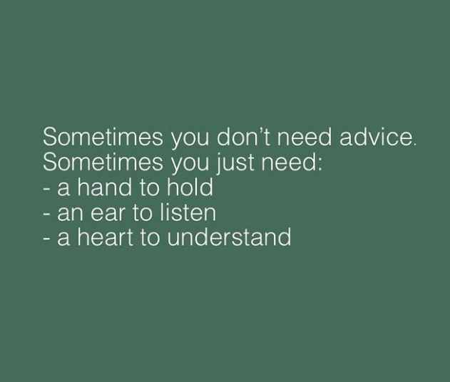 | The simple things;  Tip to ease anxiety in children and adults with ice;  - Hold ice in your hand (Focus on the temperature and texture)  - Move ice along arms (Notice the sensation)  - Hold the ice in your mouth (Push it to the roof of your mouth)  - Rub ice on your face (Reducing temperature of the face, lowers the heart rate)

Conversation Starters For Kids – we often forget to talk, especially with all the rushing around we do. Try some of these conversation starters, just one a day, and see what you find out…

What was your favourite part of the day? What superpower would you like to have and why?
What do you think makes a family close? What makes you feel happy?
If you could only keep one toy, which toy would it be? Who do you play with at school?
How were you kind to someone today? What are you proud of?
How do you cheer yourself up when you feel bad? What’s your favourite meal?
What do you like best about your family? If you could be an animal, which one would you be?
What are you looking forward to this year? What’s one good thing you’re really good at?
Let’s say you could be any age, what age would you be? How does a good friend act?
How would you change the world when you grow up? What do you like best about school?
What’s your favourite room in our house? What is your favourite thing about our family?

Support for families:
Parents reaching out (Children 11-16): parents@kooth.com
Point 1: Support for young people and their families – 0800 977 4077 or point1-support@ormistonfamilies.org.uk
Early Help hub: South Norfolk – 01508 533933
Norfolk Just One Number - www.justonenorfolk.nhs.uk or 03003000123
