

*Issue No: 29 Date: Friday 19th May 2023*

*Our Newsletter comes out every Friday with updates about what the children have been up to during the week, information, things to celebrate and important dates for the diary. Please take the time to read through and if you have any questions, please speak to Mrs Taylor in the office.*

**This Week’s Achievements**

**Willows Stars of the Week**

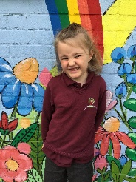

**Oaks Stars of the Week**

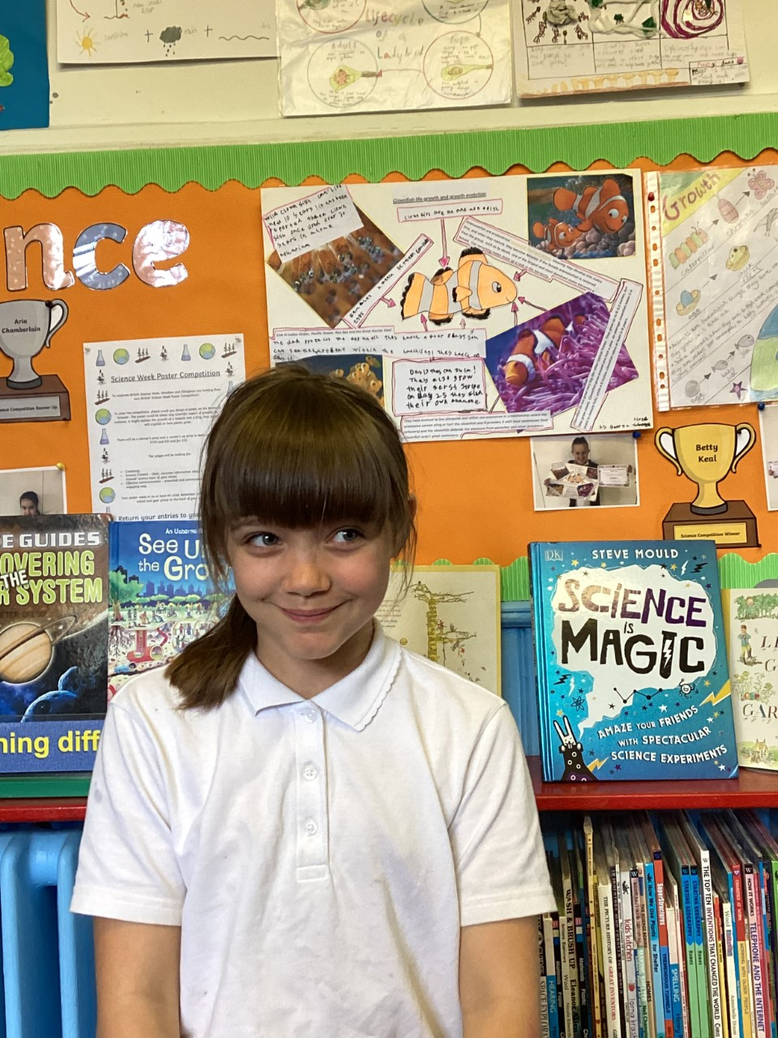 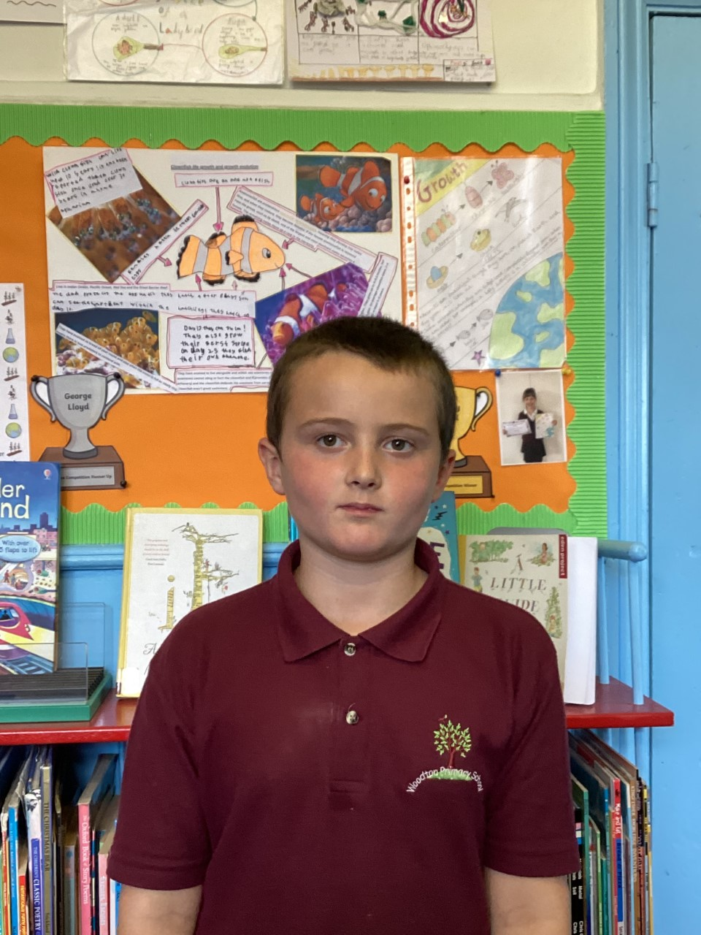

For giving everything a go this week, with a brilliant attitude.

Aria for coming in everyday with a smile.

For being a star this week and for settling in really well.

Millie for amazing us with her positive attitude this week.

For encouraging others and displaying our value of nurture in our cricket session this week

For his fantastic writing.



Willows: 1st Maisy

2nd Finlay

3rd Rupert

Oaks: 1st Woody

2nd Charlie T

3rd Lucas



**Support Act – Hector**

**Garage Rocker – Riley**

**Headliner – Alana & Isla**

 Congratulations to

Felicity R for completing Glass and Jack M-M for completing Brass & Copper stages in NumBots this week!

CHALLENGE

NURTURE

INSPIRE

CHALLENGE

NURTURE

INSPIRE



**House Points for this week**

Stephen Hawkings – 33

Beatrix Potter – 87

Benjamin Britten – 80

Kelly Holmes – 36

**Class Attendance**

Willows – 91.03%

Oaks – 91.67%



**Online Safety**

**Roblox Reminder**

A reminder to all parents that Roblox is an open app, where new games and add-ons are added daily to the platform. Many games, such as Rainbow Friends, Doors, Piggy and Poppy Playtime are classed as ‘horror’ games and often have age ratings of over 9 or over 13.

We are aware children are accessing these games on tablets at home, and are talking about them in school and bringing in merchandise. We ask that if your child has merchandise from these games, even keyrings, that they DO NOT bring these into school, and you encourage them to not talk about it in school.

How to keep your child safe on Roblox

· Talk to your child/ren about what they are playing and ask them to show you

· Check age appropriateness (over 9 or over 13)

· Turn on parental controls – this stops strangers communicating with your child

· If there is a chat function, open it and check what is being written to your child.



**News & Dates**

Premier Education is coming into school on Tuesday and Wednesday, to run two-enrichment mornings for the children. Tuesday morning is a ‘Health and Wellbeing’ lesson and Wednesday morning is a ‘Cheerleading’ activity.

Special Lunch

**‘Super Heroes’**

Norse are providing a special lunch for the children on Thursday 18th May. If you would like your child to have this school dinner, then please order in the normal way through the parent app. Please note that the main meal and vegetarian option will be the only options available for this day.







**Dates for the Diary**

**Monday 15th May/22nd May** – Shine Cricket sessions for both Willows and Oaks

**Tuesday 16th May** – Premier Education Wellbeing morning for both Oaks & Willows

**Wednesday 17th May** – Premier Education Sports morning for both Oaks & Willows

**Thursday 18th May** – NCMP visit for Reception and Year 6 children

**Monday 22nd – Friday 26th May** – Year 2 SATs

**Monday 29th May** **– 2nd June** – Half Term

**Wednesday 7th June** – Oaks Trip to Gressenhall (more details to follow)

**Friday 9th June** – Willows Trip to Time & Tide

**Wednesday 28th & Thursday 29th June** – Year 6 Bungay High School Transition Days

**Wednesday 5th July** – Oaks Summer Production (TBC)

**Friday 7th July** – Year 5 Taster Day @ Bungay High School

**Saturday 8th July** – School Summer Fete

**Monday 10th – Wednesday 12th July** – Year 6 Hobart High School Transition Days

**Thursday 13th July** – Woodton Sports Day

**Monday 24th July to Tuesday 5th September** – Summer Holidays

**Wednesday 6th September** – Return to school

Please be aware that dates may change at times.