
Issue No: 29 Date: Friday 19th May 2023

Our Newsletter comes out every Friday with updates about what the children have been up to during the week, information, things to celebrate and important dates for the diary. Please take the time to read through and if you have any questions, please speak to Mrs Taylor in the office.

This Week’s Achievements
Willows Stars of the Week
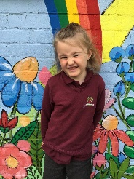

Oaks Stars of the Week
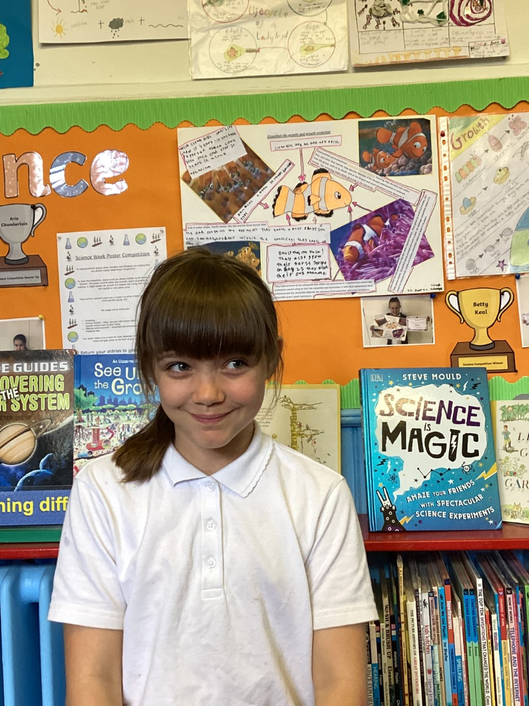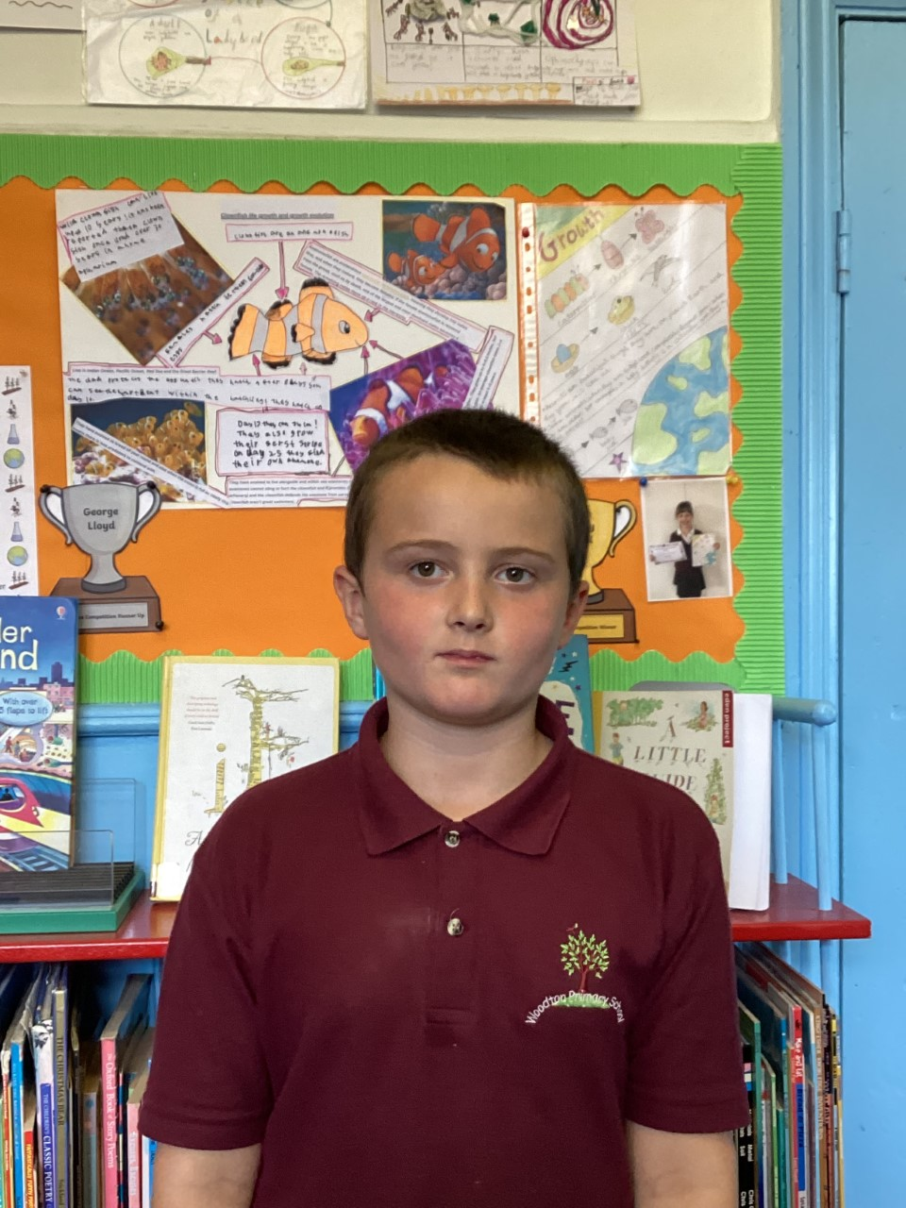

For giving everything a go this week, with a brilliant attitude.
Aria for coming in everyday with a smile.
For being a star this week and for settling in really well.
Millie for amazing us with her positive attitude this week.
For encouraging others and displaying our value of nurture in our cricket session this week
For his fantastic writing.

Willows: 1st Maisy
2nd Finlay
3rd Rupert
Oaks: 1st Woody
2nd Charlie T
3rd Lucas

Support Act – Hector
Garage Rocker – Riley
Headliner – Alana & Isla

 Congratulations to
Felicity R for completing Glass and Jack M-M for completing Brass & Copper stages in NumBots this week!

CHALLENGE
NURTURE
INSPIRE
CHALLENGE
NURTURE
INSPIRE


House Points for this week
Stephen Hawkings – 33
Beatrix Potter – 87
Benjamin Britten – 80
Kelly Holmes – 36

Class Attendance
Willows – 91.03%
Oaks – 91.67%


Online Safety

Roblox Reminder
A reminder to all parents that Roblox is an open app, where new games and add-ons are added daily to the platform. Many games, such as Rainbow Friends, Doors, Piggy and Poppy Playtime are classed as ‘horror’ games and often have age ratings of over 9 or over 13.
We are aware children are accessing these games on tablets at home, and are talking about them in school and bringing in merchandise. We ask that if your child has merchandise from these games, even keyrings, that they DO NOT bring these into school, and you encourage them to not talk about it in school.
How to keep your child safe on Roblox
· Talk to your child/ren about what they are playing and ask them to show you
· Check age appropriateness (over 9 or over 13)
· Turn on parental controls – this stops strangers communicating with your child
· If there is a chat function, open it and check what is being written to your child.

News & Dates

Premier Education is coming into school on Tuesday and Wednesday, to run two-enrichment mornings for the children. Tuesday morning is a ‘Health and Wellbeing’ lesson and Wednesday morning is a ‘Cheerleading’ activity.

Special Lunch
‘Super Heroes’
Norse are providing a special lunch for the children on Thursday 18th May. If you would like your child to have this school dinner, then please order in the normal way through the parent app. Please note that the main meal and vegetarian option will be the only options available for this day.





Dates for the Diary
Monday 15th May/22nd May – Shine Cricket sessions for both Willows and Oaks
Tuesday 16th May – Premier Education Wellbeing morning for both Oaks & Willows
Wednesday 17th May – Premier Education Sports morning for both Oaks & Willows
Thursday 18th May – NCMP visit for Reception and Year 6 children
Monday 22nd – Friday 26th May – Year 2 SATs
Monday 29th May – 2nd June – Half Term
Wednesday 7th June – Oaks Trip to Gressenhall (more details to follow)
Friday 9th June – Willows Trip to Time & Tide
Wednesday 28th & Thursday 29th June – Year 6 Bungay High School Transition Days
Wednesday 5th July – Oaks Summer Production (TBC)
Friday 7th July – Year 5 Taster Day @ Bungay High School
Saturday 8th July – School Summer Fete
Monday 10th – Wednesday 12th July – Year 6 Hobart High School Transition Days
Thursday 13th July – Woodton Sports Day
Monday 24th July to Tuesday 5th September – Summer Holidays
Wednesday 6th September – Return to school

Please be aware that dates may change at times.

