

*Issue No: 30 Date: Friday 26th May 2023*

*Our Newsletter comes out every Friday with updates about what the children have been up to during the week, information, things to celebrate and important dates for the diary. Please take the time to read through and if you have any questions, please speak to Mrs Taylor in the office.*

**This Week’s Achievements**

**Willows Stars of the Week**

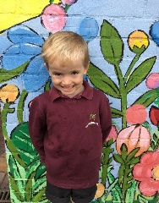 

**Oaks Stars of the Week**

 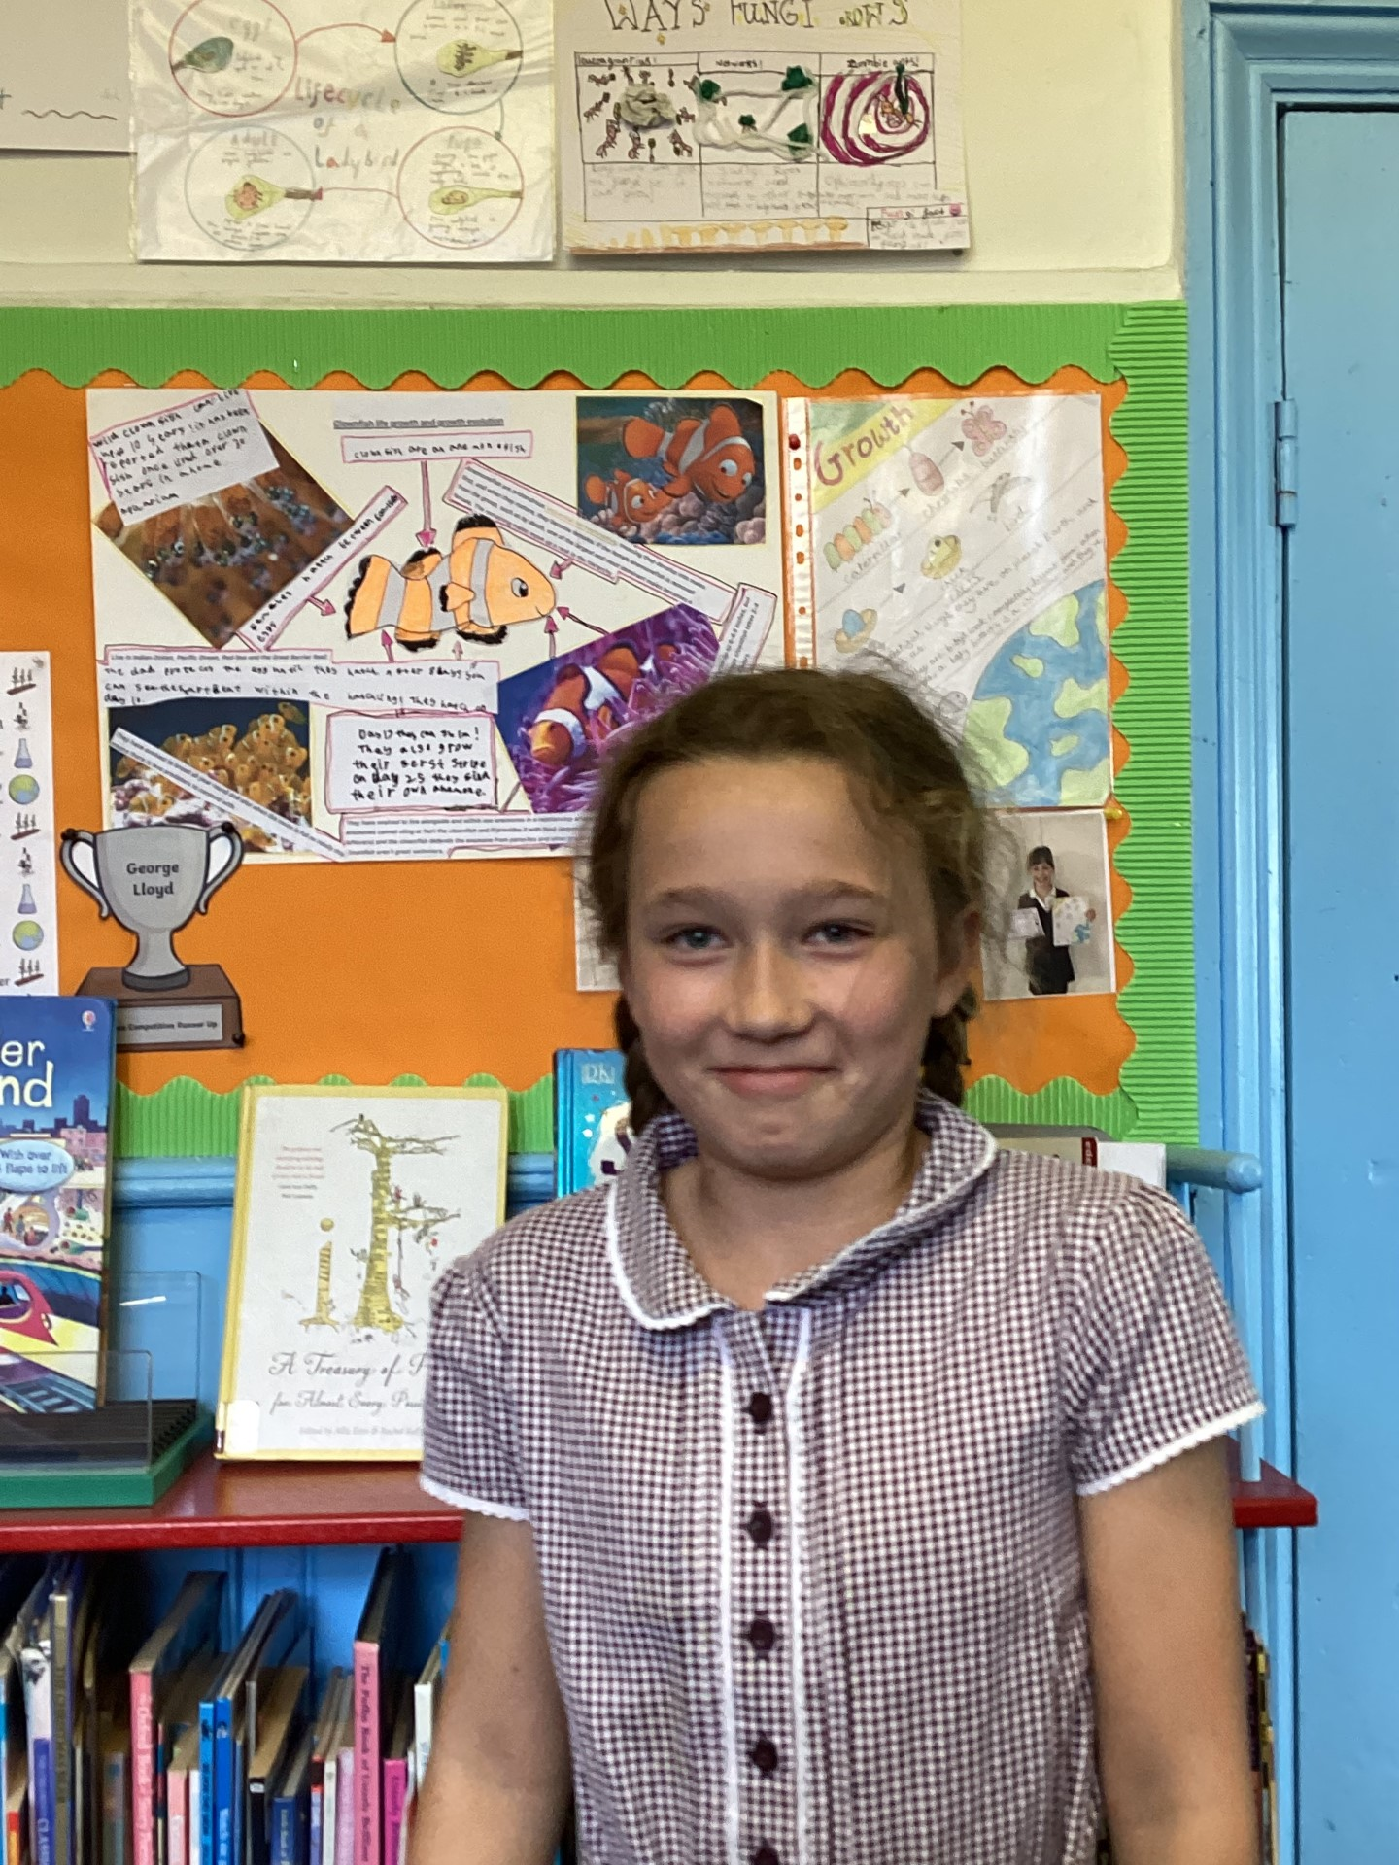

For always being a superstar and wowing us with her reading.

For demonstrating fantastic sportsmanship and enthusiasm in PE this week.

For always trying, his best and wows us with his learning.

For showing great effort in her Maths work this week.



Willows: 1st Finlay

2nd Kendall

3rd Evie

Oaks: 1st Woody

2nd Charlie T

3rd Georgina



No Numbots stages completed this week.

CHALLENGE

NURTURE

INSPIRE

CHALLENGE

NURTURE

INSPIRE



**House Points for this week**

Stephen Hawkings – 79

Beatrix Potter – 125

Benjamin Britten – 89

Kelly Holmes – 115

**Class Attendance**

Willows – 92.31%

Oaks – 96.88%



**News & Dates**

**Weekly – Let’s think about Online Safety**

**Enjoying technology at home**

Children of all ages enjoy using technology. We now see young children going online to play games, talk to family, watch videos and even learn to use voice-enabled tech like Alexa and Siri to find out about their world.

Having a conversation about online safety can begin as soon as your child is engaging with technology. Use these conversation starters to help get the conversation started:

1. What is your favourite thing to do on the iPad/tablet/my phone etc?

2. What is your favourite game/app and why do you like it?

3. Where do we use the iPad/tablet/games console and when can we use it?

4. What can you do if something online upsets you?

5. Who can help you with your favourite games and apps?

6. If a message appears on the screen, what should you do?

7. Who can go online? Do we know everyone online?

Click the link to find 8 top tips that you can put in place at home, to help keep your children safe online. https://www.childnet.com/help-and-advice/keeping-young-children-safe-online/

**Year 4 cycling Proficiency**

Well Done to the year 4’s, Sarah McClusky praised them all for their effort in their cycling proficiency training. There will be a second lesson for the year 4’s on Thursday the 8th of June. Don’t forget your bikes!



**Dates for the Diary**

**Monday 29th May** **– 2nd June** – Half Term

**Monday 5th June** – Dynamos Cricket Event for years 5 & 6

**Wednesday 7th June** – Oaks Trip to Gressenhall

**Thursday 8th June** – Year 4’s 2nd Cycling Proficiency

**Friday 9th June** – Willows Trip to Time & Tide

**Monday 12th & 19th June** – Hockley Lessons from Langley School

**Monday 12th June** – Rounders Tournament (Details to follow) (@ Hobart – 4pm till 5.30pm)

**Monday 26th June** – Hockey Tournament (Details to follow) (@ Langley – 9.30 till 12 noon)

**Wednesday 28th & Thursday 29th June** – Year 6 Bungay High School Transition Days

**Wednesday 5th July** – Oaks Summer Production (1.45pm start)

**Friday 7th July** – Year 5 Taster Day @ Bungay High School

**Saturday 8th July** – School Summer Fete

**Monday 10th – Wednesday 12th July** – Year 6 Hobart High School Transition Days

**Thursday 13th July** – Woodton Sports Day

**Monday 24th July to Tuesday 5th September** – Summer Holidays

**Wednesday 6th September** – Return to school

Please be aware that dates may change at times.