

*Issue No: 35 Date: Friday 14th July 2023*

*Our Newsletter comes out every Friday with updates about what the children have been up to during the week, information, things to celebrate and important dates for the diary. Please take the time to read through and if you have any questions, please speak to Mrs Taylor in the office.*

**This Week’s Achievements**

**Willows Stars of the Week**

 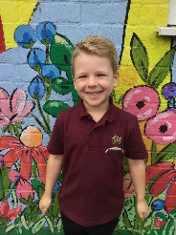

**Oaks Stars of the Week**

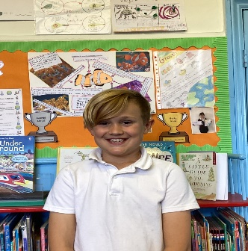 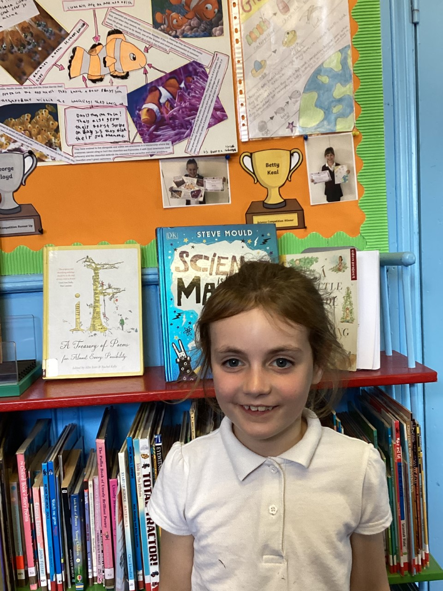

For showing great perseverance and resilience in Sports day.

For displaying maturity this week during our PSHE lesson and for putting 100% in Maths.

For showing perseverance in Sports day.

For being a delight to have in class every day.



Willows: 1st Kendall

2nd Evie

3rd Finlay

Oaks: 1st Alana

2nd Charlie L

3rd Isla



Rock Legend – Flo

Break Through Artist - Riley



Congratulations to **Lilly-May** for completing Brass stage in NumBots this week!

CHALLENGE

NURTURE

INSPIRE

CHALLENGE

NURTURE

INSPIRE



**House Points for this week**

Stephen Hawkings – 70

Beatrix Potter – 39

Benjamin Britten – 43

Kelly Holmes – 78

**Class Attendance**

Willows – 95.19%

Oaks – 95.56%



**Weekly – Let’s think about Online Safety**



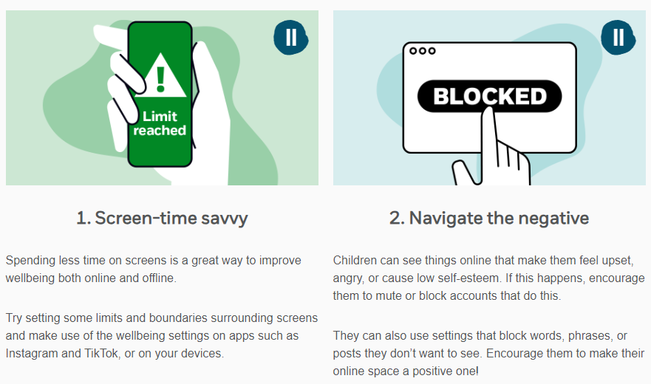

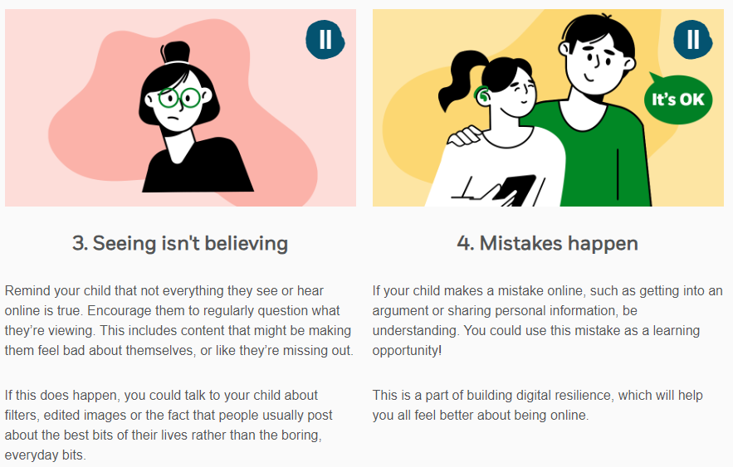

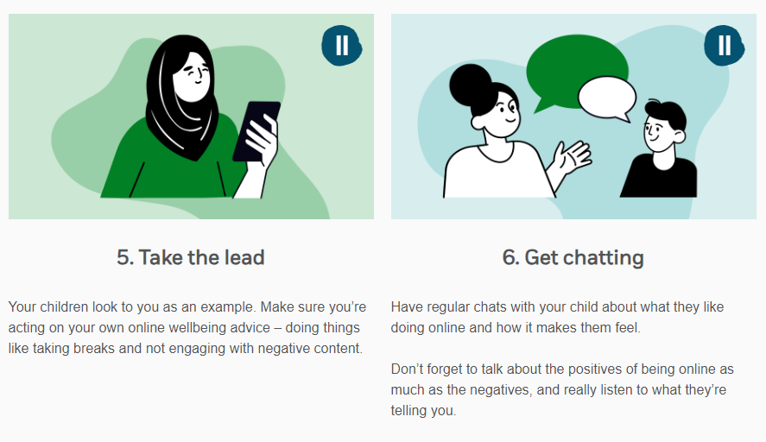

**Leavers Assembly**

**Friday 21st July**

All year six parents are invited to the leaver’s assembly on Friday the 21st of July. This will be starting from 9am and hopefully, weather permitting, we will do the presentations outside on the field.



**Whole School End of Term Party**

All of the staff would like to give the children an end of term party on the last day of term in the afternoon. There will be a sign up sheet in the school office, for parents to put what food or drink they would like to contribute, please no foods with NUTS.



Oaks Summer Production

**‘Oliver’**

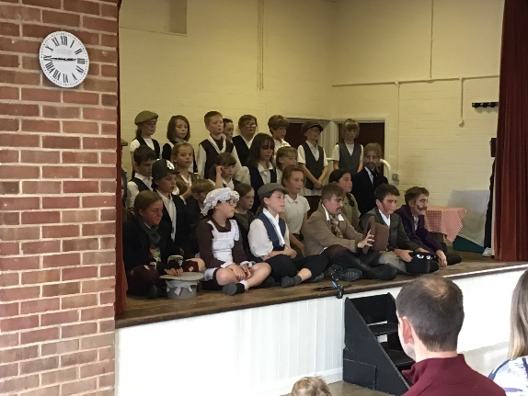

A big THANK YOU to Nick Jermy for filming the production, he has now finished editing, and would like to share for everyone to view, please click on the link below

https://youtu.be/jQNFXus06IQ

If anyone has any trouble watching it, then Nick has said to email him on [njermy@gmail.com](mailto:njermy@gmail.com) directly. He has also very kindly offered to share a digital download version too, if you would like this then please email him.

**Dates for the Diary**

**Monday 17th July** – Year 6 Leavers Treat – Tubing & Picnic

**Friday 21st July** – Leavers Assembly

**Friday 21st July** – Whole School End Of Term Party in the afternoon

**Monday 24th July to Tuesday 5th September** – Summer Holidays

**Wednesday 6th September** – Return to school

**Thursday 14th September** – Year 6 Taster Day at Bungay High school