

*Issue No: 34 Date: Friday 7th July 2023*

*Our Newsletter comes out every Friday with updates about what the children have been up to during the week, information, things to celebrate and important dates for the diary. Please take the time to read through and if you have any questions, please speak to Mrs Taylor in the office.*

**This Week’s Achievements**

**Willows Stars of the Week**

 

**Oaks Stars of the Week**

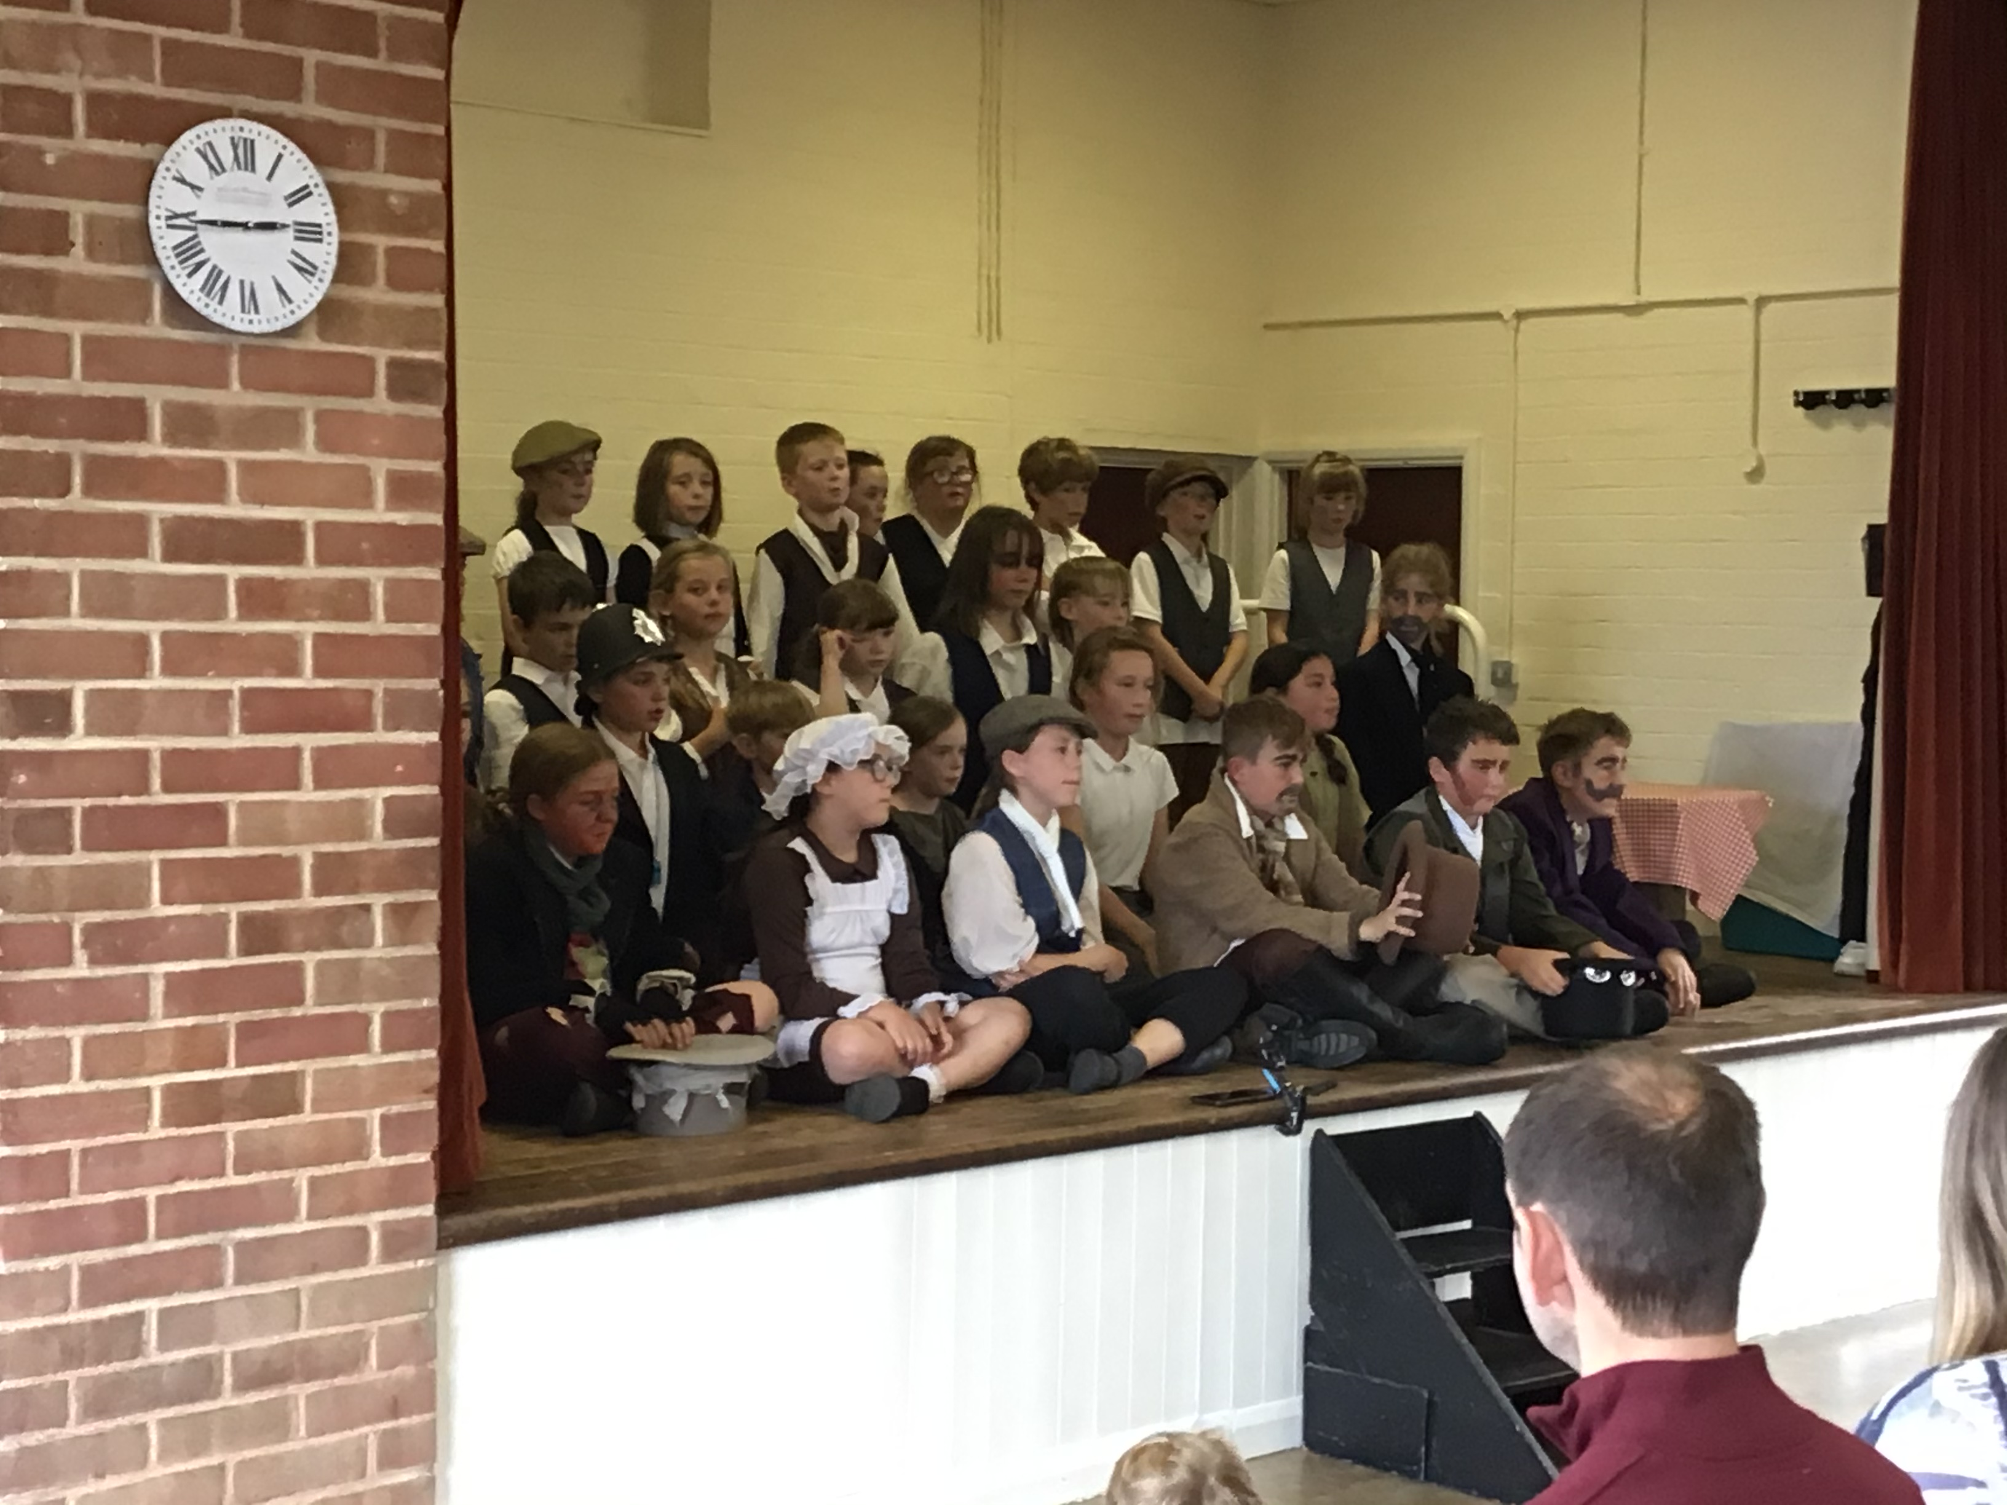

For being a star, he has come to school with a positive attitude all week.

For always being helpful and has been a great friend to everyone.

F

All of Oaks class, for all working so hard, and putting on a fabulous performance of ‘ Oliver’.



Willows: 1st Kendall

2nd Molly

3rd Evie

Oaks: 1st Hector

2nd Charlie L

3rd Isla



Rock Star – Isla



Congratulations to **Lilly-May** for completing Brass and Tin stages in NumBots this week!

CHALLENGE

NURTURE

INSPIRE

CHALLENGE

NURTURE

INSPIRE



**House Points for this week**

Stephen Hawkings – 34

Beatrix Potter – 15

Benjamin Britten – 33

Kelly Holmes – 49

**Class Attendance**

Willows – 94.55%

Oaks – 94.79%



**News & Dates**

**Weekly – Let’s think about Online Safety**



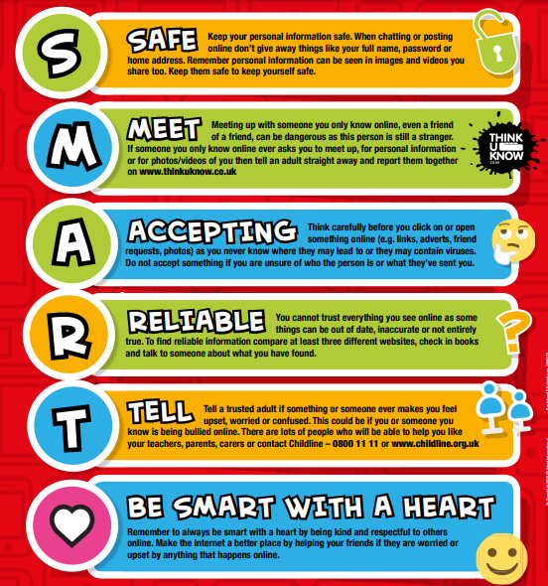

**Final Reminder**

Please can all sponsor money for the refugee-sponsored walk, be handed in by Monday 10th of July.

Thank you

**Hockey Tournament @ Langley**

**Years 5 – 6**

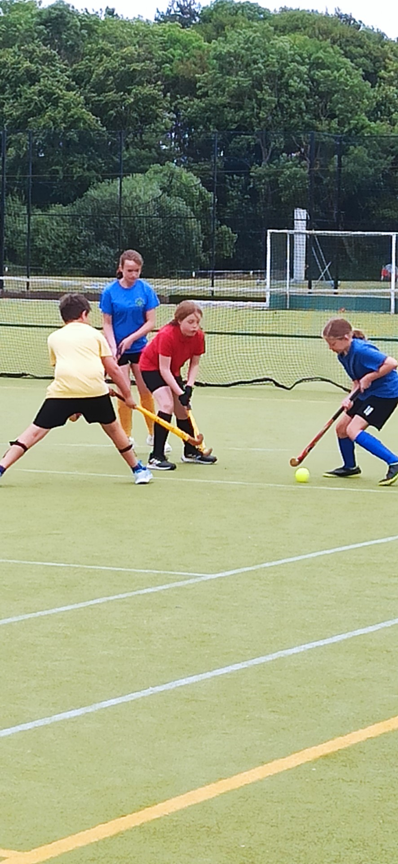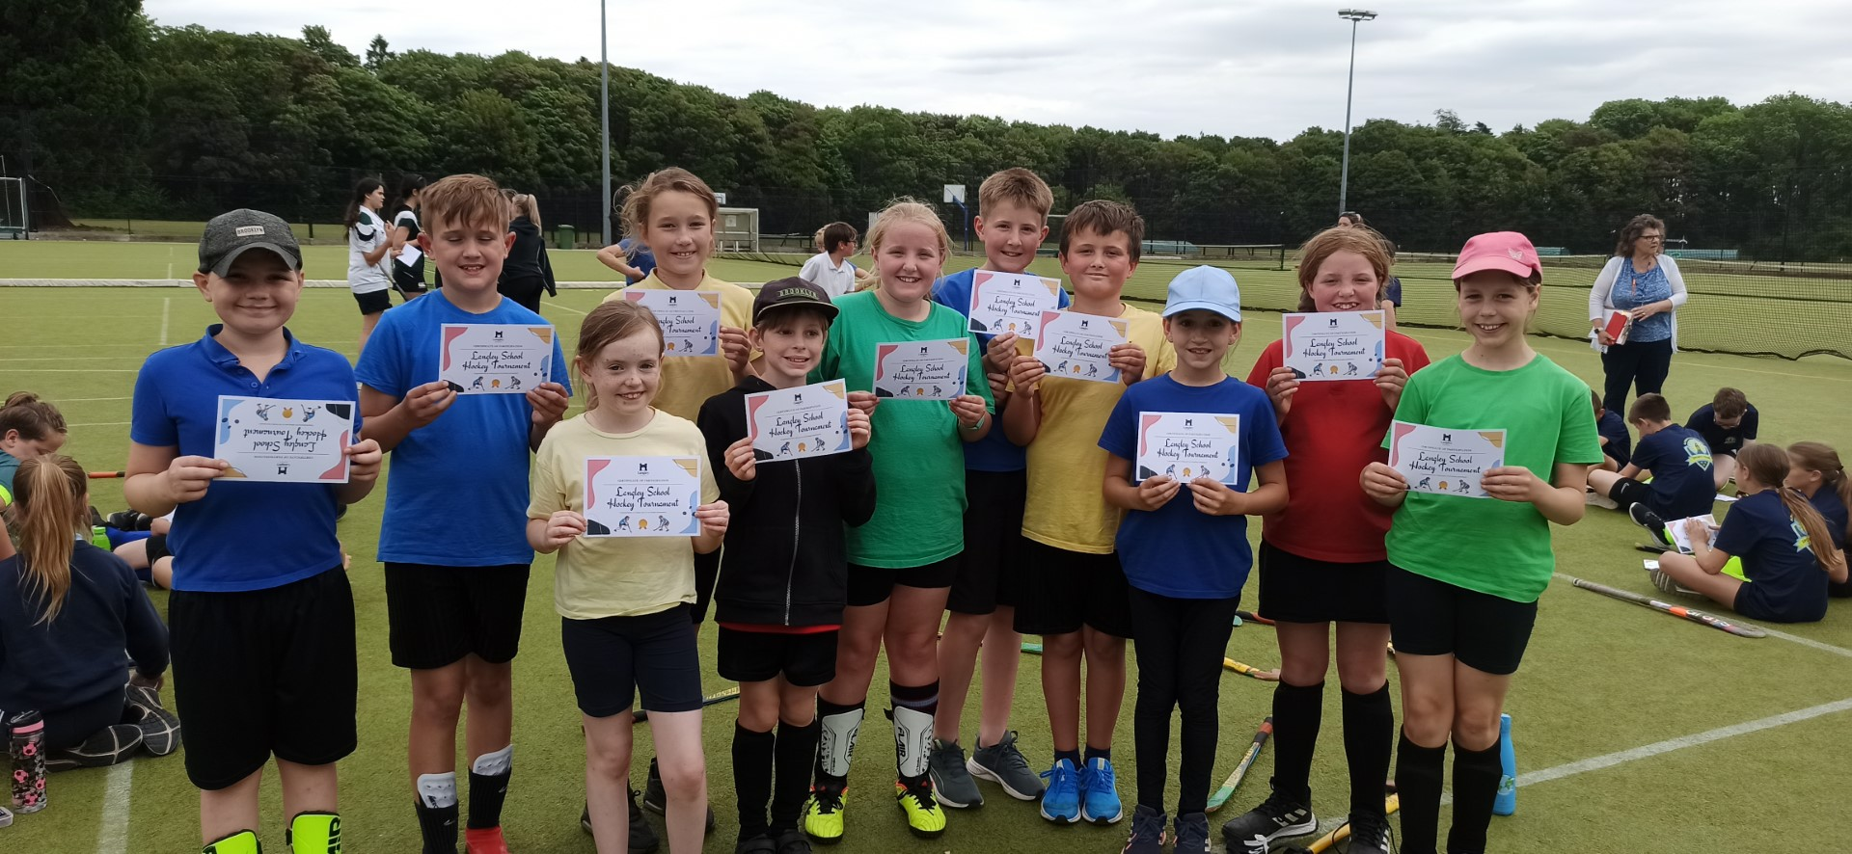

**Well Done to the children that attended the Hockey Tournament last Friday at Langley school. They played so well and showed great sportsmanship.**

**Dates for the Diary**

**Wednesday 28th & Thursday 29th June** – Year 6 Bungay High School Transition Days

**Saturday 8th July** – School Summer Fete

**Monday 10th – Wednesday 12th July** – Year 6 Hobart High School Transition Days

**Monday 10th July** – Kwik Cricket KS1 (Year 1 & 2 only)

**Wednesday 12th July** – Whole School Transition afternoon

**Thursday 13th July** – Woodton Sports Day (Parents to arrive at 1.30pm)

**Friday 14th July** – Year 6 Crucial Crew trip @ City College

**Monday 17th July** – Year 6 Leavers Treat – Tubing & Picnic

**Friday 21st July** – Leavers Assembly

**Monday 24th July to Tuesday 5th September** – Summer Holidays

**Wednesday 6th September** – Return to school

**Thursday 14th September** – Year 6 Taster Day at Bungay High school

**Sports Day – Thursday 13th July**

Reminder: Sports Day is on Thursday the 13th of July. We would like to invite all parents/carers to come and watch the children from 1.30pm. Please make sure that your child wears their house colour t-shirt, sun cream and sunhat for the day.





Oaks Summer Production

**‘Oliver’**

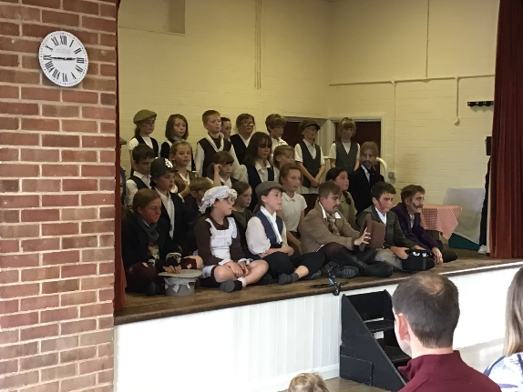

A big WELL DONE to all of Oaks class for giving an amazing performance of ‘Oliver’.