

*Issue No: 32 Date: Friday 16th June 2023*

*Our Newsletter comes out every Friday with updates about what the children have been up to during the week, information, things to celebrate and important dates for the diary. Please take the time to read through and if you have any questions, please speak to Mrs Taylor in the office.*

**This Week’s Achievements**

**Willows Stars of the Week**

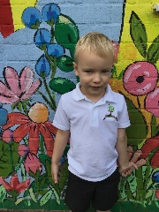 

**Oaks Stars of the Week**

 

For always making us smile and giving everything 100%.

For great work and effort in Ukulele this week.

For being so kind and nurturing with his friends.

For making excellent progress on Times Tables Rock stars this week.



Willows: 1st Finlay

Oaks: 1st Woody

2nd Charlie T

3rd Jesse



Congratulations to

Jack M-M for completing the Steel stages in NumBots this week!

CHALLENGE

NURTURE

INSPIRE

CHALLENGE

NURTURE

INSPIRE



**House Points for this week**

Stephen Hawkings – 100

Beatrix Potter – 82

Benjamin Britten – 112

Kelly Holmes – 84

**Class Attendance**

Willows – 98.72%

Oaks – 94.79%



**News & Dates**

**Weekly – Let’s think about Online Safety**

**How safe is your child online?**

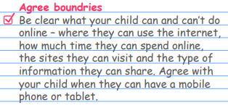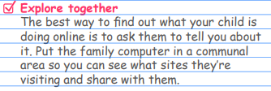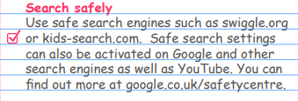

**School Class Photos and Year 6 Leavers Photos**

Our class and leavers photos went really well. The children will be bringing home a Vancol order sheet, which has a unique code and a QR code on it. Once the photos are ready to order, I will send a message home.



**Text Messages**

**We still seem to be having problems with our text messaging service. PA are looking into resolving this, but until then, the office will be emailing messages out, so please keep an eye on your inbox.**



**Oaks Oliver Production**

**On Wednesday the 5th of July, all of Oaks class will need to be dropped off at Woodton Village Hall from 8.40am. Please make sure to leave your child with a member of staff when dropping off. The children will spend the whole day there, so they will require a home packed lunch.**

**Dates for the Diary**

**Monday 19th June** – Hockley Lessons from Langley School

**Friday 23rd June** – Refugee Week Local Sponsored Walk (Whole School)

**Thursday 22nd June** – New Reception Welcome Meeting – 9am

**Tuesday 27th June** – New Reception Transition afternoon

**Wednesday 28th & Thursday 29th June** – Year 6 Bungay High School Transition Days

Friday 30th June – Years 5 & 6 Hocket Tournament @ Langley (details out next week)

**Tuesday 4th July** – Oaks Performance Rehearsal at the village hall (back in time for school collection)

**Wednesday 5th July** – Oaks Summer Production (1.45pm start)

**Thursday 6th July** – Transition afternoon for Reception & Year 1

**Friday 7th July** – Year 5 Taster Day @ Bungay High School

**Saturday 8th July** – School Summer Fete

**Monday 10th – Wednesday 12th July** – Year 6 Hobart High School Transition Days

**Monday 10th July** – Kwik Cricket KS1 (details out next week)

**Wednesday 12th July** – Whole School Transition afternoon

**Thursday 13th July** – Woodton Sports Day

**Friday 14th July** – Year 6 Crucial Crew (details out next week)

**Monday 17th July** – Year 6 Leavers Treat – Tubing (details to follow)

**Monday 24th July to Tuesday 5th September** – Summer Holidays

**Wednesday 6th September** – Return to school

Please be aware that dates may change at times.



**PTA Summer Fete**

**RAFFLE TICKETS**

The PTA’s Summer Fair raffle tickets are now on sale. Every child will be coming home with a raffle book today.

£1.00 a Ticket/ 5 tickets in a book

They have some amazing prices this year!

There is also more raffle books available from the school office if needed.

Please may we ask that all ticket stubs and monies be returned to the school office by Friday the 7th of July.