

*Issue No: 33 Date: Friday 23rd June 2023*

*Our Newsletter comes out every Friday with updates about what the children have been up to during the week, information, things to celebrate and important dates for the diary. Please take the time to read through and if you have any questions, please speak to Mrs Taylor in the office.*

**This Week’s Achievements**

**Willows Stars of the Week**

 

**Oaks Stars of the Week**

 

For giving everything 100%.

For a beautifully presented Victorian washing timeline in History.

For always giving 100% and wowing us with his neatness.

For always giving maximum effort and enthusiasm in PE.



Willows: 1st Kendall

2nd Molly

3rd Maisy

Oaks: 1st Charlie T

2nd Amelia

3rd Lucy



Garage Rocker – Evie

Gigger – Anya & Riley

Rock Star – Charlie L

**Rock Legend - Kian**



No Numbots Stages passed this week!

CHALLENGE

NURTURE

INSPIRE

CHALLENGE

NURTURE

INSPIRE



**House Points for this week**

Stephen Hawkings – 125

Beatrix Potter – 121

Benjamin Britten – 105

Kelly Holmes – 140

**Class Attendance**

Willows – 96.79%

Oaks – 92.45%



**News & Dates**

**Weekly – Let’s think about Online Safety**

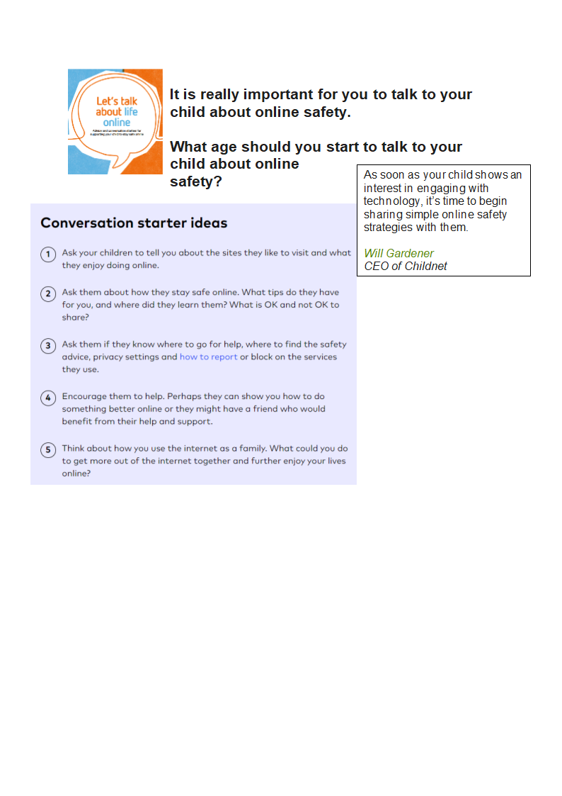

**School Class Photos and Year 6 Leavers Photos**

An email was sent out this week, giving details about the school photos being ready to order online. For free delivery to the school, photos must be ordered by the 5th of July.



**Text Messages**

**We still have no text messaging service running. PA are continuing to look into resolving the problem, but until then, the office will be emailing messages out, so please keep an eye on your inbox.**



**Oaks Summer Production**

**Tickets will be available to purchase from Wednesday the 28th of June from the school office. 3 tickets per family, at £1 a ticket.**

**Please may we ask on the day of the production, that if possible pushchairs are kept outside, as the children will need access around the audience seating. If you require wheelchair access, please notify the office.**



**Sports Day – Thursday 13th July**

Reminder: Sports Day is on Thursday the 13th of July. We would like to invite all parents/carers to come and watch the children from 1.30pm. Please make sure that your child wears their house colour t-shirt, sun cream and sunhat for the day.

Refugee Week

**Our Sponsored Walk**



Woodton took part in a Walk for Refugees to raise money for a charity who provides bikes for Refugees new to Norwich. Thank you for all your support.

Sponsor forms and monies will need to be returned to the school office, by Friday the 30th of June.

**Dates for the Diary**

**Tuesday 27th June** – New Reception Transition afternoon

**Wednesday 28th & Thursday 29th June** – Year 6 Bungay High School Transition Days

**Friday 30th June** – Years 5 & 6 Hocket Tournament @ Langley

**Tuesday 4th July** – Oaks Performance Rehearsal at the village hall (back in time for school collection)

**Wednesday 5th July** – Oaks Summer Production (1.45pm start)

**Thursday 6th July** – Transition afternoon for Reception & Year 1

**Friday 7th July** – Year 5 Taster Day @ Bungay High School (POSTPONED)

**Saturday 8th July** – School Summer Fete

**Monday 10th – Wednesday 12th July** – Year 6 Hobart High School Transition Days

**Monday 10th July** – Kwik Cricket KS1

**Wednesday 12th July** – Whole School Transition afternoon

**Thursday 13th July** – Woodton Sports Day

**Friday 14th July** – Year 6 Crucial Crew

**Monday 17th July** – Year 6 Leavers Treat – Tubing

**Monday 24th July to Tuesday 5th September** – Summer Holidays

**Wednesday 6th September** – Return to school



**PTA Summer Fete**

**RAFFLE TICKETS**

Tickets are still available from the school office

£1.00 a Ticket/ 5 tickets in a book

Please may we ask that all ticket stubs and monies be returned to the school office by Friday the 7th of July.