

*Issue No: 31 Date: Friday 09th June 2023*

*Our Newsletter comes out every Friday with updates about what the children have been up to during the week, information, things to celebrate and important dates for the diary. Please take the time to read through and if you have any questions, please speak to Mrs Taylor in the office.*

**This Week’s Achievements**

**Willows Stars of the Week**

 

**Oaks Stars of the Week**

 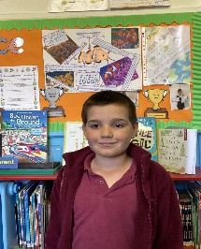

For wowing us with his reading and phonics.

For really immersing herself on our trip to Gressenhall.

For supporting and nurturing his friends.

For showing enthusiasm and sportsmanship at our Dynamo cricket event and received the sports award for teamwork.



Willows: 1st Finlay

2nd Emmie

3rd Evie

Oaks: 1st Charlie T

2nd Woody

3rd Charlie L



**Hector – Rock Star**



No Numbots stages completed this week.

CHALLENGE

NURTURE

INSPIRE

CHALLENGE

NURTURE

INSPIRE



**House Points for this week**

Stephen Hawkings – 59

Beatrix Potter – 49

Benjamin Britten – 46

Kelly Holmes – 61

**Class Attendance**

Willows – 100%

Oaks – 97.66%



**News & Dates**

**Weekly – Let’s think about Online Safety**

**C:\Users\karen taylor\AppData\Local\Microsoft\Windows\INetCache\Content.MSO\5E86063D.tmp**

**What is Rec Room?**

Rec Room is a free online multiplayer video game from America created in April 2016. Users can explore millions of player-created rooms and communicate with people from all over. Or they can create their own inventions (player-made items) to share with others.

**What is Rec Net?**

Rec Net (Rec.net) is the community website for Rec Room. Users on Rec.net login with their Rec Room details to shop, explore user inventions and see upcoming in-game events. It’s also where users can upgrade their account or add real-world money for in-game purchases.  Parents can login to Rec Net to manage their child’s account as well.

**Rec Room age minimum**

Rec Room is open to users of all ages. However, users under the age of 13 are registered to a Junior Account.  Junior Accounts limit voice and text chat, the types of usernames children can have, where they can create inventions and inappropriate content such as ‘friendly fire’ options in Quests and player-made content with mature or scary themes.

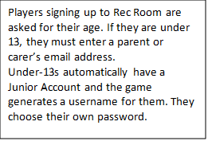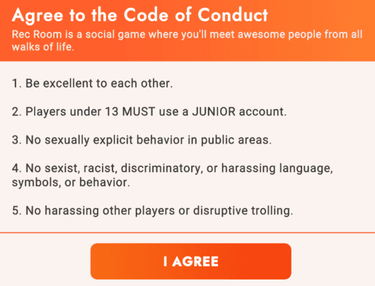

**Dates for the Diary**

**Monday 12th & 19th June** – Hockley Lessons from Langley School

**Monday 12th June** – Rounders Tournament @ Hobart – 4pm till 5.30pm **CANCELLED**

**Wednesday 14th June** – Oaks to the Village hall in the morning for a production rehearsal

**Thursday 15th June** – Vancol - Class & Leavers Photos

**Friday 16th June** – Fathers Day messages in the BBJ

**Thursday 22nd June** – New Reception Welcome Meeting – 9am

**Tuesday 27th June** – New Reception Transition afternoon

**Wednesday 28th & Thursday 29th June** – Year 6 Bungay High School Transition Days

**Tuesday 4th July** – Oaks Performance Rehearsal at the village hall (back in time for school collection)

**Wednesday 5th July** – Oaks Summer Production (1.45pm start)

**Thursday 6th July** – Transition afternoon for Reception & Year 1

**Friday 7th July** – Year 5 Taster Day @ Bungay High School

**Saturday 8th July** – School Summer Fete

**Monday 10th – Wednesday 12th July** – Year 6 Hobart High School Transition Days

**Monday 10th July** – Kwik Cricket KS1 (details to follow)

**Wednesday 12th July** – Whole School Transition afternoon

**Thursday 13th July** – Woodton Sports Day

**Friday 14th July** – Year 6 Crucial Crew (details to follow)

**Monday 17th July** – Year 6 Leavers Treat – Tubing (details to follow)

**Monday 24th July to Tuesday 5th September** – Summer Holidays

**Wednesday 6th September** – Return to school

Please be aware that dates may change at times.

**School Class Photos and Year 6 Leavers Photos**

Vancol will be visiting on Thursday 15th June to take the class photos and the year 6 leavers photos.

