

*Issue No: 36 Date: Friday 21st July 2023*

*Our newsletter comes out every Friday with updates about what the children have been up to during the week, information, things to celebrate and important dates for the diary. Please take the time to read through and if you have any questions, please speak to Mrs Taylor in the office.*

**This Week’s Achievements**

We would like to wish you all a restful summer holidays. If you do need to contact us during this break, emails are checked weekly.

Happy Summer Break!





Unsigned Act – ANYA



Congratulations to **Millie** for completing Iron and **Ned** for receiving the Gold award in NumBots this week!

CHALLENGE

NURTURE

INSPIRE

CHALLENGE

NURTURE

INSPIRE



**100% Attendance for the Year**

Willows – Phoebe R

Oaks – Florence



**Forest School Lessons**

Forest school lessons will continue every Friday.

Next Term will be;

Willows – Reception & year 1

Sycamores – Years 3 & 4

(Oaks will be the following term)



**School Dinners**

As normal, school dinners should be ordered through your parent app, by the Friday of the previous week. (For those new parents, please email the school office to place any dinner orders you may require, until you are set up on the app).

The Norse school menu is available to view on our school website. May we ask that you note the meal option that is available for that day, and only order this choice.

School dinner money MUST be paid in advance. If payments are outstanding, we will be unable to order your school dinners and a home packed lunch will need to be provided.



**Oaks Swimming**

Oaks will be swimming every Wednesday morning from September to December. Please see the email that was sent home for details of what kit is required. We still have some permissions outstanding for the swimming lessons, please give consent via the parent’s app or email the school office.



**PE Lessons – Next Term**

Children will require coming into school in their PE kits on these days;

Willows – Mondays & Wednesdays

Sycamores – Wednesdays & Thursdays

Oaks – Wednesdays

Please see the PE kit requirements in the uniform section on our school website.



**Dates for the Diary**

**Monday 24th July to Tuesday 5th September** – Summer Holidays

**Wednesday 6th September** – Return to school

**Wednesday 13th September** – Oaks start their weekly swimming lessons @ Bungay Pool

**Thursday 14th September** – Year 6 Taster Day at Bungay High school

**Monday 18th September** – Year 6 visit from Mr Li Rocchi (Hobart High)

**Monday 9th October** – Year 6 Cycling Proficiency (Details to follow)

**Tuesday 10th October** – Year 6 Cycling Proficiency (Details to follow)

**Tuesday 5th December** – Whole school Flu Immunisation (Consent forms sent out nearer the time)

**Year 6 Leavers**

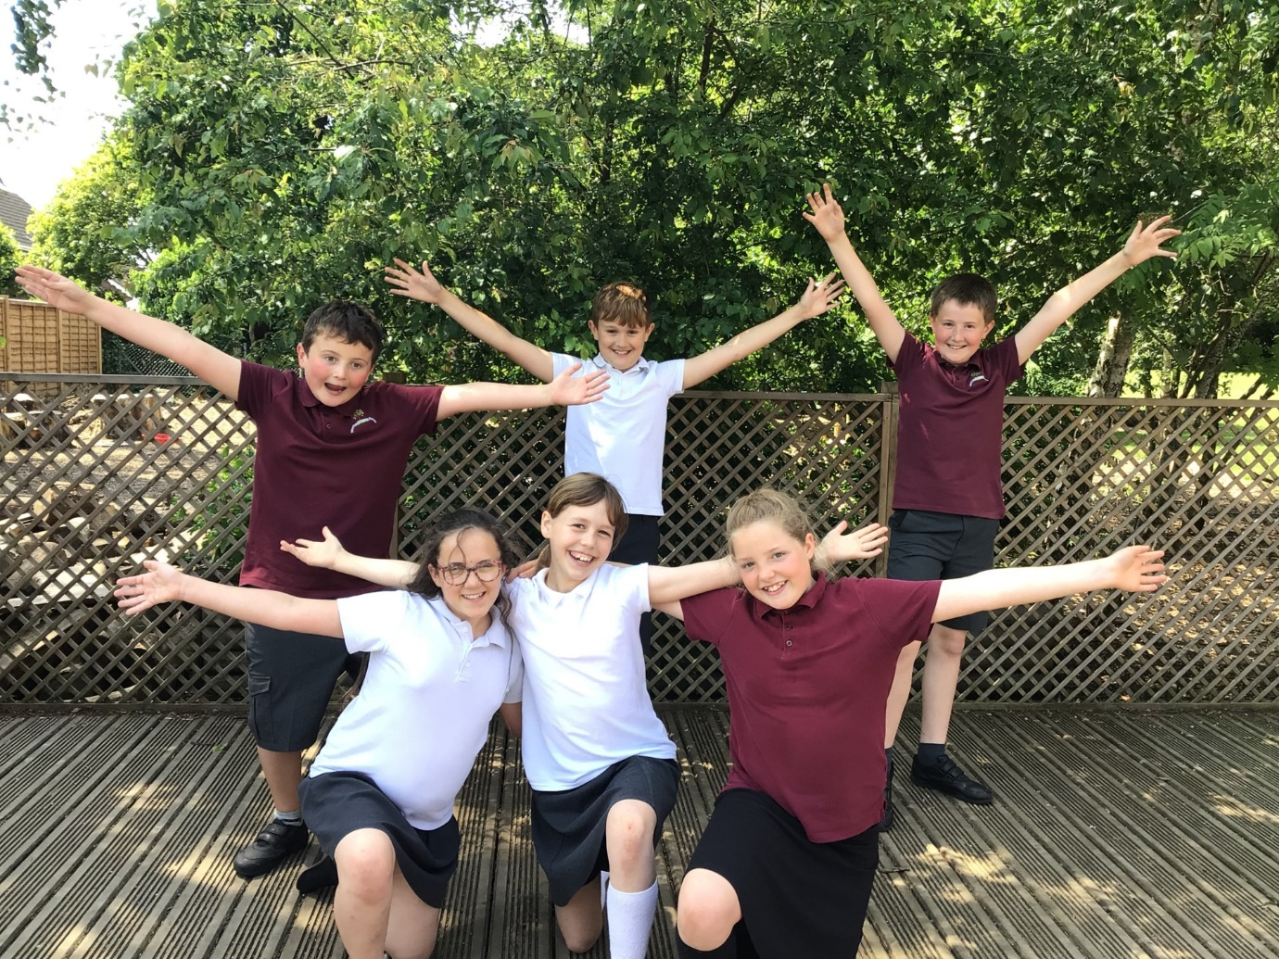

We would like to wish you all the happiness in your new path