

*Issue No: 35 Date: Friday 15th Sept 2023*

*Our Newsletter comes out every Friday with updates about what the children have been up to during the week, information, things to celebrate and important dates for the diary. Please take the time to read through and if you have any questions, please speak to Mrs Taylor in the office.*

**This Week’s Achievements**

**Willows Stars of the Week**



**Sycamores Stars of the Week**



For engaging positively with Mrs Hinton and Mrs Richardson in lessons this week.

For settling in so well on her first week.

CHALLENGE

NURTURE

INSPIRE

CHALLENGE

NURTURE

INSPIRE

**Oaks Stars of the Week**

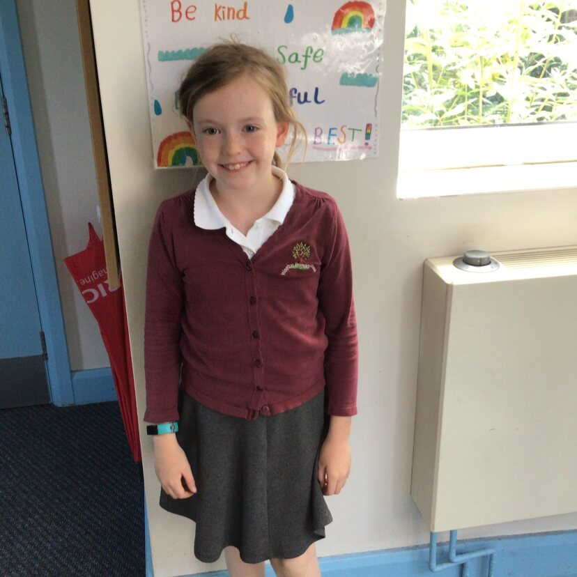

For great teamwork and outstanding work in Maths. A brilliant start to the new school year.

**House Points for this week**

Stephen Hawkings – 153

Beatrix Potter – 112

Benjamin Britten – 48

Kelly Holmes – 76

**Class Attendance**

Willows – 99.47%

Sycamores – 98.55%

Oaks – 93.63%





Sycamores: 1st Maisy

2nd Charlie L

3rd Isla

Oaks: 1st Riley

2nd Charlie T

3rd Lucy



No Rock Stars this week!



No Numbots this week.

Keep Trying!



**Online Safety**

**Weekly – Let’s think about Online Safety**



**Found!!**

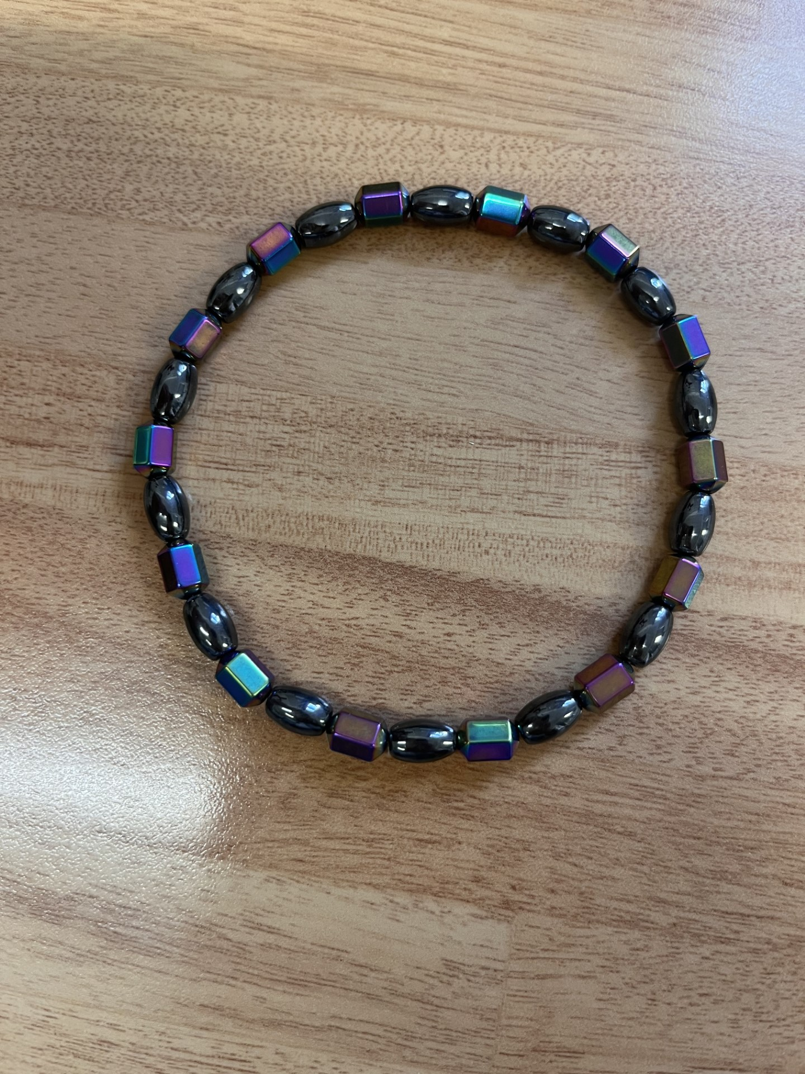

This bracelet was found outside, it is safe in the school office, waiting to be claimed.

Oaks Swimming

There will be no swimming for Oaks class on Wednesday the 20th of September, we have been informed that the pool is closed due to a new pool cover being replaced.

Swimming lessons will resume from Wednesday the 27th of September.



**Jeans 4 Genes**

On Friday the 22nd of September, we are inviting all children to come into school in non-uniform, wearing something denim for a small donation. The money raised will go towards the Jeans 4 Genes charity.



**Dates for the Diary**

**Monday 18th/25th/2nd** – Year 5 & 6 Football Tournament

**Thursday 21st Sept** – Meeting for Yr 5 & 6 Residential Trip (3.30pm)

**Friday 22nd Sept** – Jeans 4 Genes Day

**Friday 29th Sept** – Macmillan Cake Sale from 3pm

**Tuesday 10th** **Oct** – HelloYellow Day (Wear something yellow for a small donation)

**Wednesday 11th Oct** – Cross Country for years 3 & 4 (details to follow)

**Monday 9th & Tuesday 10th** – Year 6 Cycling Proficiency (details to follow)

**Mon 23rd to Fri 27th Oct** – Half Term

**Thurs 21st to Wed 3rd Jan** – Christmas Break

**Macmillan Cake Sale**

This year the PTA will be running a cake stall on Friday the 29th of September from 3pm to raise money for Macmillan Cancer Support.

Donations of cakes, biscuits, buns or scones would be greatly appreciated please. These can be brought into the school office on the morning of that Friday.

