

*Issue No: 36 Date: Friday 22nd Sept 2023*

*Our Newsletter comes out every Friday with updates about what the children have been up to during the week, information, things to celebrate and important dates for the diary. Please take the time to read through and if you have any questions, please speak to Mrs Taylor in the office.*

**This Week’s Achievements**

**Willows Stars of the Week**

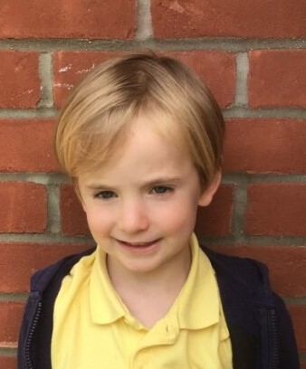

**Sycamores Stars of the Week**

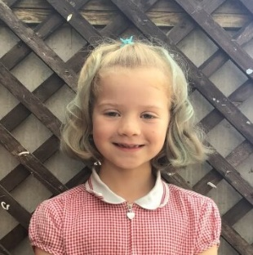

For wowing us with his fabulous reading.

For always giving 100% in her learning.

CHALLENGE

NURTURE

INSPIRE

CHALLENGE

NURTURE

INSPIRE

**Oaks Stars of the Week**

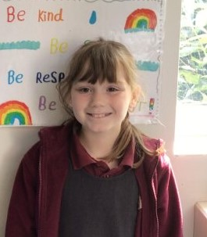

For impressing us all with the amount of effort she has been making in every lesson, especially Maths. A great start to the year!

**Class Attendance**

Willows – 96.3%

Sycamores – 97.1%

Oaks – 90.69%

**House Points for this week**

Stephen Hawkings – 105

Beatrix Potter – 132

Benjamin Britten – 73

Kelly Holmes – 78





Willows: 1st Ned

2nd Jack MM

3rd Felicity

Sycamores: 1st Flo

2nd Charlie L

3rd Evie

Oaks: 1st Riley

2nd Lucas

3rd Ava



Ned - Busker



No Numbots this week.

Keep Trying!



**Online Safety**

**Weekly – Let’s think about Online Safety**





**Staff Car Park**

Please can we remind everyone that school children walk into class through the staff car park, for safety, we ask that all parents/carers use the top car park, **NOT** the staff car park to drop and collect their children.



**Headlice**

We have had a few cases of headlice reported. Please may we ask that children’s hair are checked over the weekend and treated if needed. If treatment is needed, please take note of the instructions, as most solutions require a further treatment two weeks later.



**Macmillan Cake Sale**

This year the PTA will be running a cake stall on Friday September 29th, from 3pm to raise money for Macmillan Cancer Support.

Donations of cakes, biscuits, buns or scones would be greatly appreciated please. These can be brought into the school office on the morning of that Friday.



**Jeans 4 Genes Day**

Thank you to everyone that wore denim today and donated to the ‘Jeans 4 Genes’ charity. We raised an amazing £65.45.



**Dates for the Diary**

**Monday 25th/2nd** **Sept** – Year 5 & 6 Football Tournament – earlier start time of 4pm

**Friday 29th Sept** – Macmillan Cake Sale from 3pm

**Wednesday 4th Oct** – Tempest - Individual and Sibling School Photos

**Tuesday 10th** **Oct** – **HelloYellow** Day (Wear something yellow for a small donation)

**Wednesday 11th Oct** – Cross Country for years 3 & 4 (details to follow)

**Monday 9th & Tuesday 10th** **Oct** – Year 6 Cycling Proficiency (details to follow)

**Thursday 19th Oct** – Harvest Festival @ Woodton Church 2pm

**Friday 20th Oct** – First Class Photo in the BBJ

**Mon 23rd to Fri 27th Oct** – Half Term

**Sat 9th & Sun 10th Dec** – Ditchingham Christmas Tree Festival

**Wednesday 13th Dec** - Christingle

**Friday 15th Dec** – Willows Nativity 2pm

**Thurs 21st to Wed 3rd Jan** – Christmas Break

**Walk for Wheels**

**Sponsored Walk**

Back in June, the children all took part in a sponsored walk for ‘New Routes’ charity. We raised an amazing £488.

Thank you and WELL DONE to everyone involved.



**Years 5 & 6 Football Tournament**

**Earlier Start**

For those children that have signed up for the football tournament at Hobart, the start time has changed; it is now at an earlier time of 4pm for the next two Mondays.

