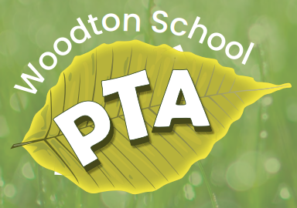
Registered Charity Name: Woodton C.P. School P.T.A.
Charity number: 1078164
Welcome Friends,
It is with great enthusiasm that the Parent Teacher Association (PTA) welcomes you to Woodton Primary School. There are many reasons why you should join our PTA. From making new friends and getting to know the school environment, through to helping raise much needed funds and making a difference to the children and school community. All these things may help you grow in confidence as a parent, and it feels good to know you are making a difference for your children and for generations to come. The PTA consists of 3 official committee members who are voted in, and the remainder of PTA members are a wonderful bunch of adults.

The PTA committee currently are:

- Donné Wiseman – chairperson (parent to Willow & Feliks)
- Anna Scriven – treasurer (parent to Molly)
- Emma Keal – secretary (parent to Hector & Betty) – after 6 wonderful years of service, this post will be vacant after July 2023 as Emma will be standing down. If you may be interested, please do let us know via our email at woodtonprimaryschoolpta@gmail.com

The purpose of our PTA is to enrich and enhance your child’s experience in the school. We invite you to become involved. Share your ideas, time, support, and talents with all of us at the school for the benefit of our kids. We look for volunteers for our upcoming events and the roles within the PTA vary. It can be as much or as little as you wish to make it.

We are a charity that raises funds to provide much-needed equipment and activities for the children who attend Woodton Primary School, including school trips, sports equipment and reading books. Our school community is small, with only 58 pupils in attendance, so every penny raised is of great value to our children and can make a huge difference to their school experience.

We look forward to meeting you all soon and wish your little ones the best start to school in September 2023.

Kind regards,
Donné

