

*Issue No: 7 Date: Friday 3rd Nov 2023*

*Our Newsletter comes out every Friday with updates about what the children have been up to during the week, information, things to celebrate and important dates for the diary. Please take the time to read through and if you have any questions, please speak to Mrs Taylor in the office.*

**This Week’s Achievements**

**Willows Stars of the Week**

**Sycamores Stars of the Week**

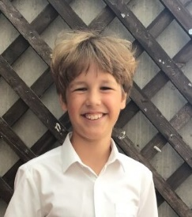

Ella-Rose for joining in and showing us her learning.

For having a fantastic, ‘can do’ attitude in all of his learning this week, always giving 100%.

CHALLENGE

NURTURE

INSPIRE

CHALLENGE

NURTURE

INSPIRE

**Oaks Stars of the Week**

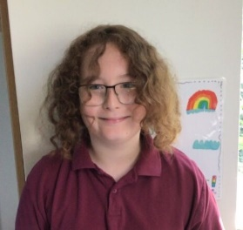

For great effort in his phonics and reading.

**Class Attendance**

Willows – 99.31%

Sycamores – 100%

Oaks – 97.79%

**House Points for this week**

Stephen Hawkings – 131

Beatrix Potter – 110

Benjamin Britten – 45

Kelly Holmes – 77





Willows: 1st Jack M

2nd Ned

3rd Lonnie

Sycamores: 1st Flo

2nd Maisy

3rd Hector

Oaks: 1st Riley

2nd Charlie T

3rd Iliana



Jack M – Support Act

Molly - Gigger



Congratulations to

Alfie for completing the **RUST** stages in NumBots this week!



**Online Safety**

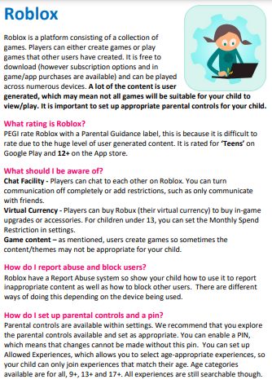

**Parents Evenings**

**Tues 7th Nov or Wed 15th Nov**

The signing up sheets are in the school office, if you haven’t already done so, please come and put your child’s name down next to a suitable day and time. This is a great opportunity to talk directly to your child’s teacher.



**Odd Socks Day**

**Friday 10th November**

To show our support for anti-bullying this year, we would like to invite everyone to wear ODD SOCKS on Friday the 10th of Nov.

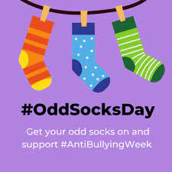

**Willows, Sycamores & Oaks Class**

All three classes would like to invite parents in on Monday the 13th of Nov at 2pm for the launch of ‘Space Week' The children will be doing some space themed activities, and would love you all to come and join in.



**School Dinners**

Please can we remind parents that there is a new menu for this term. When ordering school dinners, please check on the menu which meal option is available for that day and only order this meal.

School dinner orders MUST be ordered by noon of the Friday before, meals can not be added mid-way through the week, without speaking to the office first.



**Remembrance**

We have a box inside the office full of remembrance items to raise money for the Royal British Legion Poppy Appeal. Please feel free to come in and look. There is a donation pot next to the box.

Thank you.



**Christmas Showbox Appeal**

Thank you for those who have already filled their shoeboxes!

We still have some left in the office if anyone would like to take one.

We did ask for all of the boxes to be returned to the school office by today, but we will extend this until Thursday 7th November.

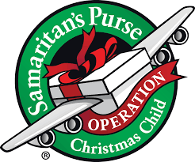

**Dates for the Diary**

**Tues 7th Nov** – Parents Evening (Appointments will be paper sign up version)

**Fri 10th Nov** – Odd Socks Day

**Wed 15th Nov** – Parents Evening (Appointments will be paper sign up version)

**Mon 13th – 17th Nov** – Space Week

**Fri 17th Nov** – Tempest revisit to retake photos for listed children

**Fri 1st Dec** – PTA Non-Uniform Day for a donation of a Xmas gift

**Fri 8th Dec** – PTA Wrapping morning

**Fri 8th Dec** – Christmas Jumper Day (Non uniform day)

**Fri 8th Dec** – Children’s Christmas Disco, ran by the PTA (Details to follow)

**Wed 13th Dec** – Christmas Lunch

**Sat 9th & Sun 10th Dec** – Ditchingham Christmas Tree Festival

**Wednesday 13th Dec** - Christingle

**Friday 15th Dec** – Willows Nativity 2pm

**Thurs 21st to Wed 3rd Jan** – Christmas Break