

*Issue No: 05 Date: Friday 13th Oct 2023*

*Our Newsletter comes out every Friday with updates about what the children have been up to during the week, information, things to celebrate and important dates for the diary. Please take the time to read through and if you have any questions, please speak to Mrs Taylor in the office.*

**This Week’s Achievements**

**Willows Stars of the Week**

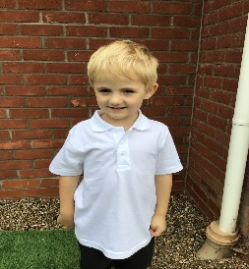

**Sycamores Stars of the Week**

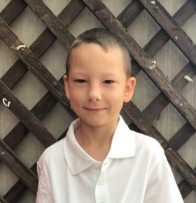

For coming into school every day with a smile and always giving everything 100%.

For showing fantastic determination and great resilience in completing the cross-country.

CHALLENGE

NURTURE

INSPIRE

CHALLENGE

NURTURE

INSPIRE

**Oaks Stars of the Week**

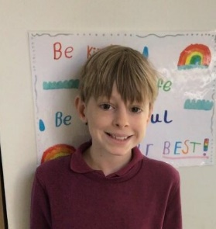

For working hard, listening carefully and showing outstanding road safety during our cycling proficiency lessons.

**Class Attendance**

Willows – 100%

Sycamores – 97.46%

Oaks – 94.61%

**House Points for this week**

Stephen Hawkings – 67

Beatrix Potter – 59

Benjamin Britten – 20

Kelly Holmes – 60





Willows: 1st Lonnie

2nd Ned

3rd Jack MM

Sycamores: 1st Hector

2nd Charlie L

3rd Finlay

Oaks: 1st Lucas

2nd Phoebe

3rd Charlie T



Ned – Unsigned Act

Crystal – Busker

Riley – Support Act



Congratulations to

Alannah for completing the **RUST** stages in NumBots this week!



**Weekly – Let’s think about Online Safety** 

It can be very easy online for children to behave in a way that they wouldn’t if they were face to face with each other.

Talk to your child about how they speak to others online and encourage them to talk to people online with respect and kindness, like they would if they were face-to-face. How they act online should be how they behave on the school playground when they are following school rules.

Here are some examples of what being unkind looks like online:

* Sending nasty or hurtful messages
* Leaving unkind comments
* Sharing photographs of somebody else without their permission
* Excluding somebody on purpose
* Impersonating somebody with a fake account
* Telling/sharing lies

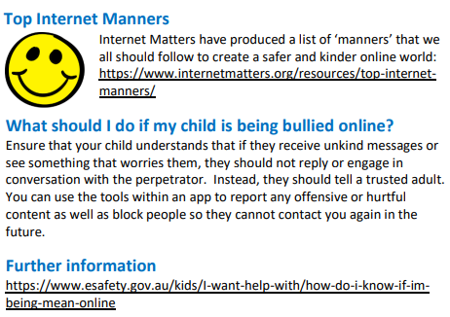

Young Minds – HELLO YELLOW Day

THANK YOU to everyone that supported our Hello Yellow fundraising day on Tuesday, we raised £38.80 for the charity.



**Year 6 Cycling**

WELL DONE to all the year 6 children for passing their cycling proficiency level 2 On Road cycling course.

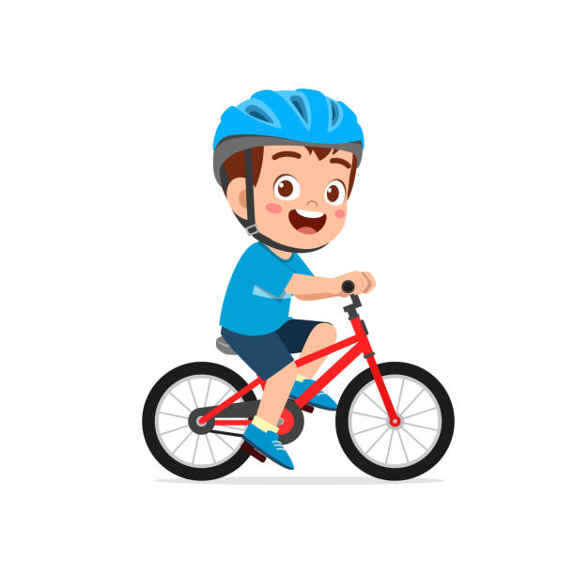

**Space Week**

From 13th - 17th November, children at Woodton Primary School will be celebrating and learning all about Space! Among other events, children will have the opportunity to meet and ask questions to a real rocket scientist. The children will also get the chance to learn more about space in a mobile planetarium, which will be visiting us. Watch this space (!) for more information and dates during the week when you will be able to come in to school to take part in some of our space activities with your child.



**Football Tournament**

Reminder: It is the last football tournament at Hobart, this Monday, with a start time of 4pm. Please notify the school office of all collection arrangements.

**Dates for the Diary**

**Monday 16th Oct –** Football Tournament rearranged date – 4pm @ Hobart

**Tuesday 17th Oct** – PTA AGM Meeting (6pm, School Hall)

**Thursday 19th Oct** – Harvest Festival @ Woodton Church 2pm

**Mon 23rd to Fri 27th Oct** – Half Term

**Mon 13th – 17th Nov** – Science Week

**Fri 1st Dec** – PTA Non-Uniform Day for a donation of a Xmas gift

**Fri 8th Dec** – PTA Wrapping morning

**Fri 8th Dec** – Christmas Jumper Day

**Fri 8th Dec** – Children’s Christmas Disco, ran by the PTA (Details to follow)

**Sat 9th & Sun 10th Dec** – Ditchingham Christmas Tree Festival

**Wednesday 13th Dec** - Christingle

**Friday 15th Dec** – Willows Nativity 2pm

**Thurs 21st to Wed 3rd Jan** – Christmas Break

**Harvest Festival**

Our Harvest Festival is on Thursday the 19th of October at Woodton church from 2pm, ALL WELCOME.

If you would like to donate for the Harvest, we are asking for non-perishable food donations to be brought to the school office. Any items collected will be donated to the Hempnall Food Bank.

