

*Issue No: 0 Date: Friday 20th Oct 2023*

*Our Newsletter comes out every Friday with updates about what the children have been up to during the week, information, things to celebrate and important dates for the diary. Please take the time to read through and if you have any questions, please speak to Mrs Taylor in the office.*

**This Week’s Achievements**

**Willows Stars of the Week**

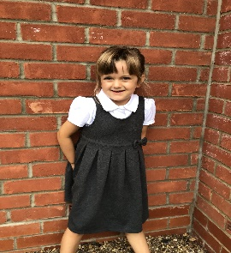

**Sycamores Stars of the Week**

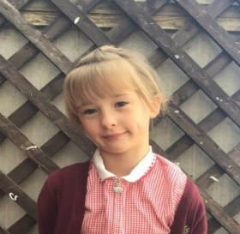

For showing, great determination and focus in her learning this week despite some of it being really challenging.

For always giving everything a go and being her best.

CHALLENGE

NURTURE

INSPIRE

CHALLENGE

NURTURE

INSPIRE

**Oaks Stars of the Week**

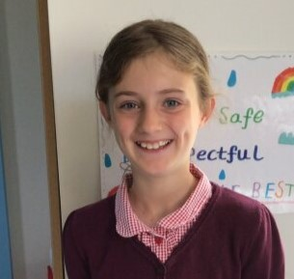

For her fantastic progress this year due to her determination and resilience across all of her learning.

**Class Attendance**

Willows – 97.22%

Sycamores – 97.83%

Oaks – 97.06%

**House Points for this week**

Stephen Hawkings – 96

Beatrix Potter – 93

Benjamin Britten – 67

Kelly Holmes – 71





Willows: 1st Jack M

2nd Lonnie

3rd Ned

Sycamores: 1st Hector

2nd Florence

3rd Finlay

Oaks: 1st Phoebe

2nd Riley

3rd Lucas



Crystal – Breakthrough

Emmie & Maisy – Wannabe

Molly – Busker



Congratulations to

Dotty for completing the **IRON** stages in NumBots this week!



Football Tournament

A BIG well done to our years 5 & 6 that participated in the football tournament at Hobart this term, they all played amazingly and showed some great sportsmanship as we teamed up with Seething.

Also, a BIG congratulations to the girls who came first with their Seething team and received medals, WELL DONE Phoebe P, Olivia and Illiana.

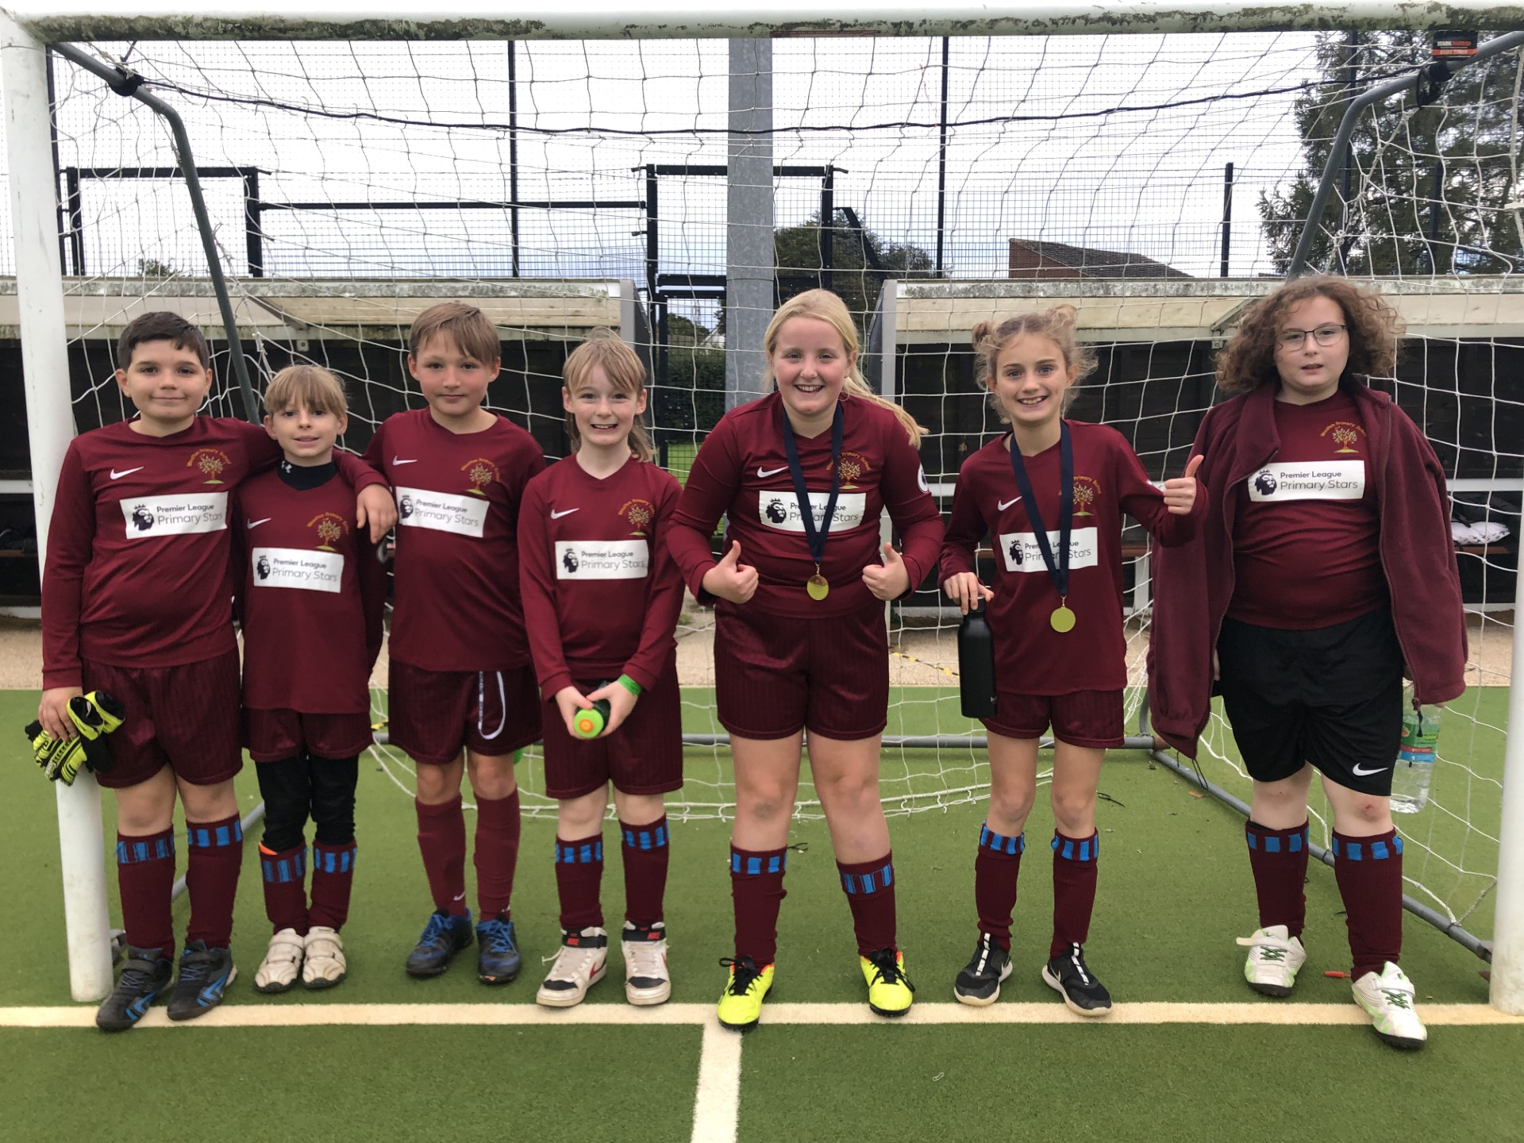

Another BIG well done to our Sycamores class who took part in the Cross Country and for Maisy for coming 3rd out of the whole cluster girls cross country.

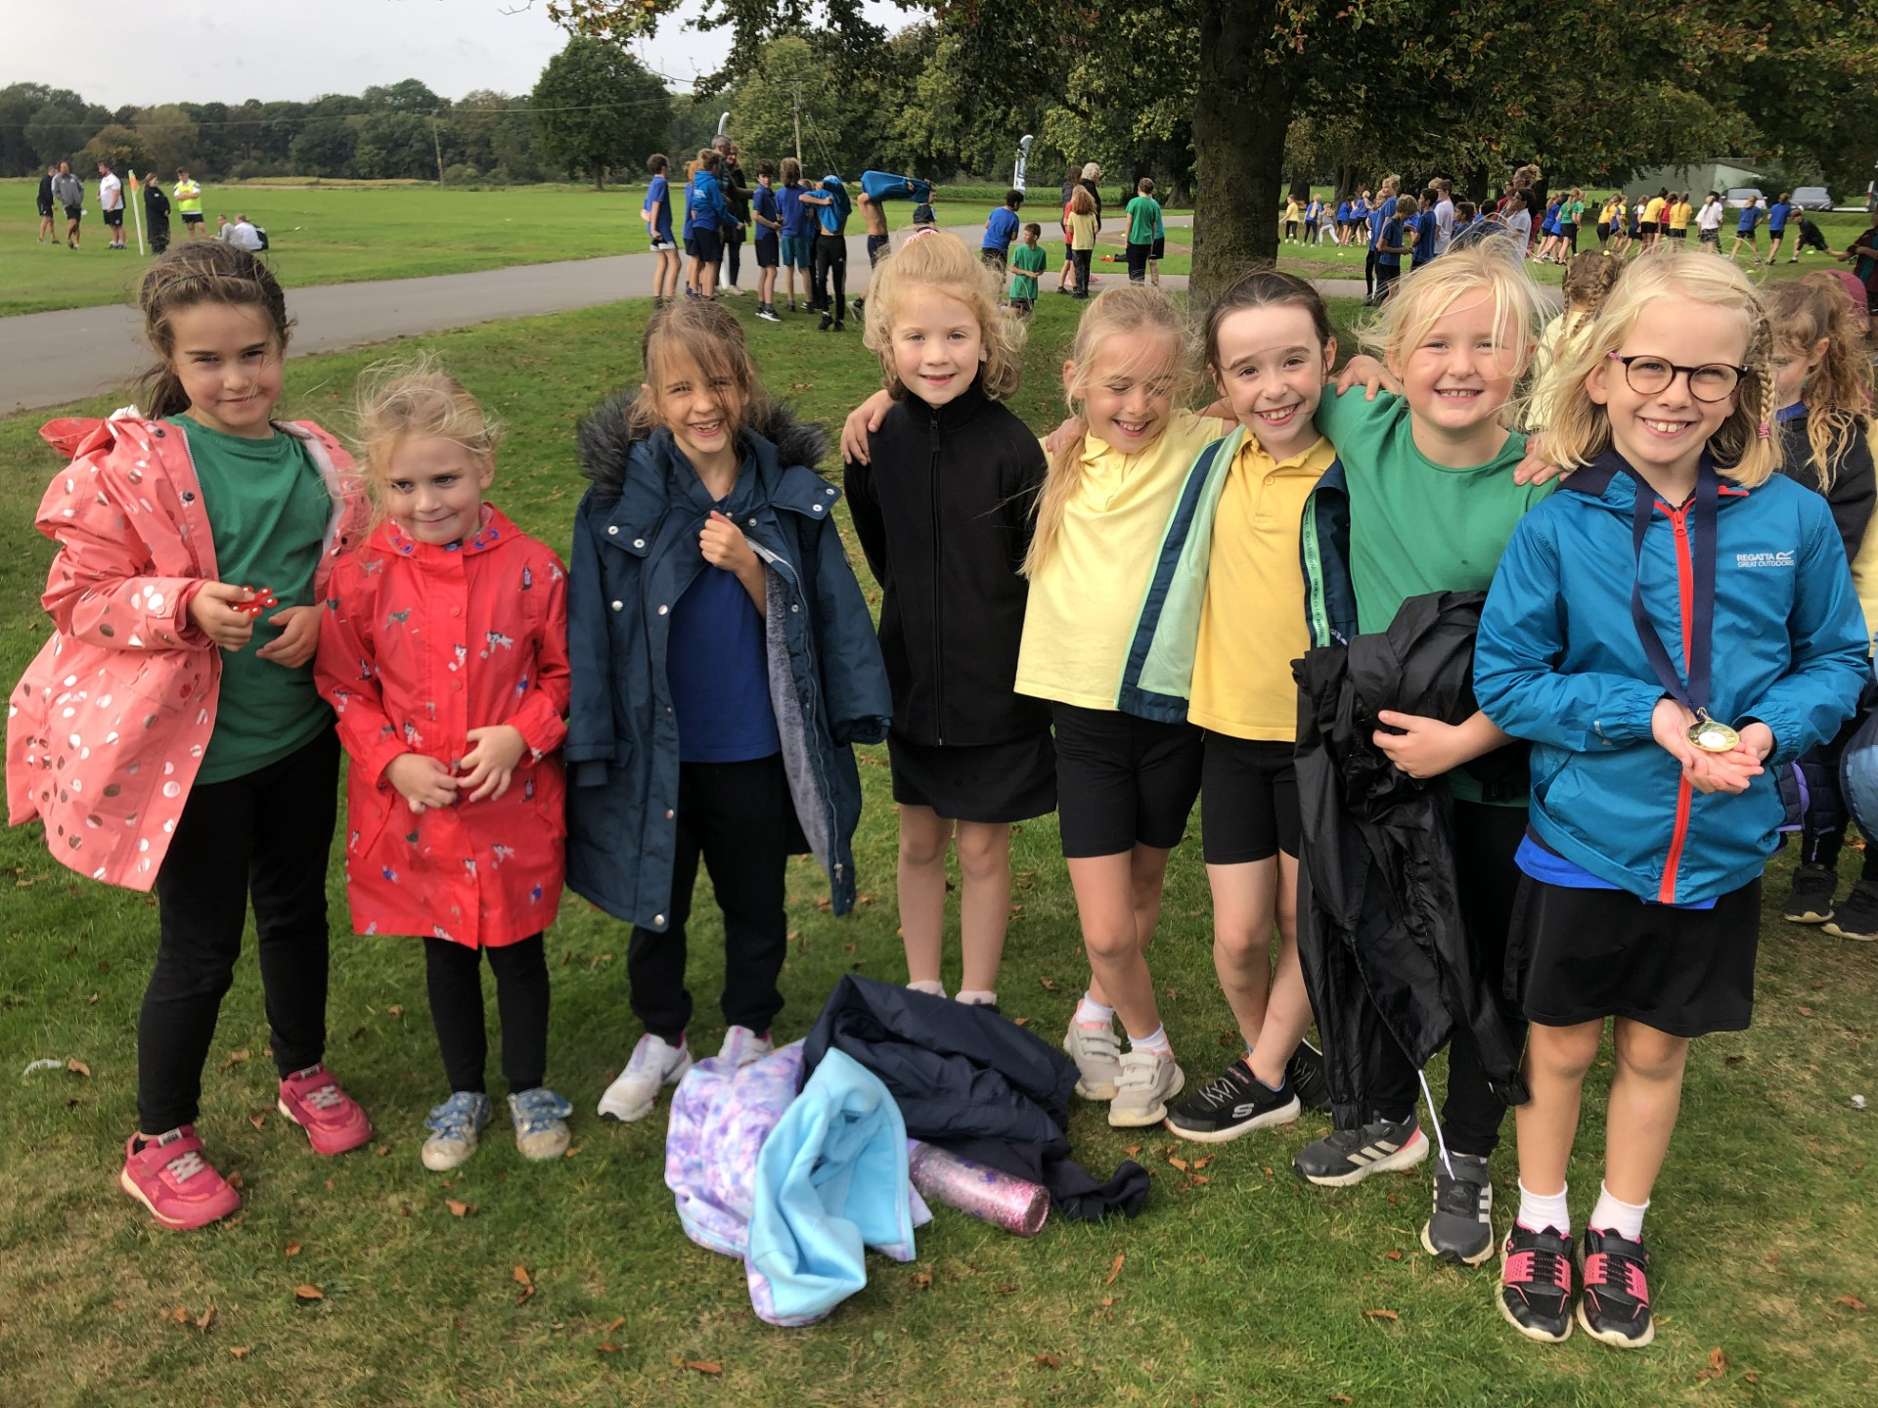

**Parents Evenings**

Parent’s evenings will be over the next few weeks. We will not be using the PA system for booking the appointments this time. We will use an appointment signup sheet, these will be placed in the school office from Tuesday 31st October.

**Remembrance**

We have a box inside the office full of remembrance items to raise money for the Royal British Legion Poppy Appeal. Please feel free to come in and look. There is a donation pot next to the box.

Thank you.



**Space Week**

From 13th - 17th November, children at Woodton Primary School will be celebrating and learning all about Space! Among other events, children will have the opportunity to meet and ask questions to a real rocket scientist. The children will also get the chance to learn more about space in a mobile planetarium, which will be visiting us. Watch this space (!) for more information and dates during the week when you will be able to come in to school to take part in some of our space activities with your child.



**Dates for the Diary**

**Mon 23rd to Fri 27th Oct** – Half Term

**Tues 7th Nov** – Parents Evening (Appointments will be paper sign up version)

**Wed 15th Nov** – Parents Evening (Appointments will be paper sign up version)

**Mon 13th – 17th Nov** – Science Week

**Fri 17th Nov** – Tempest revisit to retake photos for listed children

**Fri 1st Dec** – PTA Non-Uniform Day for a donation of a Xmas gift

**Fri 8th Dec** – PTA Wrapping morning

**Fri 8th Dec** – Christmas Jumper Day (Non uniform day)

**Fri 8th Dec** – Children’s Christmas Disco, ran by the PTA (Details to follow)

**Sat 9th & Sun 10th Dec** – Ditchingham Christmas Tree Festival

**Wednesday 13th Dec** - Christingle

**Friday 15th Dec** – Willows Nativity 2pm

**Thurs 21st to Wed 3rd Jan** – Christmas Break