

*Issue No: 04 Date: Friday 06th Oct 2023*

*Our Newsletter comes out every Friday with updates about what the children have been up to during the week, information, things to celebrate and important dates for the diary. Please take the time to read through and if you have any questions, please speak to Mrs Taylor in the office.*

**This Week’s Achievements**

**Willows Stars of the Week**

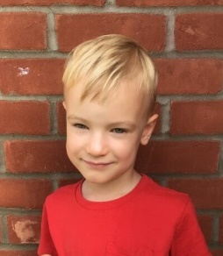

**Sycamores Stars of the Week**

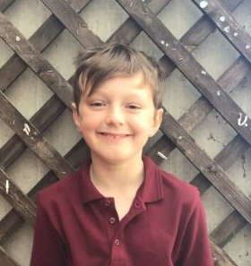

For being an amazing mathematician. He has engaged positively in all math’s lessons and always wants to take on a new extra challenge.

For wowing everyone in Willows with his amazing reading and maths.

CHALLENGE

NURTURE

INSPIRE

CHALLENGE

NURTURE

INSPIRE

**Oaks Stars of the Week**

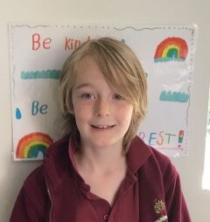

For putting much effort and making brilliant progress in our swimming lessons.

**Class Attendance**

Willows – 94.95%

Sycamores – 96.01%

Oaks – 94.65%

**House Points for this week**

Stephen Hawkings – 89

Beatrix Potter – 90

Benjamin Britten – 44

Kelly Holmes – 64





Willows: 1st Ned

2nd Jack M M

3rd Lonnie

Sycamores: 1st Flo

2nd Theo E

3rd Hector

Oaks: 1st Riley

2nd Jesse

3rd Toby



No Rock Legends this week!



Congratulations to

Dotty for completing the **RUST** stages in NumBots this week!



**Uniform**

Please can we remind parents and carers, that all uniform and sports kits must be clearly labelled. If items are left behind after school and have no name in them, they will be placed out on the table the following day to be claimed. Thank you

**Weekly – Let’s think about Online Safety**

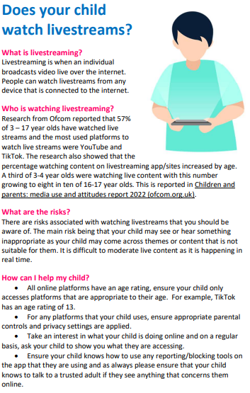

**Willows Class**

Miss Snelling has asked that Willows children do not bring in any toys into school.

**Year 6 Cycling**

Year 6 cycling proficiency will be on Mon 9th and Tues 10th October.

Please can all bikes be placed in the bike shelter and a member of staff told if it will be stored at school overnight.

Permission forms must be returned.



Young Minds – HELLO YELLOW Day

Tuesday 10th of October

Let’s support every child’s Mental Health!

Join us in wearing non-uniform with an item of Yellow on Tuesday.

For a small donation of £1 for the YoungMinds charity.

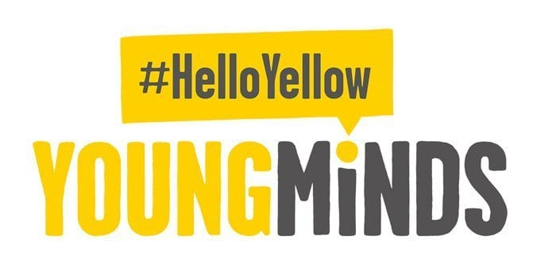

**Dates for the Diary**

**Monday 16th Oct –** Football Tournament rearranged date – 4pm @ Hobart

**Tuesday 10th** **Oct** – **HelloYellow** Day (Non- uniform, wear something yellow for a small donation)

**Monday 9th & Tuesday 10th** **Oct** – Year 6 Cycling Proficiency

**Wednesday 11th Oct** – Cross Country for years 3 & 4 (children to bring a home packed lunch)

**Thursday 19th Oct** – Harvest Festival @ Woodton Church 2pm

**Mon 23rd to Fri 27th Oct** – Half Term

**Sat 9th & Sun 10th Dec** – Ditchingham Christmas Tree Festival

**Wednesday 13th Dec** - Christingle

**Friday 15th Dec** – Willows Nativity 2pm

**Thurs 21st to Wed 3rd Jan** – Christmas Break

**Breakfast Club**

Please may we ask that when children are being dropped off at breakfast club, they are dropped off at the door and the door is kept closed. Please knock on the door and Mrs Coleman will come and collect your child. Thank you

**Football Tournament**

The Hobart football tournament was cancelled on Monday evening due to bad weather. This has now been rescheduled to Monday the 16th of October, at the same time of 4pm at Hobart. Please notify the school office of all collection arrangements.

**Macmillan Cake Sale**

Thank you to everyone that kindly donated cakes for the Macmillan cake stall.

It raised an amazing £188.



**Staff Car Park**

Please may we remind everyone that school children walk into class through the staff car park, for safety, we ask that all parents/carers use the top car park, **NOT** the staff car park to drop and collect their children.



**Harvest Festival**

Our Harvest Festival is on Thursday the 19th of October at Woodton church from 2pm, ALL WELCOME.

If you would like to donate for the Harvest, we are asking for non-perishable food donations to be brought to the school office. Any items collected will be donated to the Hempnall Food Bank.

