WELLNESS
Home Life

Hello from your Wellbeing team, May 2023

This month is Mental Health Awareness month, when awareness is raised about how mental health can have an impact on physical, emotional and mental wellbeing of our children, families and communities. This newsletter, we have advice and support about transitions that many of us will be experiencing soon. Myself (Mrs Taylor), Mrs Brooks and Mrs Wood are always here to help with advice or just listen so please do not hesitate to email us on wellbeing@woodton.norfolk.sch.uk for any extra support.
A thought

Kindness begins with understanding that we all struggle.

Support for families:
Parents reaching out (Children 11-16): parents@kooth.com
Point 1: Support for young people and their families – 0800 977 4077 or point1-support@ormistonfamilies.org.uk
Early Help hub: South Norfolk – 01508 533933
Norfolk Just One Number – justonenorfolk.nhs.uk or 03003000123
Pupil Premium – PP is funding to improve education outcomes for disadvantaged pupils in schools in England. This funding can pay for school equipment, trips and school dinners. If you would like to see if you are eligible, please follow the guidance in this link https://www.norfolk.gov.uk/education-and-learning/schools/school-meals-and-milk
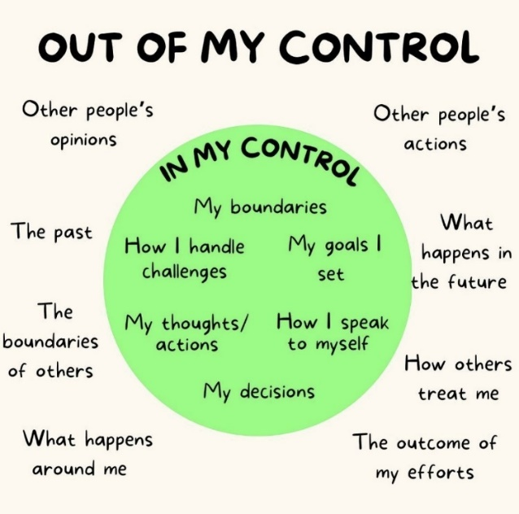
Sometimes we all think things are beyond our control, even children can feel this. It is essential to focus on what we can control, no matter how small that may be. So if you find you are struggling at any time, make a list of things that are out of your control and the things that are in your control. This can help the mind regulate, when we are in fright or flight mode.

Just a thought;  An individual can sound and look confident and still have anxiety. | The simple things;  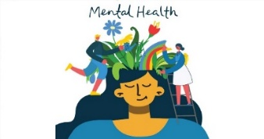  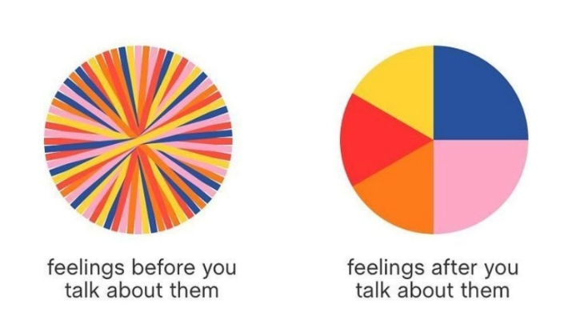
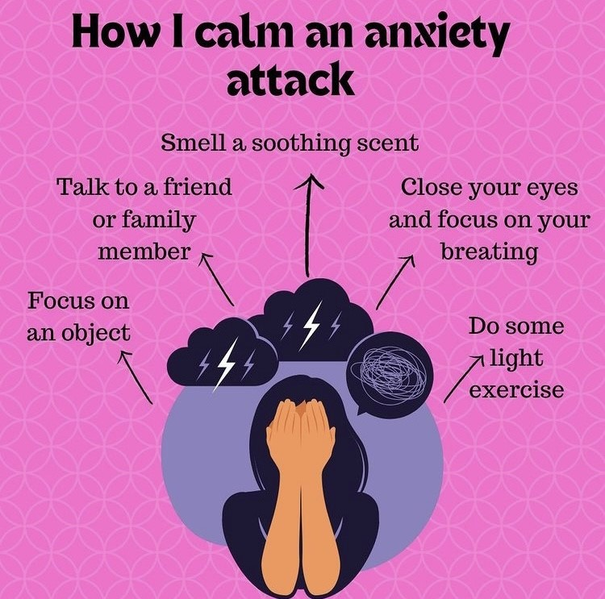
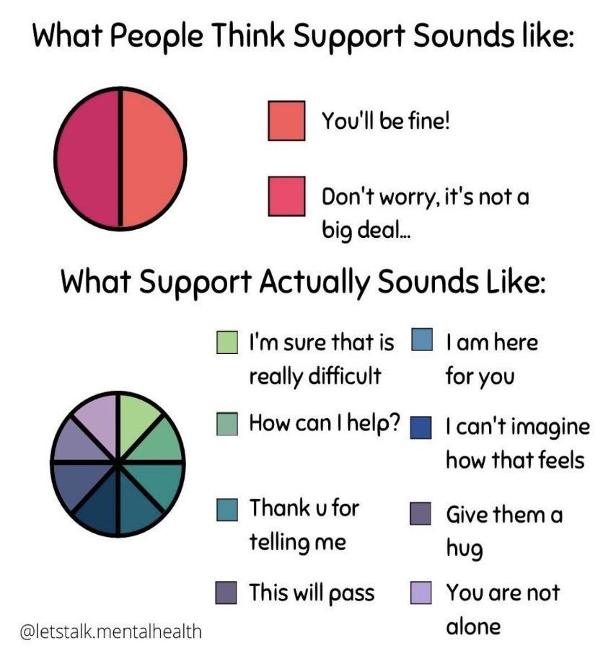

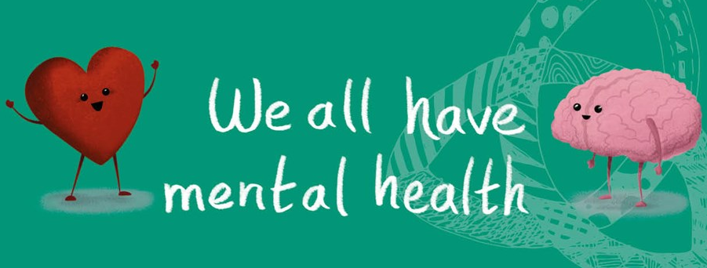

Supporting Transitions
All children go through all kinds of changes as they grow up – including when they move into a new class, go to secondary school, move to a new house or area, or experience changes within their family. These times of transition can be exciting. However, they can also be stressful, worrying or upsetting.
Change can be difficult when a young person does not want it to happen or does not feel ready for it, feels worried about something new or unknown, needs time to let go of something that has ended or feels that what is happening to them is out of their control. A child or young person may also find change difficult if they are already struggling with other things.
Signs that your child may be struggling can be;
- Changes in sleeping or eating habits
- Being withdrawn
- Changes in behaviour
- Struggles to communicate
If you see these signs, it is really important to try to talk to your child. Keep talking to your child and trying to communicate in any way you can – hugging, listening to them, texting them. In any way, keep the line of communication open with them.
To help your child with any anxiety maybe support them in researching their new change; help them find exciting things about the new thing that is coming, e.g how to improve sleep.
Try to keep routines and hobbies the same, although recognise when they are tired and maybe need some down time. Most importantly of all, give your child encouragement, reassurance and tell them how proud you are.
Looking after yourself, is just as important, recognise when you may be struggling yourself and when things may be getting hard. Talk to family, friends or work colleagues. You may be surprised who else is having to deal with a similar situation.

