

*Issue No: 11 Date: Friday 1st Dec 2023*

*Our Newsletter comes out every Friday with updates about what the children have been up to during the week, information, things to celebrate and important dates for the diary. Please take the time to read through and if you have any questions, please speak to Mrs Taylor in the office.*

**This Week’s Achievements**

**Willows Stars of the Week**

**Sycamores Stars of the Week**



For demonstrating a positive attitude towards and a love of reading which shines through when reading independently and when being read to.

Millie for always trying her best in class.

CHALLENGE

NURTURE

INSPIRE

CHALLENGE

NURTURE

INSPIRE

**Oaks Stars of the Week**



For outstanding progress in his swimming lessons this term.

**Class Attendance**

Willows – 88.43%

Sycamores – 95.29%

Oaks – 94.12%

**House Points for this week**

Stephen Hawkings – 134

Beatrix Potter – 141

Benjamin Britten – 73

Kelly Holmes – 122





Willows: 1st Millie

2nd Jack M M

3rd Lonnie

Sycamores: 1st Maisy

2nd Finlay

3rd Charlie L

Oaks: 1st Illiana

2nd Riley

3rd Lucas



Charlie W – Garage Rocker

Finlay & Ada – Headliners



Congratulations to

**Alannah** for completing the **IRON, Dotty** for completingthe **TIN and Lilly-May** for completingthe **COPPER** stages in NumBots this week!



**PTA Wrapping Morning**

**Friday 8th December**

The PTA will be holding their annual wrapping morning next Friday.

This is where children can choose 1 or 2 gifts to give a parent or guardian for Christmas. All presents cost £1 each and will be wrapped up ready for the big day.



**Online Safety**

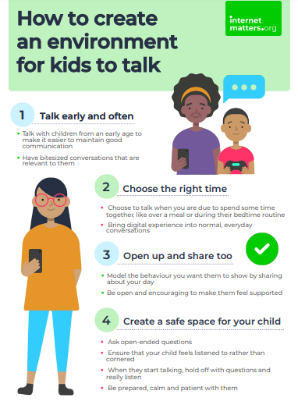



**Volunteers**

We are looking for volunteers to hear children read.

If you have time to spare each week and would be interested in volunteering regularly, please contact the school office for an application form.



**Christmas Jumper Day**

**Friday 8th December**

Children are invited to come into school in non-uniform wearing a Christmas Jumper for £1 donation. All monies raised will be donated to ‘Save the Children’ charity, who support children all over the UK.



**Hippodrome Trip**

Children will require a home packed lunch for this day, so all dinner orders on the system will be changed to own lunch. If you do require a school packed lunch for this trip, please contact the school office, as this will need to be booked in advance.



**Dates for the Diary**

**Tues 5th Dec** – Flu Nasal Vaccinations

**Fri 8th Dec** – PTA Christmas Wrapping morning

**Fri 8th Dec** – Christmas Jumper Day (Non-uniform day)

**Fri 8th Dec** – Children’s Christmas Disco at Woodton Village Hall (5.30pm – 7.30pm)

**Tues 12th Dec** – Whole-School Hippodrome Trip

**Wed 13th Dec** – Christingle (Children will need to bring in an orange each)

**Thurs 14th Dec** – Santa Dash

**Thurs 14th Dec** – Christmas lunch with a Christmas Jumper

**Fri 15th Dec** – Willows Nativity 2pm

**Wed 20th Dec** – Children’s Christmas Carol Service @ Woodton Church (starts at 2pm)

**Thurs 21st to Wed 3rd Jan** – Christmas Break (Return on the 4th Jan 2024) 