

*Issue No: 12/13 Date: Friday 15th Dec 2023*

*Our Newsletter comes out every Friday with updates about what the children have been up to during the week, information, things to celebrate and important dates for the diary. Please take the time to read through and if you have any questions, please speak to Mrs Taylor in the office.*

**This Week’s Achievements**

**Willows Stars of the Week**

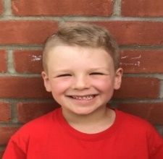 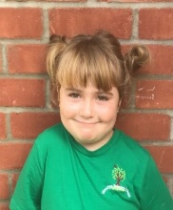

**Sycamores Stars of the Week**

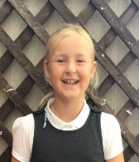

Aria having a fantastic attitude in all her learning this week, completing all tasks to a high standard.

For showing amazing resilience in Maths this week, when looking at inverse operations.

For trying his hardest.

For being an amazing Emperoress in the Nativity.

CHALLENGE

NURTURE

INSPIRE

CHALLENGE

NURTURE

INSPIRE

**Oaks Stars of the Week**

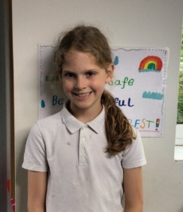 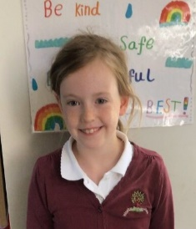

For demonstrating excellent team work and role model behaviour in PE.

For an outstanding description in English.



**Class Attendance**

**08-12-23 15-12-23**

Willows – 95.34% Willows – 97.98%

Sycamores – 96.04% Sycamores – 97.23%

Oaks – 94.02% Oaks – 97.33%

**House Points for this week**

Stephen Hawkings – 222

Beatrix Potter – 190

Benjamin Britten – 164

Kelly Holmes – 172



08-12-23 15-12-23

Willows: 1st Ned Willows: 1st Lilly-May

2nd Jack M M

3rd Millie Sycamores: 1st Finlay

Sycamores: 1st Finlay 2nd Molly

2nd Flo 3rd Flo

3rd Isla Oaks: 1st Riley

Oaks: 1st Riley 2nd Leila

2nd Lucas 3rd Lucas

3rd Nora

 

Kendall – Wannabe Eliza – Garage Rocker

Eliza – Garage Rocker Kendall - Wannabe

Charlie W – Busker Charlie W - Gigger

Hector – Rock Legend Winter – Unsigned Act

Molly – Support Act Molly - Headliner

Ada & Finlay – Rock Star

Congratulations to

Noah for completing the **Iron** and Phoebe R for completing the **Brass** stages in NumBots last week!

Congratulations to

Phoebe R for completing the **Copper** stage in NumBots this week!



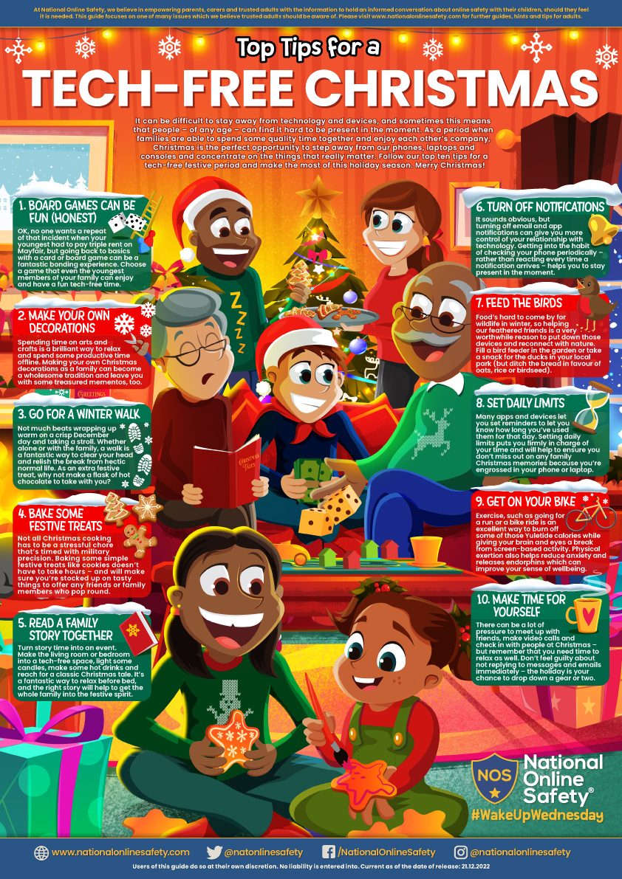

**Oaks Old Hall Farm Visit**

**Monday 18th December**

An email has been sent out today, to all Oaks parents/carers, giving details about a local walk to Old Hall Farm on Monday afternoon. Please may we ask that Oaks come in with warm waterproof clothing and wellington boots for the walk, as it will be muddy.

**Hippodrome Trip**

We would like to say a BIG thank you to all of the PTA, for the amazing whole school trip they organised to the Hippodrome Circus on Tuesday. The children were captivated by the performance and thoroughly enjoyed the whole experience.



**End of Term**

We will be sending home book bags and wellies on Tuesday the 19th, so this will make it easier on the Wednesday when children will be going home with parents after the Christmas Carol service at the church.

Children will NOT need to come into school next week in their PE kit, it will be school uniform for the last three days. Everyone is also invited to once again wear their festive jumpers on Wednesday for the Christmas Carol Service at the church.



**Dates for the Diary**

**Wed 20th Dec** – Carol Service @ Woodton Church 2pm

**Thurs 21st to Wed 3rd Jan** – Christmas Break (Return on the 4th Jan 2024)

**A very Merry Christmas and a Happy New**

**Year from everyone at Woodton Primary school.**

