

*Issue No: 8 Date: Friday 10th Nov 2023*

*Our Newsletter comes out every Friday with updates about what the children have been up to during the week, information, things to celebrate and important dates for the diary. Please take the time to read through and if you have any questions, please speak to Mrs Taylor in the office.*

**This Week’s Achievements**

**Willows Stars of the Week**

**Sycamores Stars of the Week**

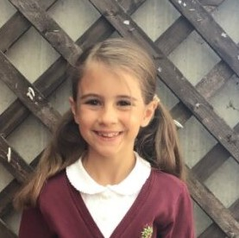

Arlo for working really hard on his reading in school and at home.

For meeting our ‘Challenge’ value in all her learning this week.

CHALLENGE

NURTURE

INSPIRE

CHALLENGE

NURTURE

INSPIRE

**Oaks Stars of the Week**

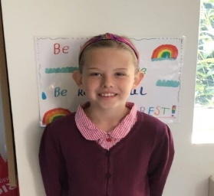

For excellent work in English, sharing great ideas with her learning partner.

**Class Attendance**

Willows – 94.44%

Sycamores – 91.67%

Oaks – 90.69%

**House Points for this week**

Stephen Hawkings – 144

Beatrix Potter – 126

Benjamin Britten – 108

Kelly Holmes – 111





Willows: 1st Ned

2nd Jack M M

3rd Lonnie

Sycamores: 1st Flo

2nd Crystal

3rd Maisy

Oaks: 1st Riley

2nd Charlie T

3rd Lucas



Jack MM – Support Act

Molly – Breakthrough

Winter – Gigger

Crystal & Emmie – Headliners

Lucas – Rock Legend



Congratulations to

Phoebe R for completing the **TIN** stages in NumBots this week!



**No Toys**

Please may we ask that children do not bring in any toys into school, these can be distracting in class, as well as being at risk of becoming lost or broken.

Thank you



**Online Safety**

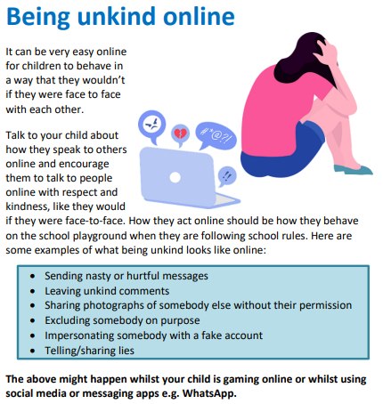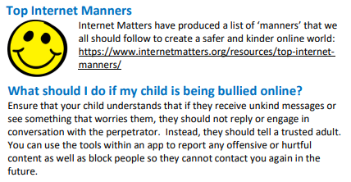



**Dates for the Diary**

**Wed 15th Nov** – Parents Evening

**Mon 13th – 17th Nov** – Space Week

**Fri 17th Nov** – Planetarium at Woodton Village hall

**Fri 17th Nov** – Tempest revisit to retake photos for listed children

**Fri 1st Dec** – PTA Non-Uniform Day for a donation of a Xmas gift

**Fri 8th Dec** – PTA Christmas Wrapping morning

**Fri 8th Dec** – Christmas Jumper Day (Non-uniform day)

**Fri 8th Dec** – Children’s Christmas Disco at Woodton Village Hall

**Wed 13th Dec** – Christingle

**Thurs 14th Dec** – Santa Dash

**Thurs 14th Dec** – Christmas lunch with a Christmas Jumper

**Fri 15th Dec** – Willows Nativity 2pm

**Thurs 21st to Wed 3rd Jan** – Christmas Break (Return on the 4th Jan 2024)

**Hippodrome Trip**

Information has been sent home by email this week, giving details about the whole school trip to the Hippodrome that the PTA have kindly organised. This will be on Tuesday the 12th of December; home packed lunches will be required on this day. To help towards the cost of the transport, we are asking for a £5 donation per child. Please give consent via the parent portal, and hand payments into the school office by Friday 24th of November.

For more information, please see the email or speak to the school office.



**Willows, Sycamores & Oaks Class**

All three classes would like to invite parents in on Monday the 13th of November at 2pm for the launch of ‘Space Week' The children will be doing some space themed activities, and would love you all to come and join in.



**Christmas Lunch**

The Christmas menu has been sent out this week by email. Please note this lunch will be on Thursday the 14th of December.

If your child would like to join in with this special lunch then you can order in the normal way through your parent portal.

We are also inviting children to come into school wearing a Christmas jumper on this same day for a small donation, which will go to the ‘Save the Children’ charity, who help children around the UK.

