

*Issue No: 9/10 Date: Friday 24th Nov 2023*

*Our Newsletter comes out every Friday with updates about what the children have been up to during the week, information, things to celebrate and important dates for the diary. Please take the time to read through and if you have any questions, please speak to Mrs Taylor in the office.*

**This Week’s Achievements**

**Willows Stars of the Week**

 

**Sycamores Stars of the Week**

 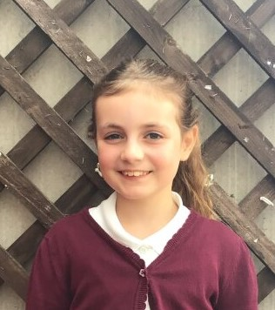

For being consistently kind and hardworking. Always being her best.

For always being focused on her learning and setting an example of what our class expectations should be.

For always persevering in all his learning.

For always trying her best in everything she does.

CHALLENGE

NURTURE

INSPIRE

CHALLENGE

NURTURE

INSPIRE

**Oaks Stars of the Week**

 

For making a great effort with his independent work in Math’s and English.

For always working well with others in class and putting his best effort across all lessons.



**Class Attendance**

**17-11-23 24-11-23**

Willows – 94.44% Willows – 93.98%

Sycamores – 96.38% Sycamores – 91.7%

Oaks – 90.02% Oaks – 94.12%

**House Points for this week**

Stephen Hawkings – 302

Beatrix Potter – 249

Benjamin Britten – 143

Kelly Holmes – 177



17-11-23 24-11-23

Willows: 1st Ned Willows: 1st Jack M M

2nd Jack M M 2nd Lonnie

3rd Lonnie 3rd Lilly-May

Sycamores: 1st Crystal Sycamores: 1st Hector

2nd Flo 2nd Charlie L

3rd Hector 3rd Flo

Oaks: 1st Riley Oaks: 1st Illiana

2nd Phoebe 2nd Lucas

3rd Lucas 3rd Riley

 

Molly & Anya – Breakthrough Eliza - Wannabe

Crystal – Rock Star Paige – Rock Star

Theo – Headliners Isla – Rock Legend

Isla – Rock Legend



Congratulations to

Joel for completing the **TIN** and Jack D for completing the **Iron** stages in NumBots last week!

Congratulations to

Joel for completing the **TIN** and Cleo and Jack for completing the **Iron** stages in NumBots this week!

**Online Safety**

Do you know the age ratings for online apps?

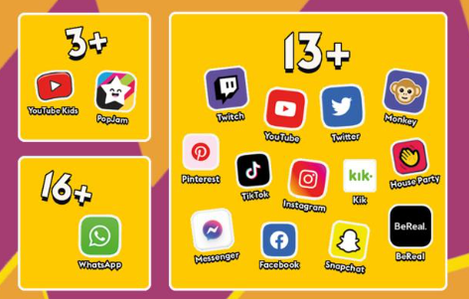

Do you know which apps your children use?

Do you know who they speak to and what is being said?

The new **Online Safety Bill**, which has been approved by Government, will:

* enforce age limits and implement age-checking measures
* ensure risks and dangers posed to children on social media platforms will be more transparent, and they will have to publish risk assessments
* prevent children from accessing harmful and age-inappropriate content



**Christmas Lunch**

Please note the main meal option or the vegetarian option are the only meals available on Thursday the 14th of December.

Children are invited to come into school wearing a Christmas jumper on this same day for a small donation, which will go to the ‘Save the Children’ charity, who help children around the UK.

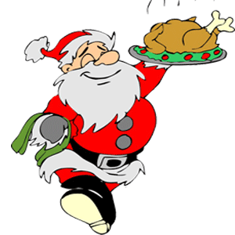

**Nasal Flu Vaccination**

Just a reminder that the nursing team will be here for the nasal flu vaccinations on Tuesday 4th of December. An email was sent home in October giving details on how to give consent. If you have, any questions please contact, the nursing team directly.



**Non-Uniform Day**

The PTA are holding a non-uniform day next Friday (1st Dec). All children are invited to come into school in non-uniform for a donation of a Christmas gift for the Christmas wrapping morning on Friday the 8th of December.

**Hippodrome Trip**

We have a few permissions still outstanding for the Hippodrome trip. We must receive consent as soon as possible for your child’s place to be secured.



**Car Park**

Just a reminder to use the top car park unless you have received permission from the school. This is to ensure there is space for staff to park and to keep children safe.

Thank you

**Dates for the Diary**

**Fri 1st Dec** – PTA Non-Uniform Day for a donation of a Xmas gift

**Tues 5th Dec** – Whole school Flu Vaccination

**Fri 8th Dec** – PTA Christmas Wrapping morning

**Fri 8th Dec** – Christmas Jumper Day (Non-uniform day)

**Fri 8th Dec** – Children’s Christmas Disco at Woodton Village Hall

**Wed 13th Dec** – Christingle

**Thurs 14th Dec** – Santa Dash

**Thurs 14th Dec** – Christmas lunch with a Christmas Jumper

**Fri 15th Dec** – Willows Nativity 2pm

**Wed 20th Dec** – Carol Service @ Woodton Church 2pm

**Thurs 21st to Wed 3rd Jan** – Christmas Break (Return on the 4th Jan 2024)