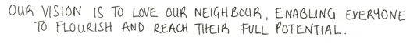
Issue No: 15 Date: Friday 26th Jan 2024

Our Newsletter comes out every Friday with updates about what the children have been up to during the week, information, things to celebrate and important dates for the diary. Please take the time to read through and if you have any questions, please speak to Mrs Taylor in the office.

This Week’s Achievements
Willows Stars of the Week
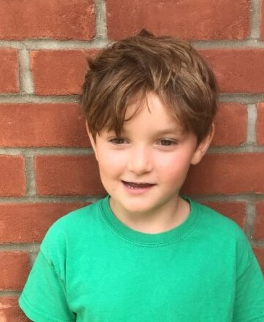

Sycamores Stars of the Week
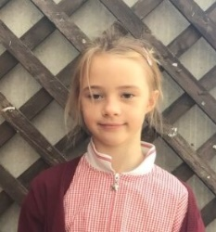

For demonstrating his amazing skills in PE this week.
For being an inspirational scientist and regularly demonstrating her passion for learning.
CHALLENGE
NURTURE
INSPIRE
CHALLENGE
NURTURE
INSPIRE

Oaks Stars of the Week
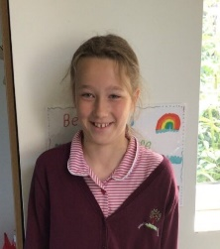

For excellent participation in History (and always remembering to hook the door back in the mornings for others!)

Class Attendance
Willows – 99.12%
Sycamores – 96.43%
Oaks – 96.08%

House Points for this week
Stephen Hawkings – 131
Beatrix Potter – 103
Benjamin Britten – 82
Kelly Holmes – 137

Willows: 1st Jack M M
2nd Lonnie
3rd Ned
Sycamores: 1st Molly
2nd Hector
3rd Eliza
Oaks: 1st Jesse
2nd Riley
3rd Holly

Kendall – Gigger
Maisy – Unsigned Act
Jack M M – Headliner
Molly – Rock Star

Congratulations to
Alfie for completing the IRON, Phoebe R for completing the STEEL, Jack M M for completing the CHROME and Felicity for completing the TUNGSTON stages in NumBots this week!

News this week…
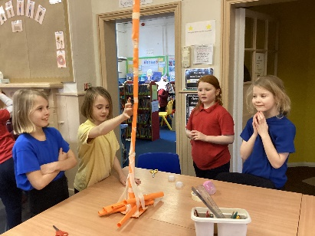
Science Club
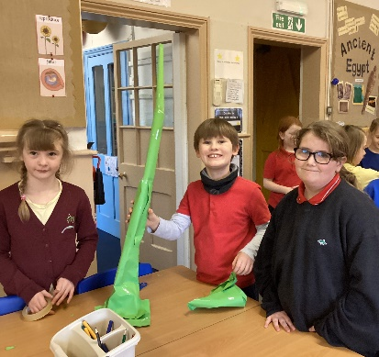
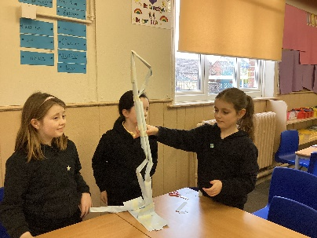

Our 4 amazing Science Ambassadors ran their first lunchtime science club this week. The challenge was to make a freestanding tower out of tape and just 6 pieces of paper. Everyone did a brilliant job, with the highest tower being 1m 20cm high! Well done to our Ambassadors and everyone who took part. We look forward to seeing everyone again next Wednesday!
Sycamores – Spirit of the Games Festival
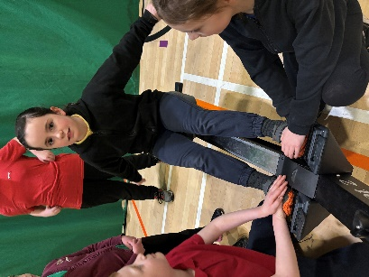
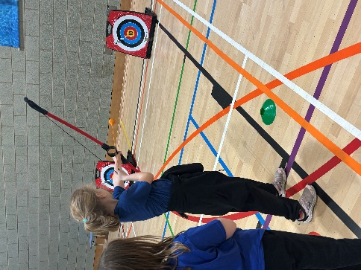
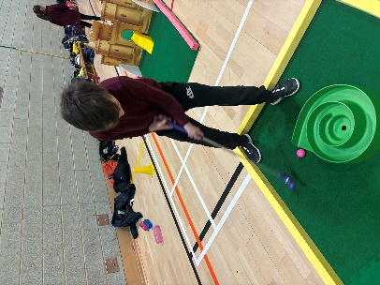
Sycamores had an amazing time at the 'Spirit of the Games' festival at the UEA on Thursday. They took part in a wide range of sporting games and were praised for how well they worked as a team. A big thank you to Emma Keal for supporting Mrs Hinton and Mrs Richardson on this sporting event.

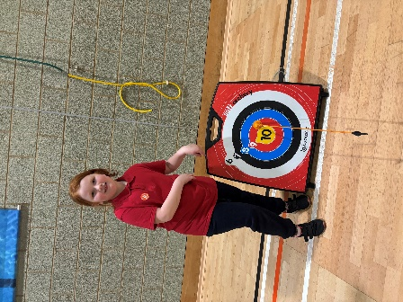

Dates for the Diary
Friday 9th February – Children’s Mental Health Non Uniform Day – Dress to Express £1
Friday 9th February - Creative Celebration Evening – 6pm
Monday 19th until Friday 23rd Feb – Half Term
Monday 5th March – Year 4 Seatbelt Lesson
Monday 5th March – Year 4 Cycling Proficiency (Details to follow)
Wednesday 6th March – Year 6 Forensic Science Day
Thursday 7th March – World Book Day (Details to follow)
Tuesday 12th March – Year 4 Cycling Proficiency (Details to follow)
Wednesday 13th March – Willows Dance Festival (Details to follow)
Thursday 28th Mar until Friday 12th Apr – Easter Holidays
Monday 6th May – May Bank Holiday
Monday 27th until Friday 31st May – Half Term
Website – http://www.ellinghamandwoodton.co.uk/

Reminders:
Oaks Class – PE on Mondays & Wednesdays
Sycamore Class – PE on Wednesdays & Thursdays
Willows Class – Mondays & Wednesdays
Fridays Forest School lessons– Reception/Year 1 and Sycamores this term

Express Yourself – Non-Uniform Day
Friday 9th February
Children’s Mental Health Week 2024 will take place from 5-11 February.
The theme this year is
‘My Voice Matters’.
To support this, we will be holding a non-uniform day, giving children the opportunity to ‘Dress to Express’ on Friday the 9th of February, for a £1 donation. All monies raised will be donated to the charity, Place2Be.
Creative Celebration Evening
Friday 9th February
A letter has been sent home this week, giving details about a special event that is taking place on Friday the 9th of February. This event is an amazing opportunity for children to celebrate their skills in either Music, Art or Literature. Please see the letter for more details.
Consent slips need to be returned to the school office by Friday the 2nd of February.
Tickets will be available to purchase from the office next week.

Volunteers
We are looking for volunteers to hear children read. If you have time to spare each week and would be interested in volunteering regularly, please contact the school office for an application form.

