

*Issue No: 30 7 Date: Friday 6th June 2025*

*Our Newsletter comes out every Friday with updates about what the children have been up to during the week, information, things to celebrate and important dates for the diary. Please take the time to read through and if you have any questions, please speak to Mrs Taylor in the office.*

**This Week’s Achievements**

**Sycamores Star of the Week**



**Willows Star of the Week**



For working really well in PE this week and showing determination.

For working really hard in her learning this week and demonstrating all our schools expectations. Keep it up!

Millie for showing perseverance in reading and great determination in Forest school.

For having a positive attitude in all his learning this week.

**Class Attendance**

Willows – 97.74%

Sycamores – 94.85%

Oaks – 94.53%

CHALLENGE

NURTURE

INSPIRE

CHALLENGE

NURTURE

INSPIRE

**Oaks Star of the Week**

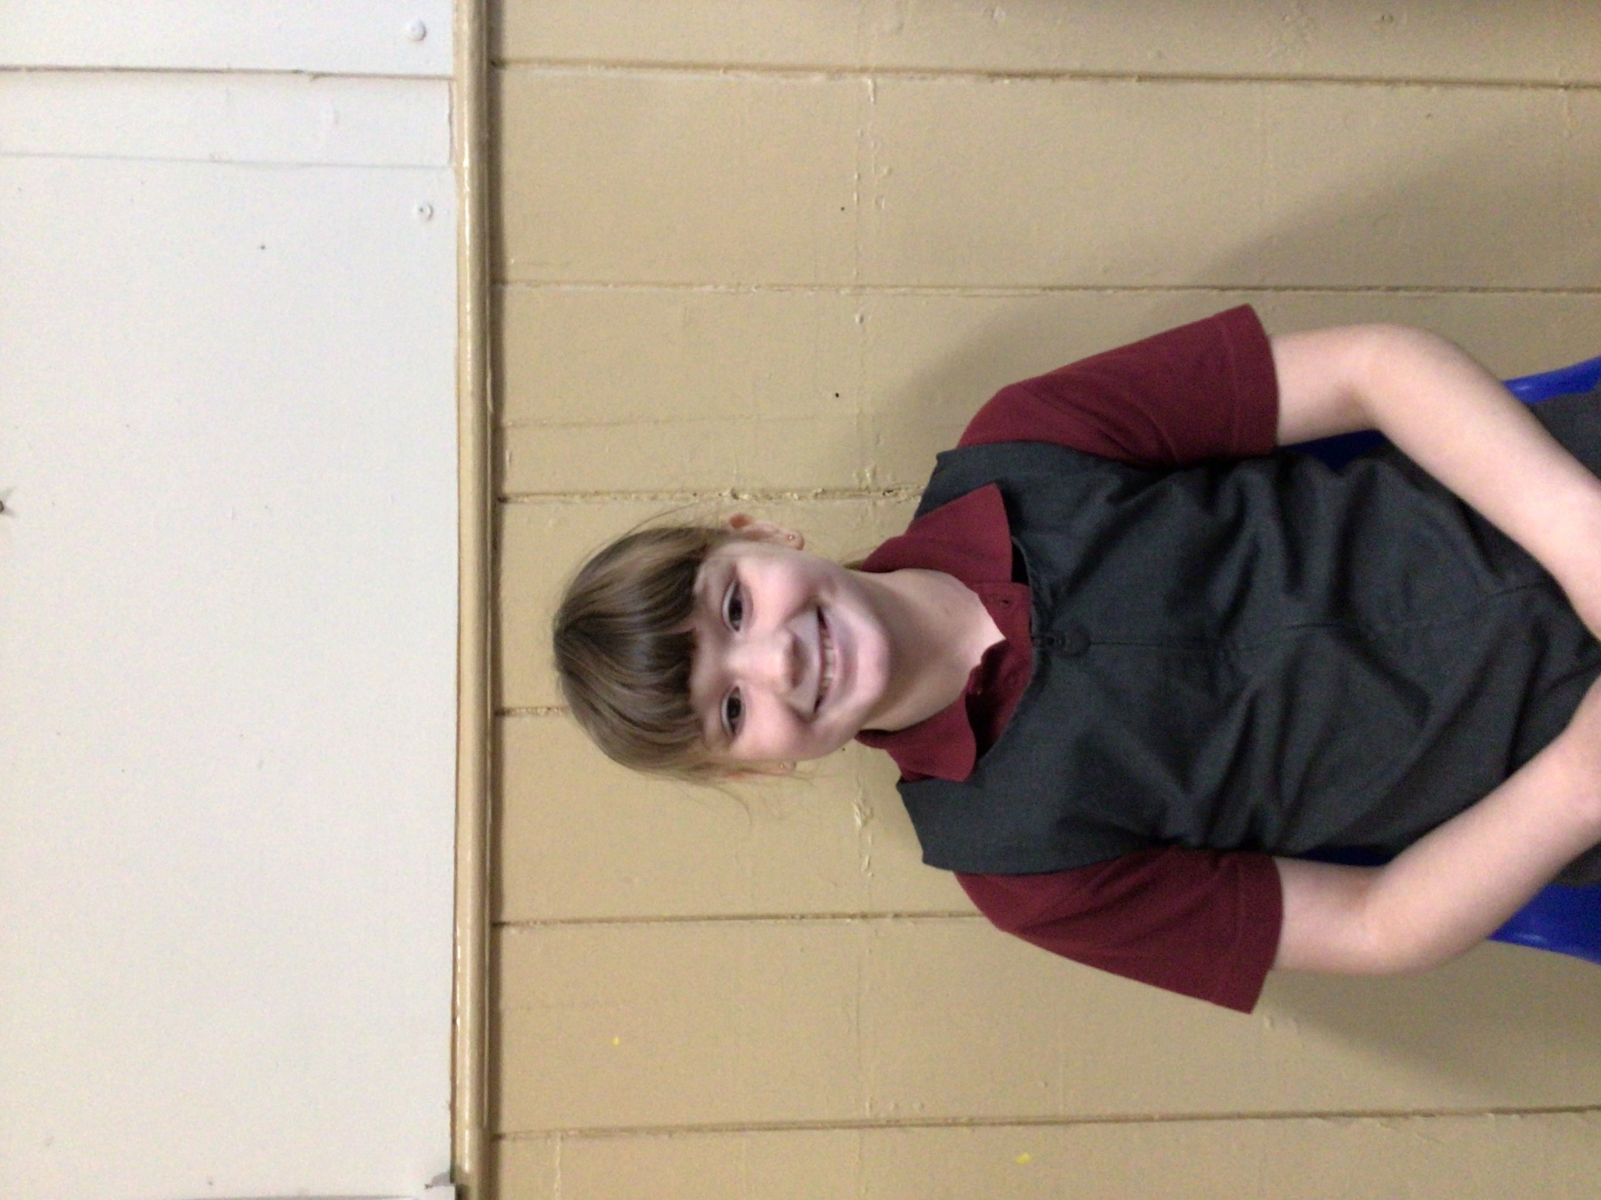

**House Points for this week**

Stephen Hawkings – 202

Beatrix Potter – 174

Benjamin Britten – 134

Kelly Holmes – 192

For her enthusiasm in Art and in our play rehearsals this week.



Congratulations to Dotty for completing the Carbon Fibre stage on Numbots this week.



Willows: 1st Arlo

2nd Jude

3rd Phoebe

Sycamores: 1st Evie

2nd Ned

3rd Kendall

Oaks: 1st Sienna

2nd Flo

3rd Jesse



Millie – Garage Rocker

Charlie Wi – Headliner

Alannah – Rock Star



Congratulations to Evie for achieving the ‘ROCK HERO’ award in TTRS.

**Reminders for this Term:**

**Oaks Class** – PE Mondays & Tuesdays

**Sycamores Class** – PE Wednesdays & Thursdays

**Willows Class** – PE Tuesdays & Fridays

**Fridays Forest School lessons**– Yr 2’s & Oaks

**Monday – Friday** (3.15 till 4.30) Little Legends after-school club

**Monday – Friday** (8 till 8.40) Breakfast Club

**Mondays** – Football Club (3.15 till 4.15)

**Mondays** – Fidgets Art Club (yrs 2,3 &4)

**Mondays** – Gardening Club (3.15 till 4.15)

**Tuesdays** – Fidgets Art Club (yrs 5 & 6)

**Wednesdays** – Street Dance Club (3.15 till 4.15)

**Fridays** – Forest School club (3.15 till 4.15)

**Dates for the Diary**

**Monday 9th June** – Selected Oaks Rounders Event – Hobart High school

**Tuesday 10th June** – Tempest Photos – Class & Year 6 Leavers

**Wednesday 18th June** – Oaks Athletics Event – UEA, Norwich

**Wednesday 25th June** – EYFS & KS1 Transition afternoon

**Thursday 26th June** – Whole School Royal Norfolk Show Trip – details to follow

**Monday 30th June** – Year 6 Forensic Science Day at Hobart High

**Tuesday 1st July** – KS1 Transition morning

**Thursday 3rd July** – Woodton Sports Day – Parents welcome from 2pm

**Wednesday 9th July** – Whole School Transition afternoon

**Wednesday 16th July** – Oaks Performance 2pm

**Thursday 17th July** – Year 6 Leavers Treat Day – Details to follow

**Tuesday 22nd July** – Year 6 Leavers assembly – 2pm

Website – <http://www.ellinghamandwoodton.co.uk/>

**Tempest Photography**

**Tuesday the 10th of June**

Tempest will be coming into school next Tuesday to take our class and year 6 leavers photos. Please may we ask that if your child has PE on this day, that they bring in their PE kit in a bag for them to change into afterwards. Thank you

**Sports Day 2025**

Following the success of our Federation Festival, we were hoping to bring both schools together for a sporting event at the end of July. Unfortunately, this is not going to be possible. We will still be getting together at Woodton in the future and will keep you posted!

We would like to invite parents to join us for our sports day races on Wednesday 1st July from 2pm.

We look forward to seeing you there!

**Year 6 Cycling Proficiency**

A massive WELL DONE to the year 6 pupils who took part in the cycling proficiency ‘Level 2 On Road’ cycling course this week.

