

*Issue No: 29 7 Date: Friday 23rd May 2025*

*Our Newsletter comes out every Friday with updates about what the children have been up to during the week, information, things to celebrate and important dates for the diary. Please take the time to read through and if you have any questions, please speak to Mrs Taylor in the office.*

**This Week’s Achievements**

**Willows Star of the Week**

For working really hard in all her learning this week and demonstrating all our schools expectations.

**Sycamores Star of the Week**



For working really hard in her learning this week and demonstrating all our schools expectations. Keep it up!

Millie for showing perseverance in reading and great determination in Forest school.

For demonstrating great resilience this week in all of her learning.

**Class Attendance**

Willows – 96.63%

Sycamores – 95.19%

Oaks – 95.96%

CHALLENGE

NURTURE

INSPIRE

CHALLENGE

NURTURE

INSPIRE

**Oaks Star of the Week**

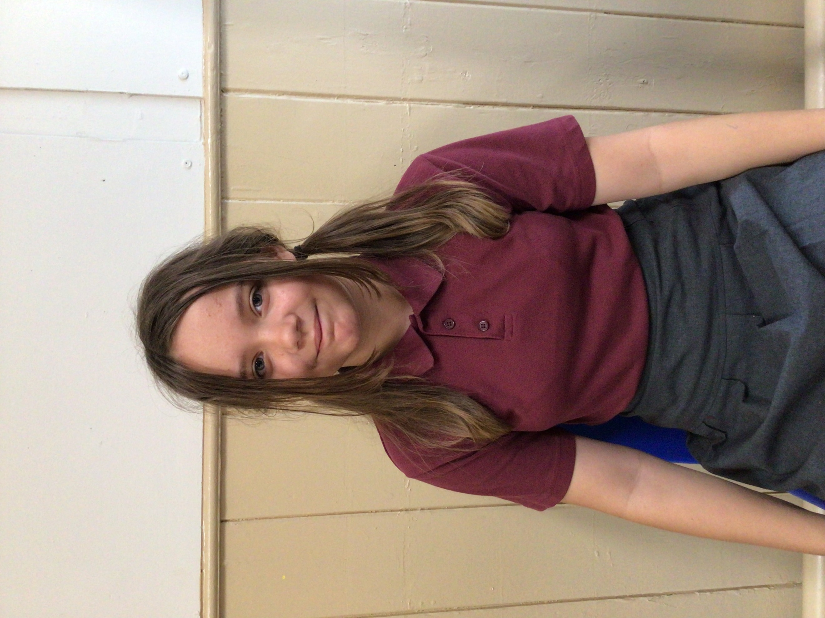

**House Points for this week**

Stephen Hawkings – 357

Beatrix Potter – 430

Benjamin Britten – 506

Kelly Holmes – 355

For showing kindness and being a great role model in class this week.



Willows: 1st Alannah

Sycamores: 1st Maisy

2nd Eliza

3rd Molly

Oaks: 1st Flo

2nd Charlie L

3rd Sienna



Rupert – Garage Rocker

Jude & Charlie Wh – Rock Star

Finlay – Rock Hero

Alannah G – Headliner

Flo – Rock Hero



**Congratulations to Isla G for completing the Rust stage on Numbots this week.**



**Reminders for This Term:**

**Oaks Class** – PE Mondays & Tuesdays

**Sycamores Class** – PE Wednesdays & Thursdays

**Willows Class** – PE Tuesdays & Fridays

**Fridays Forest School lessons**– Reception & yr 1’s and Sycamores

**Monday – Friday** (3.15pm until 4.30pm/5pm) Little Legends after-school club

**Monday – Friday** (8am until 8.40am) Breakfast Club

**Mondays** – Football Club (3.15pm until 4.15pm)

**Mondays** – Green Finger Gardening club (3.15pm until 4.15pm)

**Wednesdays** – Funky Feet Street Dance Club (3.15pm until 4.15pm)

**Fridays** – Forest School club (3.15pm until 4.15pm)

**Federation Festival**

Tuesday 20th May

Please make sure your child has their water bottle, a sunhat and suncream applied before school for the federation festival. One of the activities will have a campfire, so they will require a long sleeve jumper.

If they haven’t had a special lunch ordered, they will require a home packed lunch for this day.

All parents are welcome to join us from 2.30pm, and all children can be collected at the normal time from Ellingham Primary school.

Reminder

Please may we ask that children do not crawl under the school fence from the playing field and allowed to climb the tree in the playground/car park area, this is not safe.

Thank you

**Dates for the Diary**

**Tuesday 20th May** – Federation Festival at Ellingham VC Primary School

**Mon 26th May – Fri 30th May** – Half Term

**Tuesday 3rd June** – Year 6 Cycling On Road Training

**Wednesday 4th June** – Year 6 Cycling On Road Training

**Monday 9th June** – Selected Oaks Rounders Event – Hobart High school

**Tuesday 10th June** – Tempest Photos – Class & Year 6 Leavers

**Wednesday 18th June** – Oaks Athletics Event – UEA, Norwich

**Monday 23rd June** – Selected yrs 3-4 children for Tri-Golf – Bungay Golf Club

**Thursday 26th June** – Whole School Royal Norfolk Show Trip – details to follow

**Tuesday 22nd July** – Year 6 Leavers assembly – 2pm

Website – <http://www.ellinghamandwoodton.co.uk/>