

*Issue No: 26 7 Date: Frida 2nd May 2025*

*Our Newsletter comes out every Friday with updates about what the children have been up to during the week, information, things to celebrate and important dates for the diary. Please take the time to read through and if you have any questions, please speak to Mrs Taylor in the office.*

**This Week’s Achievements**

**Willows Star of the Week**

**Sycamores Star of the Week**

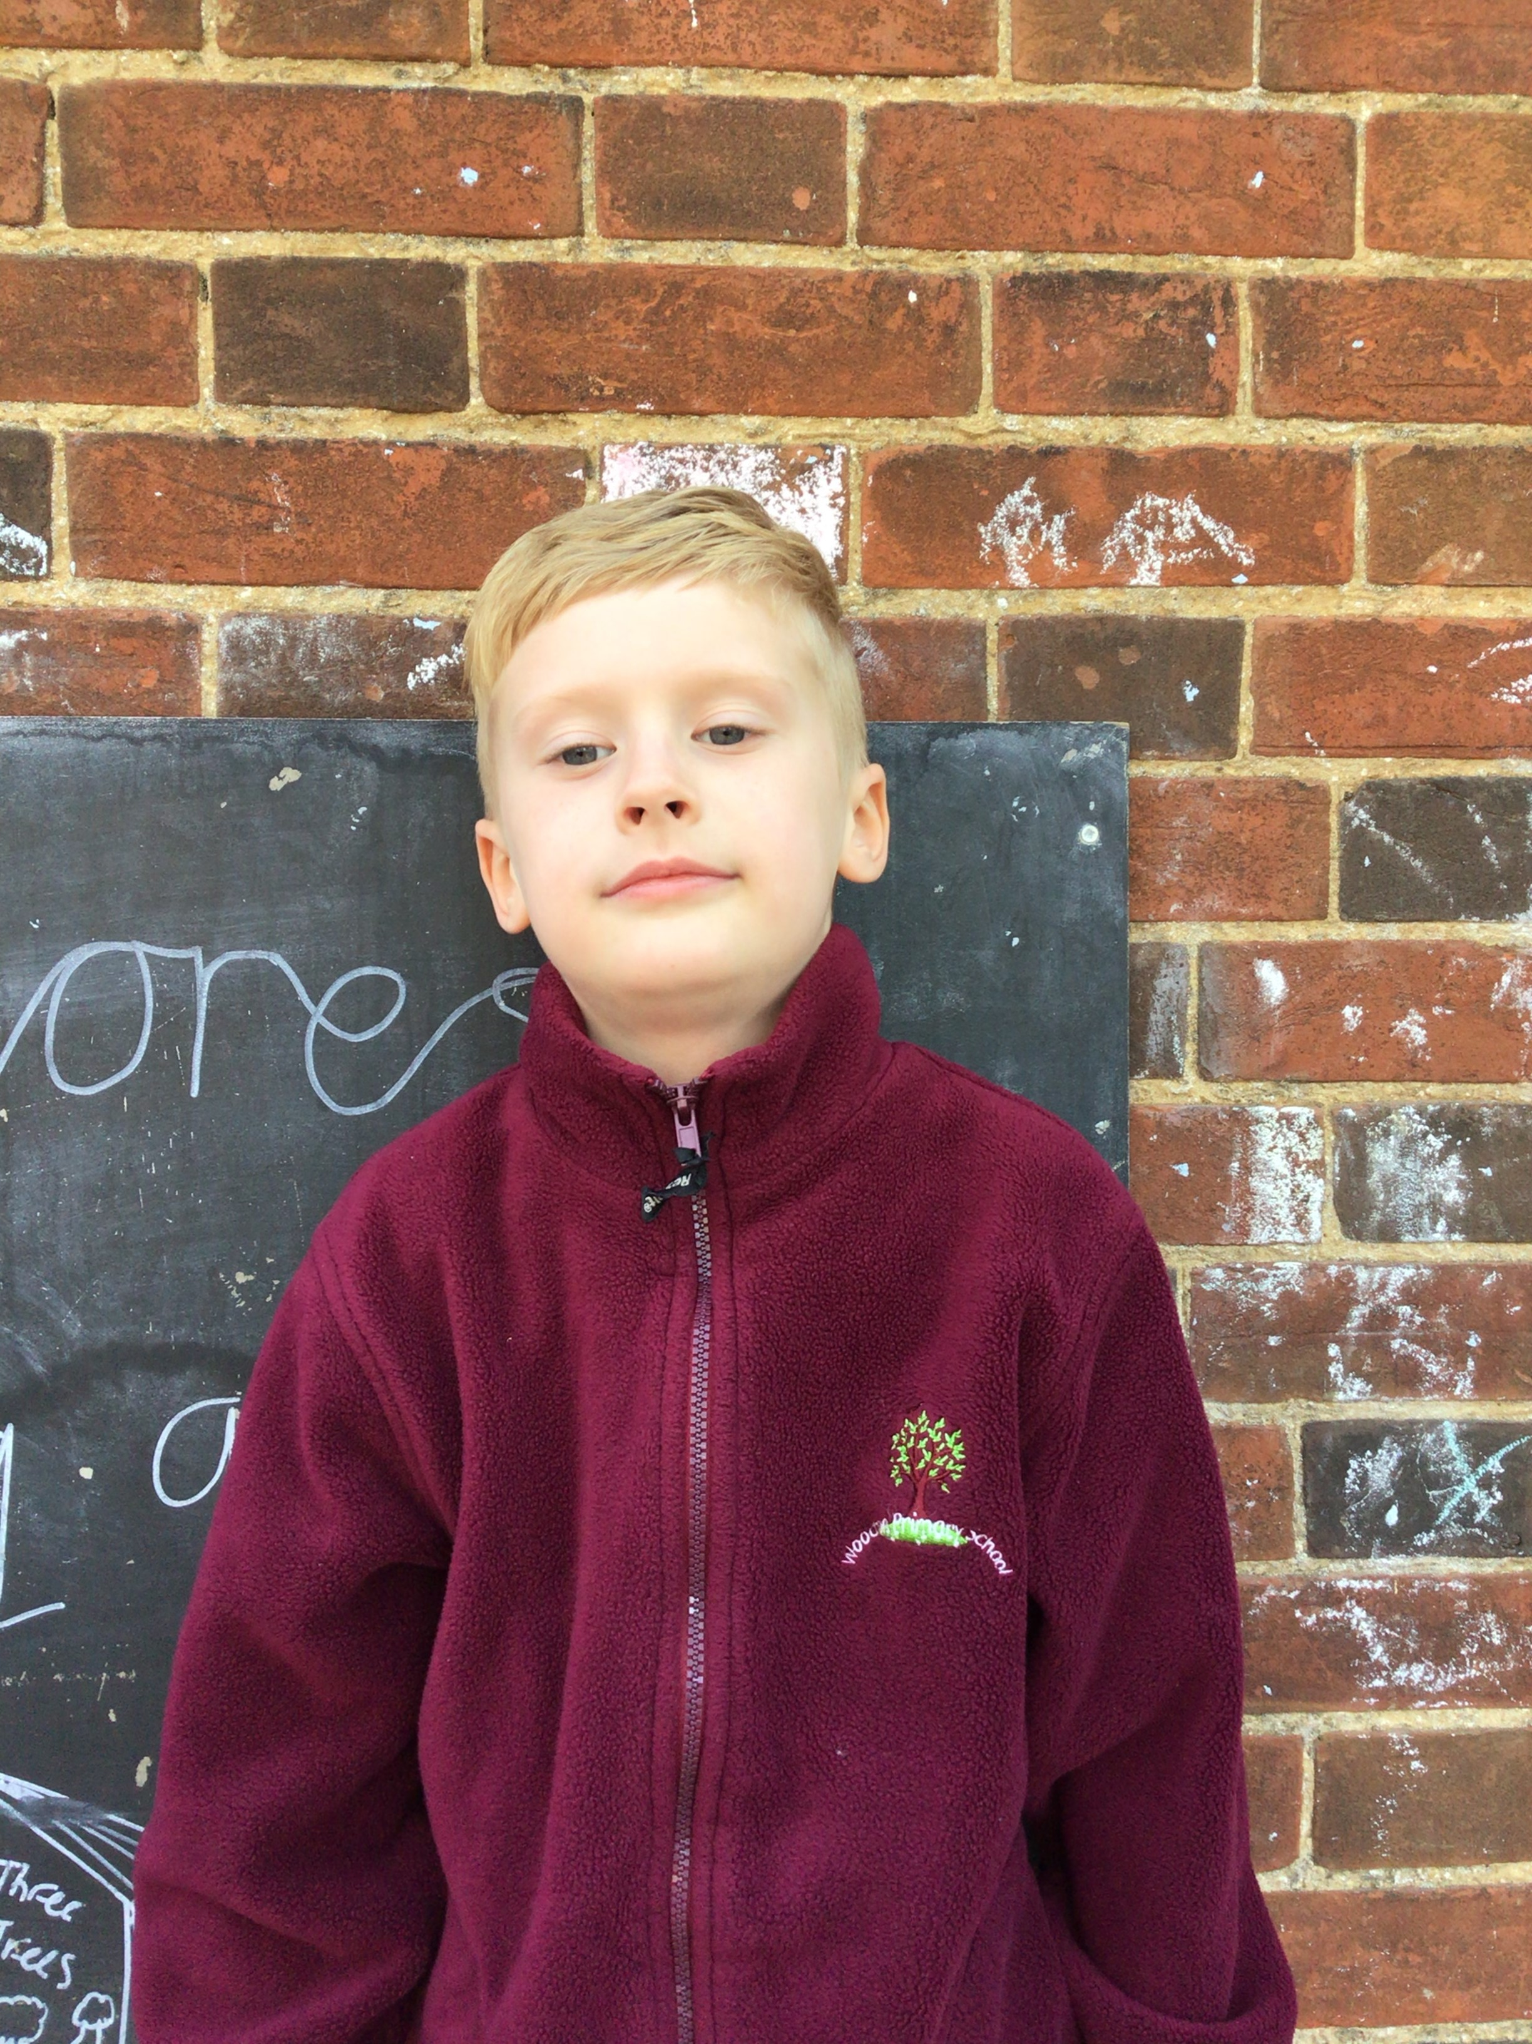

Isla G for settling in so well to Willows this week.

Millie for showing perseverance in reading and great determination in Forest school.

For having a positive attitude in all his learning this week.

**Class Attendance**

Willows – 98.61%

Sycamores – 92.16%

Oaks – 96.23%

CHALLENGE

NURTURE

INSPIRE

CHALLENGE

NURTURE

INSPIRE

**Oaks Star of the Week**

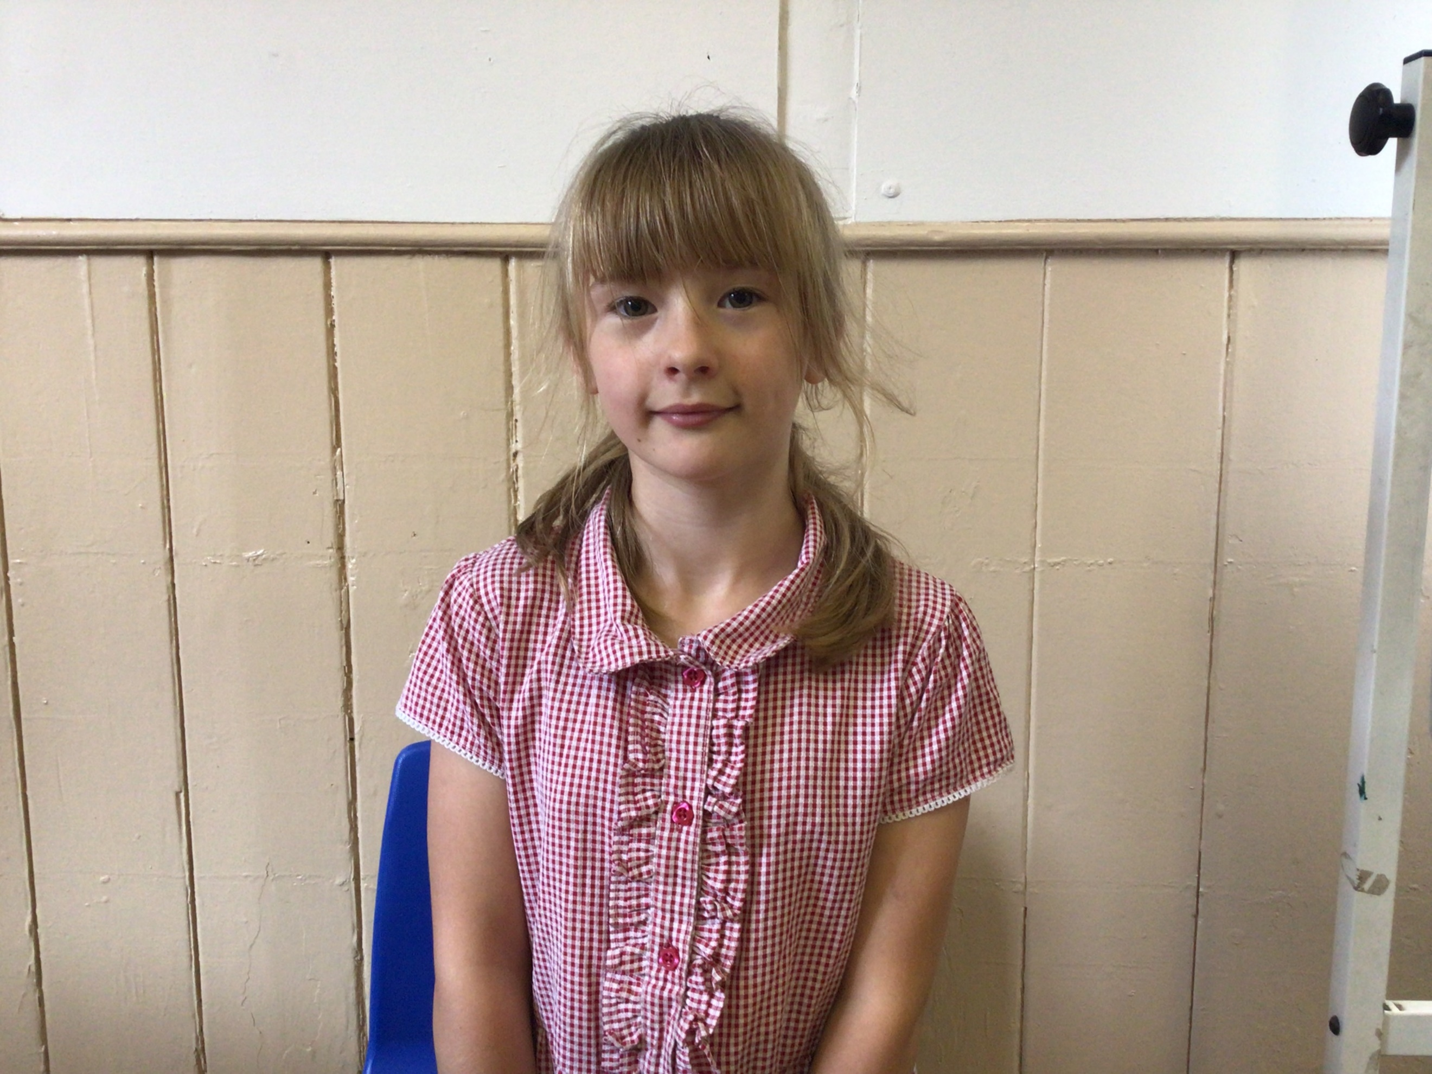

**House Points for this week**

Stephen Hawkings – 206

Beatrix Potter – 203

Benjamin Britten – 183

Kelly Holmes – 242

For being a great team member in class and always having a positive attitude.



**No Numbot stages completed this week!**



Willows: 1st Jack

2nd Arlo

Sycamores: 1st Theo

2nd Felicity

3rd Evie

Oaks: 1st Jesse James

2nd Ethan

3rd Isla



Kendall – Rock Legend

Theo – Rock Star

Charlie Wi - Support



**Reminders for This Term:**

**Oaks Class** – PE Mondays & Tuesdays

**Sycamores Class** – PE Wednesdays & Thursdays

**Willows Class** – PE Tuesdays & Fridays

**Fridays Forest School lessons**– Reception & yr 1’s and Sycamores

**Monday – Friday** (3.15pm until 4.30pm/5pm) Little Legends after-school club

**Monday – Friday** (8am until 8.40am) Breakfast Club

**Mondays** – Football Club (3.15pm until 4.15pm)

**Mondays** – Green Finger Gardening club (3.15pm until 4.15pm)

**Tuesdays** – Years 3, 4, 5 & 6’s Art Club (3.15pm until 4.15pm)

**Wednesdays** – Year 6 SATs Club (3.15pm until 4.15pm)

**Wednesdays** – Funky Feet Street Dance Club (3.15pm until 4.15pm)

**Fridays** – Forest School club (3.15pm until 4.15pm)

**Save The Date**

We are planning to have a **Federation Festival** on **Tuesday the 20th of May**

Please save the date, afternoon only

More details to follow…

**VE Day Celebration**

Whole School Picnic – Thursday 8th May

All children are invited to come in, in non-uniform wearing something red, white or blue.



**Forest School Day Swap**

Forest School will be swapping it’s day from Friday the 9th of May to Thursday the 8th of May, please make sure if your child has forest school this term they bring their change of clothes on this day. This applies to the Forest school Club too.



**Dates for the Diary**

**Monday 5th May** – Bank Holiday Monday

**Thursday 8th May** – VE Day – Whole school Picnic with a non-uniform day with something white,blue,red

**Mon 12th – Fri 16th May** – Year 6 SATs week

**Thursday 15th May** – By the Seaside Special lunch

**Friday 16th May** – Year 6 SATs Treat

**Tuesday 20th May** – Federation Festival – afternoon only

**Mon 26th May – Fri 30th May** – Half Term

**Tuesday 3rd June** – Year 6 Cycling On Road Training

**Wednesday 4th June** – Year 6 Cycling On Road Training

**Monday 9th June** – Selected Oaks Rounders Event – Hobart High school

**Tuesday 10th June** – Tempest Photos – Class & Year 6 Leavers

**Wednesday 18th June** – Oaks Athletics Event – UEA, Norwich

**Monday 23rd June** – Selected yrs 3-4 children for Tri-Golf – Bungay Golf Club

**Thursday 26th June** – Whole School Royal Norfolk Show Trip – details to follow

**Tuesday 22nd July** – Year 6 Leavers assembly – 2pm

Website – <http://www.ellinghamandwoodton.co.uk/>