

*Issue No: 32 7 Date: Friday 20th June 2025*

*Our Newsletter comes out every Friday with updates about what the children have been up to during the week, information, things to celebrate and important dates for the diary. Please take the time to read through and if you have any questions, please speak to Mrs Taylor in the office.*

**This Week’s Achievements**

**Sycamores Star of the Week**

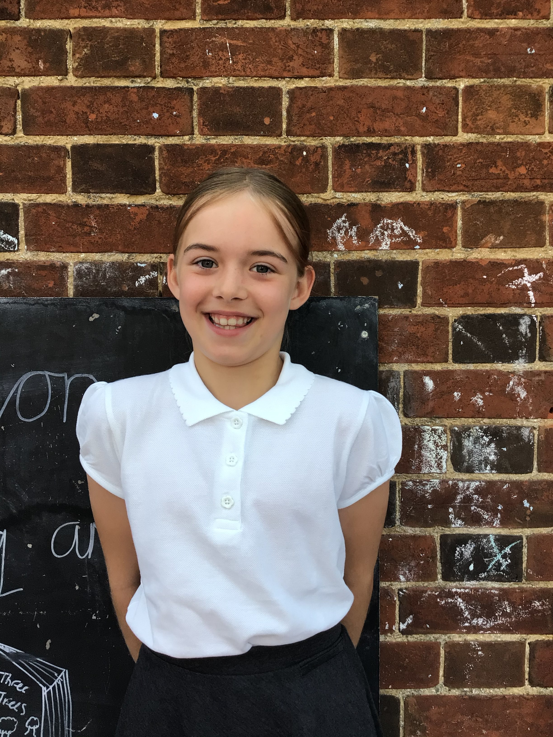

**Willows Star of the Week**

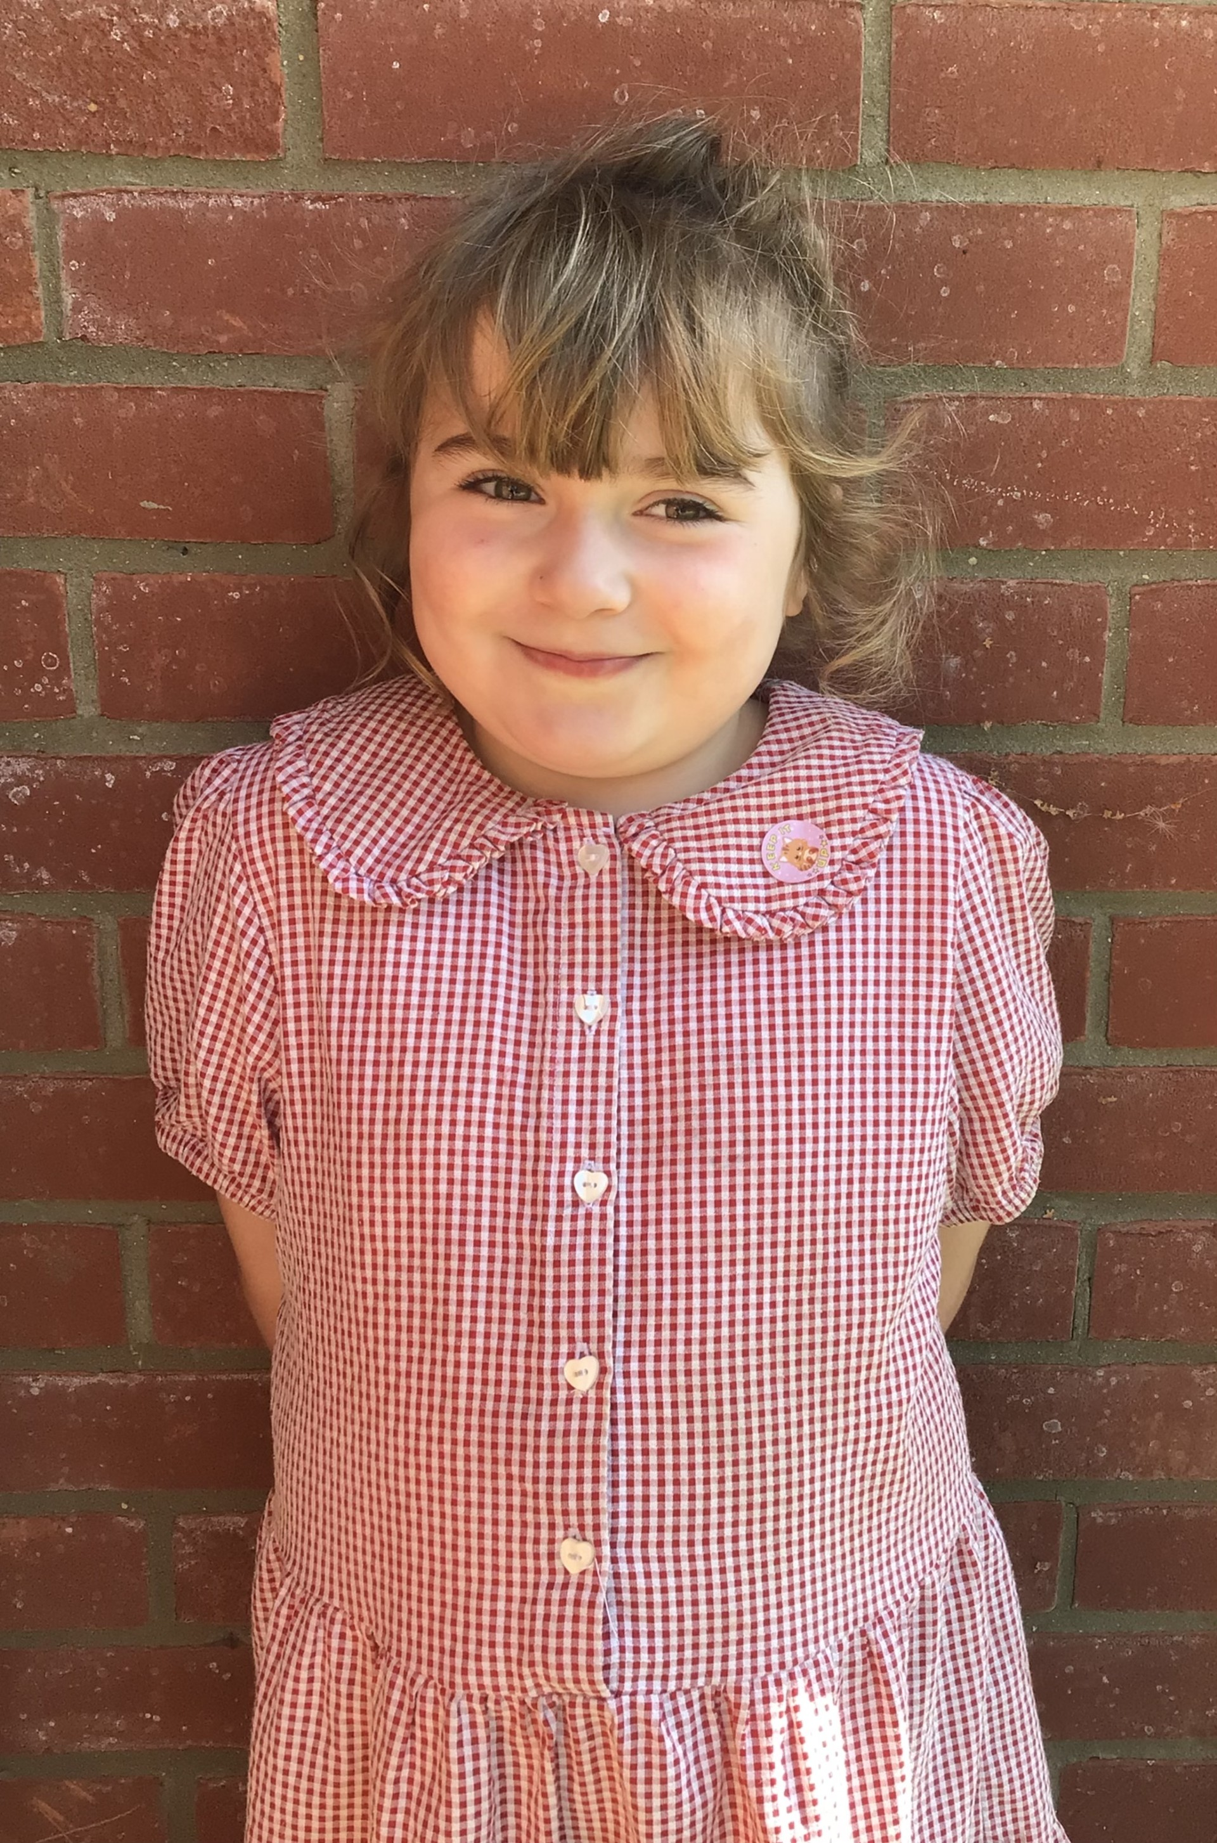

For demonstrating all of our

expectations and being a

good role model.

For working really hard in her learning this week and demonstrating all our schools expectations. Keep it up!

Millie for showing perseverance in reading and great determination in Forest school.

For having a positive attitude in all her learning this week.

**Class Attendance**

Willows – 96.83%

Sycamores – 95.41%

Oaks – 94.90%

CHALLENGE

NURTURE

INSPIRE

CHALLENGE

NURTURE

INSPIRE

**Oaks Star of the Week**

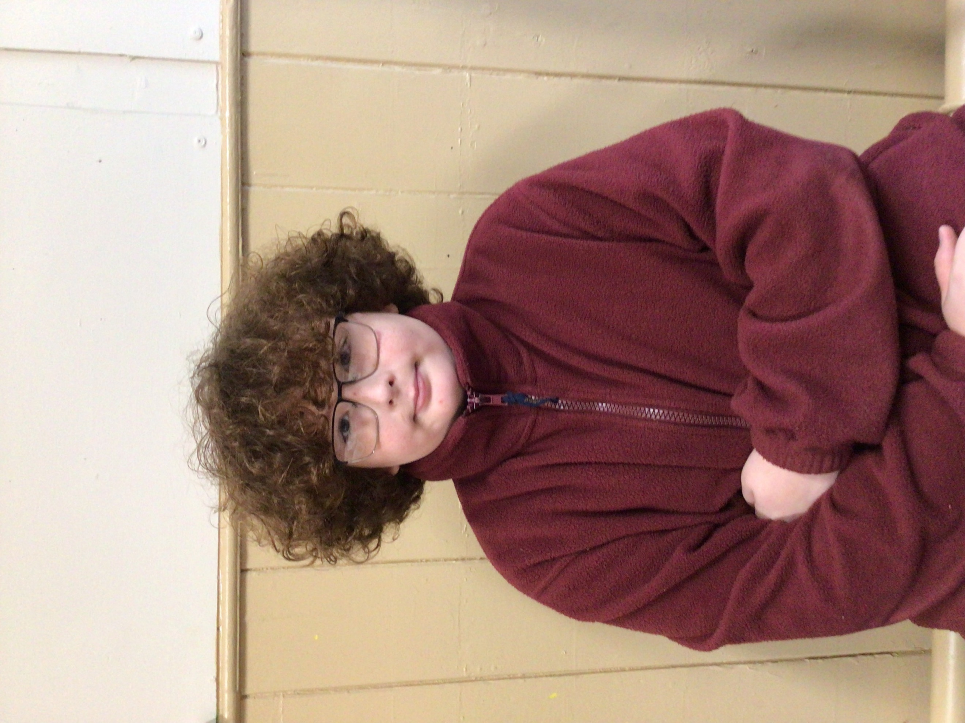

**House Points for this week**

Stephen Hawkings – 166

Beatrix Potter – 118

Benjamin Britten – 172

Kelly Holmes – 159

For showing a great attitude in his learning this week and sharing fantastic answers in his Science.



Willows: 1st Jude

2nd Arlo

3rd Phoebe

Sycamores: 1st Evie

2nd Molly

3rd Maisy

Oaks: 1st Sienna



Rupert – Breakthrough Artist

Jack MM & Jude – Rock Legend

Jack D & Aria – Rock Star



Congratulations to DOTTY for completing the TITANIUM level on Numbots this week!



**Playground Gate**

Following the recent incidents along the main road, the playground gate will be unlocked by staff at the beginning and at the end of the day.

**Reminders for this Term:**

**Oaks Class** – PE Mondays & Tuesdays

**Sycamores Class** – PE Wednesdays & Thursdays

**Willows Class** – PE Tuesdays & Fridays

**Fridays Forest School lessons**– Yr 2’s & Oaks

**Monday – Friday** (3.15 till 4.30) Little Legends after-school club

**Monday – Friday** (8 till 8.40) Breakfast Club

**Mondays** – Football Club (3.15 till 4.15)

**Mondays** – Fidgets Art Club (yrs 2,3 &4)

**Mondays** – Gardening Club (3.15 till 4.15)

**Tuesdays** – Fidgets Art Club (yrs 5 & 6)

**Wednesdays** – Street Dance Club (3.15 till 4.15)

**Fridays** – Forest School club (3.15 till 4.15)

**Dates for the Diary**

**Tuesday 24th June –** Oaks to Woodton Village Hall for a whole day of rehearsal

**Wednesday 25th June** – EYFS & KS1 Transition afternoon

**Thursday 26th June** – Whole School Royal Norfolk Show Trip

**Monday 30th June** – Year 6 Forensic Science Day at Hobart High

**Tuesday 1st July** – KS1 Transition morning

**Thursday 3rd July** – Woodton Sports Day – Parents welcome from 1.30pm

**Wednesday 9th July** – Whole School Transition afternoon

**Friday 18th July** – Oaks ‘Treasure Island’ Performance 1.45pm

**Thursday 17th July** – Year 6 Leavers Treat Day – Details to follow

**Tuesday 22nd July** – Year 6 Leavers assembly – 2pm

Website – <http://www.ellinghamandwoodton.co.uk/>

**The Norfolk Show**

**Whole School Trip**

**Thursday 26th June 2025**

Please remember all children will need a packed lunch for Thursday. School uniform must be worn with comfortable shoes for the day and suncream will need to be applied before school.

There are water stations around the show ground for bottles to be refilled through the day.

**Tempest Photos**

Links were sent out earlier in the week to be able to view and order the class and leavers school photos.

There is still 7 more days remaining to order these for free delivery direct to the school.

**Sports Day 2025**

We would like to invite parents to join us for our Sports day races on Thursday 3rd July. The field gates will open at 1.30pm, giving enough time for everyone to sit down ready for the races to start at 1.45pm.

We look forward to seeing you there!

**‘Treasure Island’**

Oaks will be showing their summer performance on Friday the 18th of July, starting at 1.45pm. Oaks children will need to be dropped off at the village hall in the morning, and they will require a packed lunch for the day.

Willows and Sycamores will be walking up in the afternoon to watch the performance but will walk back to school to be collected as normal.

