

*Issue No: 29 7 Date: Friday 23rd May 2025*

*Our Newsletter comes out every Friday with updates about what the children have been up to during the week, information, things to celebrate and important dates for the diary. Please take the time to read through and if you have any questions, please speak to Mrs Taylor in the office.*

**This Week’s Achievements**

**Willows Star of the Week**

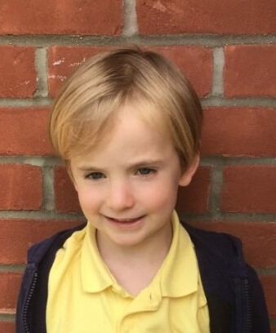

For working really well, writing his story in English this week.

**Sycamores Star of the Week**



For working really hard in her learning this week and demonstrating all our schools expectations. Keep it up!

Millie for showing perseverance in reading and great determination in Forest school.

For demonstrating great resilience this week in all of her learning.

**Class Attendance**

Willows – 96.63%

Sycamores – 95.19%

Oaks – 95.96%

CHALLENGE

NURTURE

INSPIRE

CHALLENGE

NURTURE

INSPIRE

**Oaks Star of the Week**

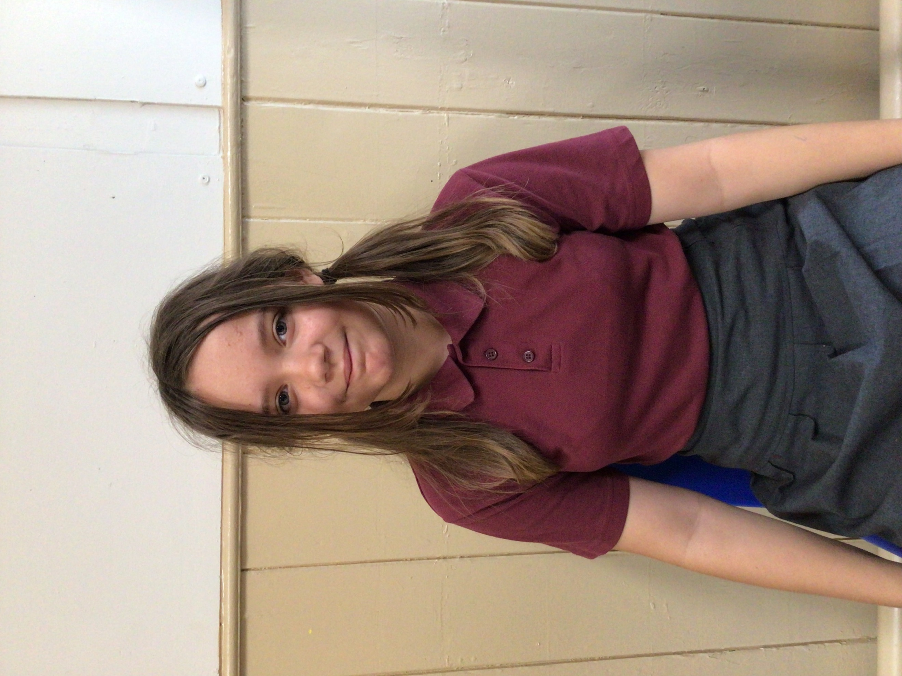

**House Points for this week**

Stephen Hawkings – 202

Beatrix Potter – 174

Benjamin Britten – 134

Kelly Holmes – 192

For showing kindness and being a great role model in class this week.



Congratulations to Alfie for completing the Glass stage on Numbots this week.



Willows: 1st Jude

2nd Phoebe

3rd Maci

Sycamores: 1st Kendall

2nd Evie

3rd Charlie W

Oaks: 1st Sienna

2nd Flo

3rd Jesse



Rupert – Unsigned Act

Ned – Rock Star



**Reminders for Next Term:**

**Oaks Class** – PE Mondays & Tuesdays

**Sycamores Class** – PE Wednesdays & Thursdays

**Willows Class** – PE Tuesdays & Fridays

**Fridays Forest School lessons**– Yr 2’s & Oaks

**Monday – Friday** (3.15pm until 4.30pm/5pm) Little Legends after-school club

**Monday – Friday** (8am until 8.40am) Breakfast Club

**Mondays** – Football Club (3.15pm until 4.15pm)

**Mondays** – Fidgets Art Club (yrs 2,3 &4)

**Mondays** – Green Finger Gardening club (3.15pm until 4.15pm)

**Tuesdays** – Fidgets Art Club (yrs 5 & 6)

**Wednesdays** – Funky Feet Street Dance Club (3.15pm until 4.15pm)

**Fridays** – Forest School club (3.15pm until 4.15pm)

**Dates for the Diary**

**Mon 26th May – Fri 30th May** – Half Term

**Tuesday 3rd June** – Year 6 Cycling On Road Training

**Wednesday 4th June** – Year 6 Cycling On Road Training

**Monday 9th June** – Selected Oaks Rounders Event – Hobart High school

**Tuesday 10th June** – Tempest Photos – Class & Year 6 Leavers

**Wednesday 18th June** – Oaks Athletics Event – UEA, Norwich

**Monday 23rd June** – Selected yrs 3-4 children for Tri-Golf – Bungay Golf Club

**Thursday 26th June** – Whole School Royal Norfolk Show Trip – details to follow

**Tuesday 22nd July** – Year 6 Leavers assembly – 2pm

Website – <http://www.ellinghamandwoodton.co.uk/>

**Federation Festival**

What an amazing day, we started the day with a whole federation yoga session, which was then followed by an assortment of activities. Thank you to everyone that came and watched the talent show at the end of the day.

