

*Issue No: 27 7 Date: Friday 09th  May 2025*

*Our Newsletter comes out every Friday with updates about what the children have been up to during the week, information, things to celebrate and important dates for the diary. Please take the time to read through and if you have any questions, please speak to Mrs Taylor in the office.*

**This Week’s Achievements**

**Willows Star of the Week**

**Sycamores Star of the Week**

Aria for demonstrating kindness to everyone this week.

For showing great determination in DT, cutting up his vegetables and has wowed us with his writing this week.

Millie for showing perseverance in reading and great determination in Forest school.

**Class Attendance**

Willows – 98.95%

Sycamores – 92.94%

Oaks – 98.33%

CHALLENGE

NURTURE

INSPIRE

CHALLENGE

NURTURE

INSPIRE

**Oaks Star of the Week**



**House Points for this week**

Stephen Hawkings – 225

Beatrix Potter – 232

Benjamin Britten – 238

Kelly Holmes – 232

For a fantastic effort with her writing this week.



Willows: 1st Phoebe

2nd Maci

3rd Alannah

Sycamores: 1st Maisy

2nd Kendall

3rd Eliza

Oaks: 1st Flo

2nd Jesse-James

3rd Sienna



Rupert - Wannabe

Eliza - Headliner



**No Numbot stages completed this week!**



**Reminders for This Term:**

**Oaks Class** – PE Mondays & Tuesdays

**Sycamores Class** – PE Wednesdays & Thursdays

**Willows Class** – PE Tuesdays & Fridays

**Fridays Forest School lessons**– Reception & yr 1’s and Sycamores

**Monday – Friday** (3.15pm until 4.30pm/5pm) Little Legends after-school club

**Monday – Friday** (8am until 8.40am) Breakfast Club

**Mondays** – Football Club (3.15pm until 4.15pm)

**Mondays** – Green Finger Gardening club (3.15pm until 4.15pm)

**Tuesdays** – Years 3, 4, 5 & 6’s Art Club (3.15pm until 4.15pm)

**Wednesdays** – Year 6 SATs Club (3.15pm until 4.15pm)

**Wednesdays** – Funky Feet Street Dance Club (3.15pm until 4.15pm)

**Fridays** – Forest School club (3.15pm until 4.15pm)

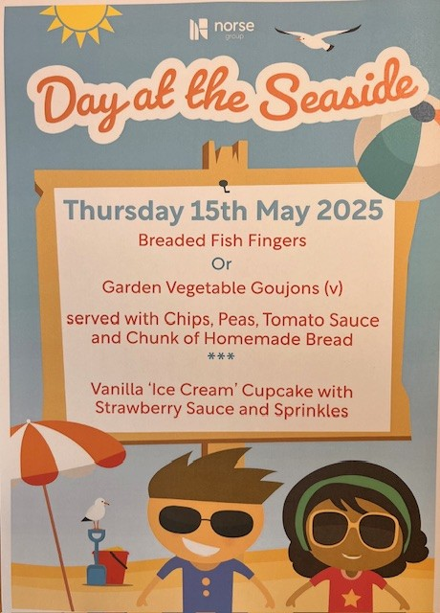

**Save The Date**

An email was sent out this week giving details about our **Federation Festival** on **Tuesday the 20th of May.**

Please can everyone give consent through the parent portal, by Monday the 12th of May.

If you have any questions about the day or about the collection from Ellingham Primary, please contact the school office to discuss.

**Dates for the Diary**

**Mon 12th – Fri 16th May** – Year 6 SATs week

**Thursday 15th May** – By the Seaside Special lunch

**Friday 16th May** – Year 6 SATs Treat

**Tuesday 20th May** – Federation Festival at Ellingham VC Primary School

**Mon 26th May – Fri 30th May** – Half Term

**Tuesday 3rd June** – Year 6 Cycling On Road Training

**Wednesday 4th June** – Year 6 Cycling On Road Training

**Monday 9th June** – Selected Oaks Rounders Event – Hobart High school

**Tuesday 10th June** – Tempest Photos – Class & Year 6 Leavers

**Wednesday 18th June** – Oaks Athletics Event – UEA, Norwich

**Monday 23rd June** – Selected yrs 3-4 children for Tri-Golf – Bungay Golf Club

**Thursday 26th June** – Whole School Royal Norfolk Show Trip – details to follow

**Tuesday 22nd July** – Year 6 Leavers assembly – 2pm

Website – <http://www.ellinghamandwoodton.co.uk/>