

*Issue No: 35 7 Date: Friday 11th July 2025*

*Our Newsletter comes out every Friday with updates about what the children have been up to during the week, information, things to celebrate and important dates for the diary. Please take the time to read through and if you have any questions, please speak to Mrs Taylor in the office.*

**This Week’s Achievements**

**Sycamores Star of the Week**

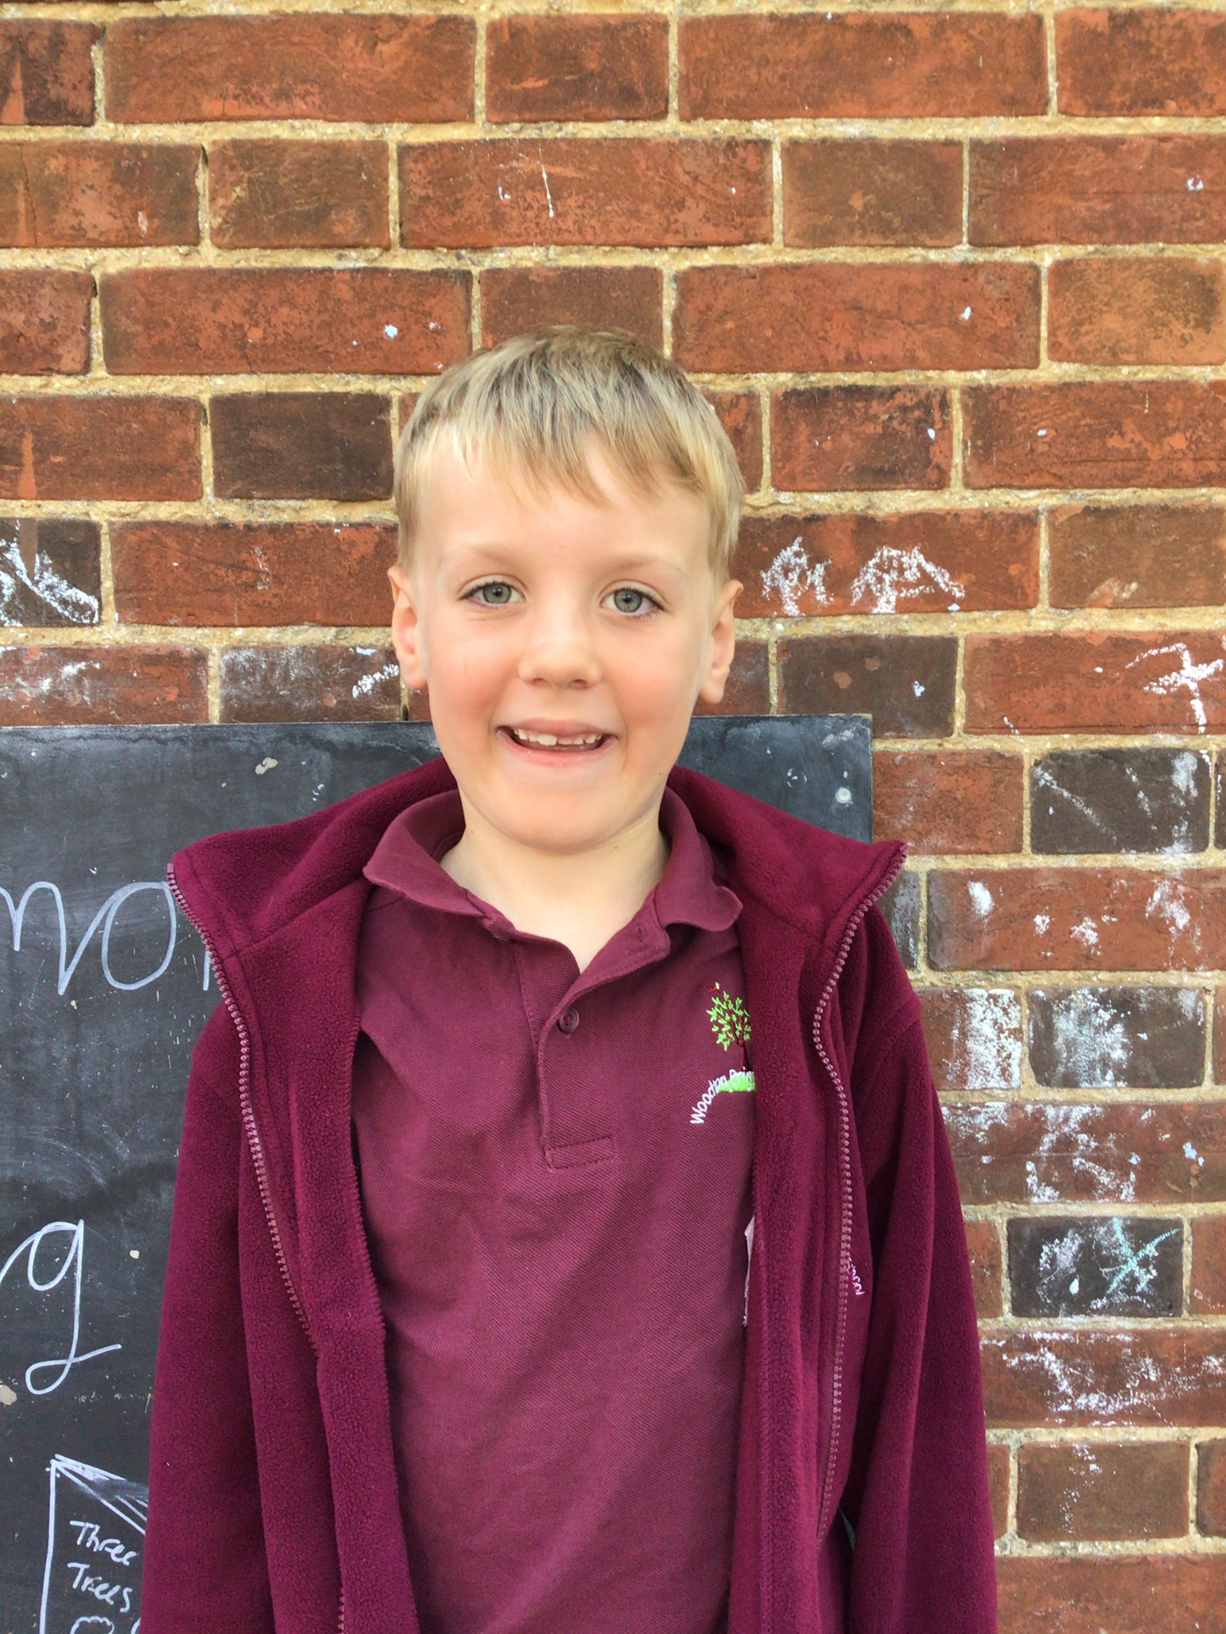

**Willows Star of the Week**

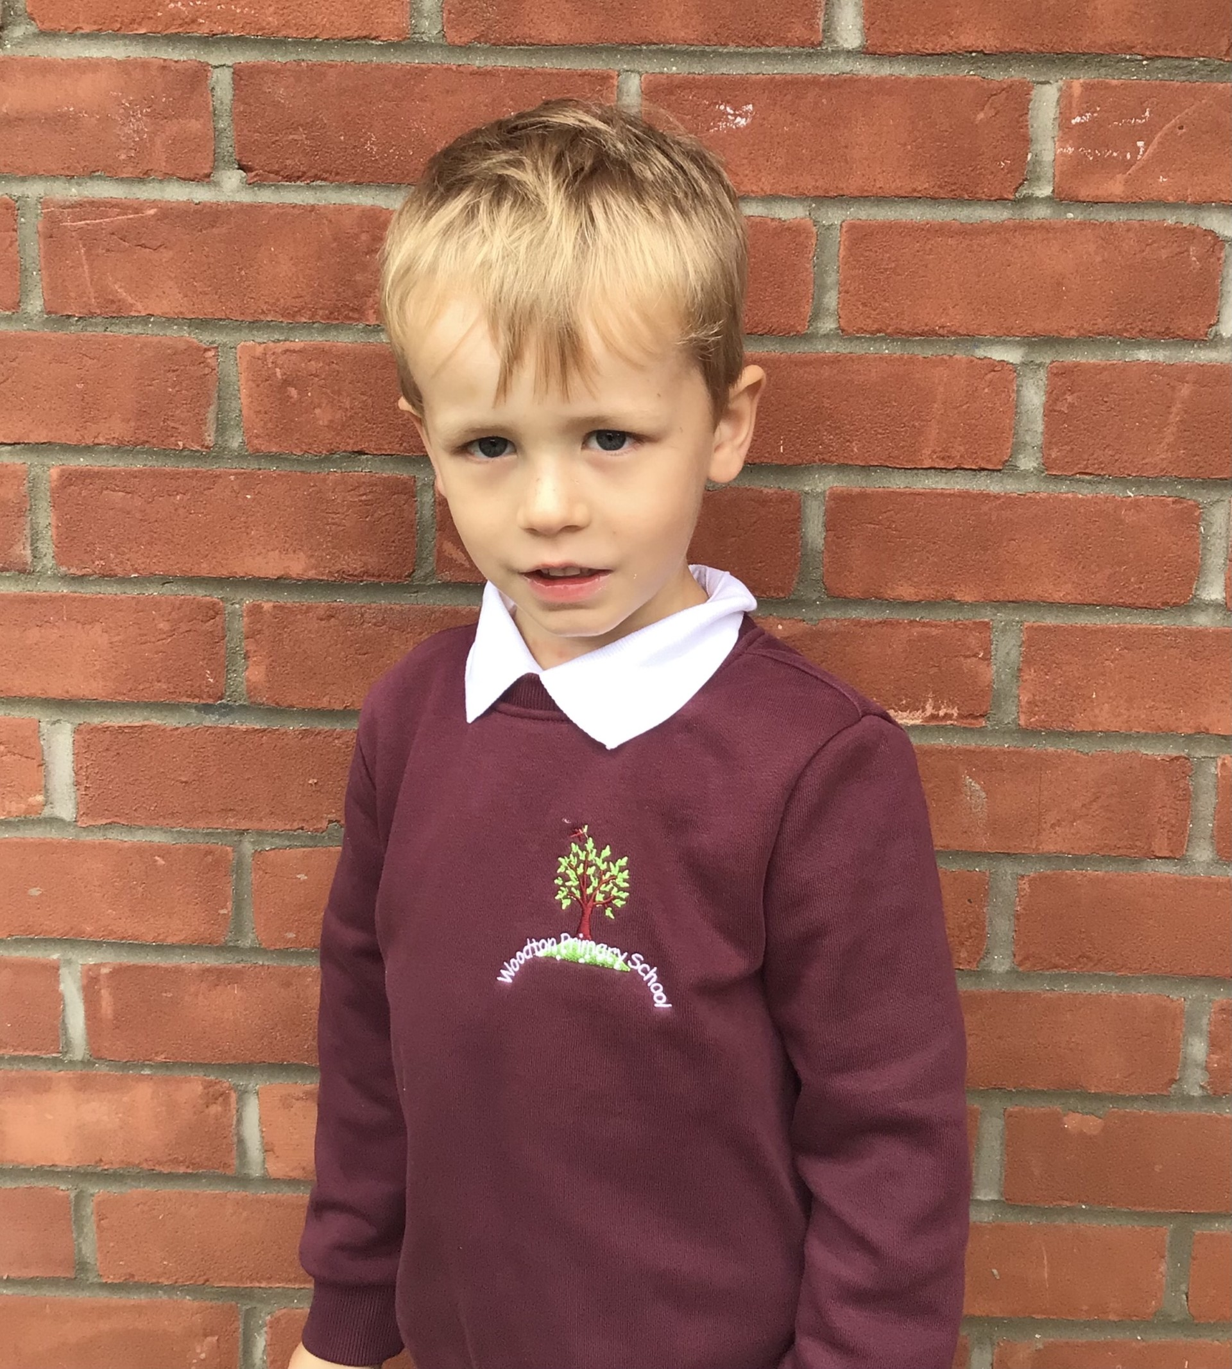

For demonstrating good sportsmanship in PE this week.

For demonstrating all of our expectations and for being a good role model.

**Class Attendance**

Willows – 96.30%

Sycamores – 94.79%

Oaks – 92.71%

CHALLENGE

NURTURE

INSPIRE

CHALLENGE

NURTURE

INSPIRE

**Oaks Star of the Week**

**House Points for this week**

Stephen Hawkings – 140

Beatrix Potter – 129

Benjamin Britten – 224

Kelly Holmes – 112

For fantastic work in Art this week.



Willows: 1st Phoebe

2nd Jude

3rd Arlo

Sycamores: 1st Evie

2nd Molly

3rd Bea

Oaks: 1st Ada

2nd Sienna

3rd Flo



Rock Hero – Bea!!!!

Rock star – Charlie Will

Unsigned Act - Maci



No Numbots this week!



Congratulations to Bea for achieving the ‘ROCK HERO’ award in TTRS.

**Forest School Lesson**

**Friday the 18th July**

As Oaks are at Woodton village hall next Friday for their performance preparation, all of **Sycamores** and **Willows** will be having a special Forest school session with Zoe.

If your child is in Willows or Sycamores, please make sure they bring a change of clothes to change into for them to participate in this lesson.

**Reminders for this Term:**

**Oaks Class** – PE Mondays & Tuesdays

**Sycamores Class** – PE Wednesdays & Thursdays

**Willows Class** – PE Tuesdays & Fridays

**Monday – Friday** (3.15 till 4.30) Little Legends after-school club

**Monday – Friday** (8 till 8.40) Breakfast Club

There are no external clubs running next week. Gardening, Football, Art, Dance and Forest school clubs have all finished now for this academic year.

**Beccles & Bungay Journal**

**Year 6 - Top Class Supplement**

A ‘Top Class’ photo has been published today in the BBJ newspaper of our Year 6 pupils leavers photo.

**Year 6 Leavers Treat Day**

Reminder – All year 6 pupils will require a home packed lunch for this day, as well as a water bottle and a suitable bag to carry these items in.

They can wear non-uniform for the day, but please remember that they are doing clip and climb, so they will require suitable clothing for this.

**Return to School Menu Change**

Norse have changed the menu option for the day we return to school.

Wednesday the 3rd of September will be Pizza with an ice cream dessert.

The rest of this week will be as stated on the normal menu.

**Oaks Performance - ‘Treasure Island’**

Oaks will be showing their summer performance on Friday the 18th of July, starting at 1.45pm. Oak’s children will need to be dropped off at the village hall in the morning, and they will require a packed lunch for the day.

**Tickets for the Oaks performance will be on sale** at the school office from Monday 14th of July. Tickets have been designed by some of our Oaks children and will be sold for £2 each, there is no limit on the tickets.

**Career’s Day**

We would like to say a BIG thank you to Heather Jermy and John Turner for coming in last Friday and giving a talk to our Oaks class about their fascinating careers.

**Bottom Playground Gate**

Please may we ask that whoever uses the playground gate that leads onto the road, pulls it too after each use.

Thank you

**Dates for the Diary**

**Thursday 17th July** – Year 6 Leavers Treat Day

**Friday 18th July** – Oaks ‘Treasure Island’ Performance 1.45pm

**Friday 18th July** – PTA meeting – ALL WELCOME in the school hall at 4.30pm

**Monday 21st July** – Class Circus Workshops

**Tuesday 22nd July** – Year 6 Leavers assembly – 2pm

Website – <http://www.ellinghamandwoodton.co.uk/>