

*Issue No: 02 7 Date: Friday 12th Sept 2025*

*Our Newsletter comes out every Friday with updates about what the children have been up to during the week, information, things to celebrate and important dates for the diary. Please take the time to read through and if you have any questions, please speak to Mrs Taylor in the office.*

**This Week’s Achievements**

**Sycamores Star of the Week**

**Willows Star of the Week**

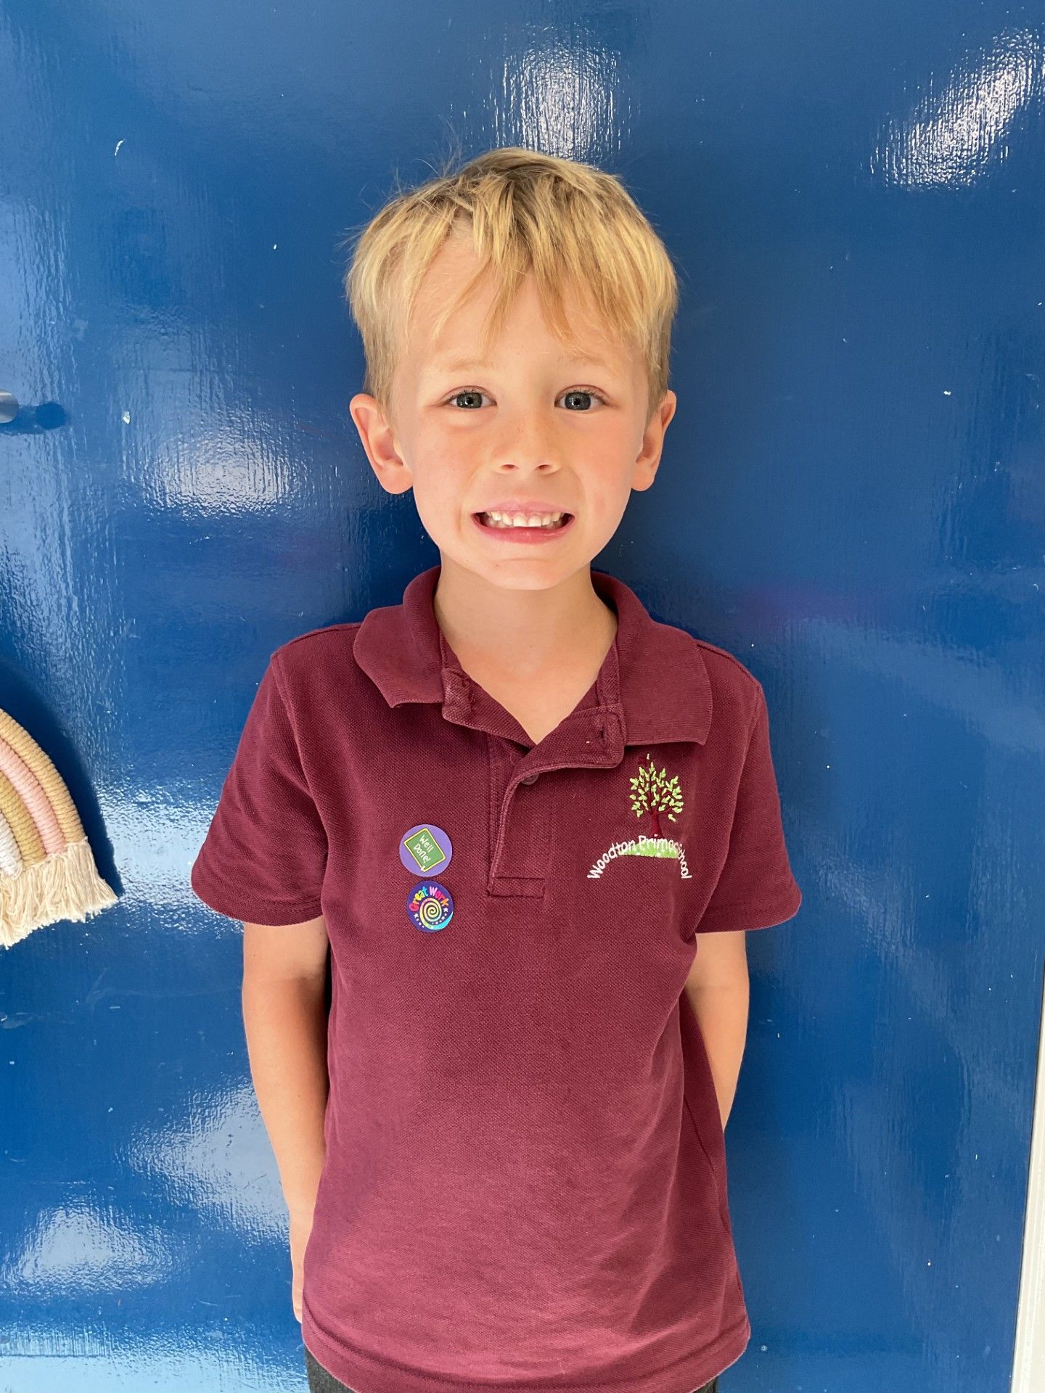

Arlo working hard and demonstrating being his best.

For coming back to school with a fantastic ‘can do’ attitude.

**Class Attendance**

Willows – 100%

Sycamores – 97.55%

Oaks – 97.78%

CHALLENGE

NURTURE

INSPIRE

CHALLENGE

NURTURE

INSPIRE

**Oaks Star of the Week**



**House Points for this week**

Stephen Hawkings – 358

Beatrix Potter – 361

Benjamin Britten – 585

Kelly Holmes – 368

For showing a great attitude in all her learning and being a kind and friendly partner to everyone.



Sycamores: 1st Arlo

2nd Alfie

3rd Phoebe

Oaks: 1st Bea

2nd Molly

3rd Evie



No Rock Legends this week!



No Numbots this week!



**Morning Drop Off**

From Monday morning, we will be starting the line up routine, we previously had.

Willows class will line up in front of the new fenced rain garden, Sycamores and Oaks will line up at the other side of the rain garden. All children must be lined up by 8.40, which is when the class teachers will walk them in.

For the safety of other children, please may we ask that no parents enter the school.



**Reminders forTerm:**

**Oaks Class** – PE Mondays, Swimming on Wednesdays

**Sycamores Class** – PE Wednesdays & Thursdays

**Willows Class** – PE Mondays & Fridays

**Forest School lessons** **this term** – Sycamores & Willows

**Monday – Friday** (8 till 8.40) Breakfast Club

**Monday – Friday** (3.15 till 5pm) Little Legends after-school club

**Mondays** – Fidgets Art Club (yrs 2,3 & 4) – 3.15pm – 4.15pm

**Mondays** – Football Club (KS2) – 3.15pm – 4.15pm

**Tuesdays** – Fidgets Art Club (yrs 5 & 6) – 3.15pm – 4.15pm

**Wednesdays** – Gardening Club – 3.15pm – 4.15pm (starting the 17th Sept, 1st one at lunchtime)

**Wednesdays** – Funky Feet Dance Club – 3.15pm – 4.15pm

**Fridays** – Forest School Club – 3.15pm – 4.15pm (starting the 19th Sept)





**Jeans for Genes Day**

Friday 19th September

We would like to invite everyone to come into school next Friday wearing non-uniform with an item of denim in exchange for a small donation to the Jeans for Genes charity. Donations can be made through the below link

<https://www.justgiving.com/page/ellingham-vc-and-woodton-primary-school-federation-6>

**PTA Raffle Books**

Raffle books will be coming home with every child today, please check school bags.

So many lovely prizes up for grabs!

Need more!! Come and collect from the school office.



**After-school Clubs**

We still have spaces in some of our after-school clubs, if you would like to sign your child up, please speak to the school office.

Fidgets Art Club – Mondays (for years 2,3 & 4)

Football Club – Mondays (for years 3,4,5 & 6)

Gardening Club – Wednesdays (for years 1,2,3,4,5 & 6)

Dance Club – Wednesdays (for all years)

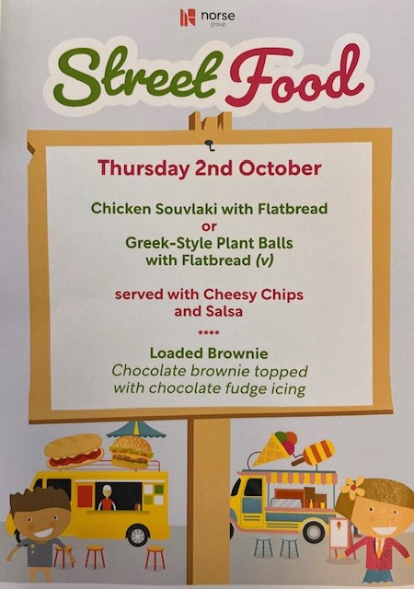

Dear Parent and guardians,

Please see details of an exciting opportunity for male footballers in school year 2,3,4,5,6. To attend a free trial training session at one of our player development centres in the Suffolk area with the view to gaining a place with us. Players on our programmes pay a small fee to take part in the programme but receive the following benefits

* Take part in weekly training sessions delivered by our UEFA qualified coaches, we pride ourselves on sessions being both educational and enjoyable for our players
* Train with highly talented players to develop skills and tactical understanding.
* The opportunity to progress within the clubs development pathway.
* Full training kit.
* The opportunity to travel on residential training trips.
* Take part in fixtures against other development programmes.

Please see full details below of the session and how to book your place.

 Whitton Booking link- <https://www.abler.io/shop/ncfcfd/suffolks/product/Q2x1YlNlcnZpY2U6NDYxNzg=?>

If you have any questions please do not hesitate to get in touch with me via email –Stephen.Clarke@canaries.co.uk

**Dates for the Diary**

**Monday 15th/22nd/29th September** – Football tournament for selected children

**Monday 15th September** – Sycamores Samba lessons start and continue for 10 weeks

**Friday 19th September** – Jeans 4 Genes Day (please see above)

**Saturday 20th September** – Woodton Primary Summer Fete – from 12pm

**Wednesday 1st October** – Yrs 3 & 4 Cross Country at Langley (details to follow)

**Thursday 2nd October** – Special Lunch – Street Food

**Friday 10th October** – Hello Yellow Day

**Wed 15th, Thurs 16th, Fri 17th October** – Oaks Residential Trip

**Friday 24th October** - Tempest Individual & Sibling photos

**Friday 24th October** – Whole School Flu Vaccinations (details to follow)

**Thursday 6th November** – Sycamores school trip to Norwich Cathedral

Website – <http://www.ellinghamandwoodton.co.uk/>