

*Issue No: 03 7 Date: Friday 19th Sept 2025*

*Our Newsletter comes out every Friday with updates about what the children have been up to during the week, information, things to celebrate and important dates for the diary. Please take the time to read through and if you have any questions, please speak to Mrs Taylor in the office.*

**This Week’s Achievements**

**Sycamores Star of the Week**

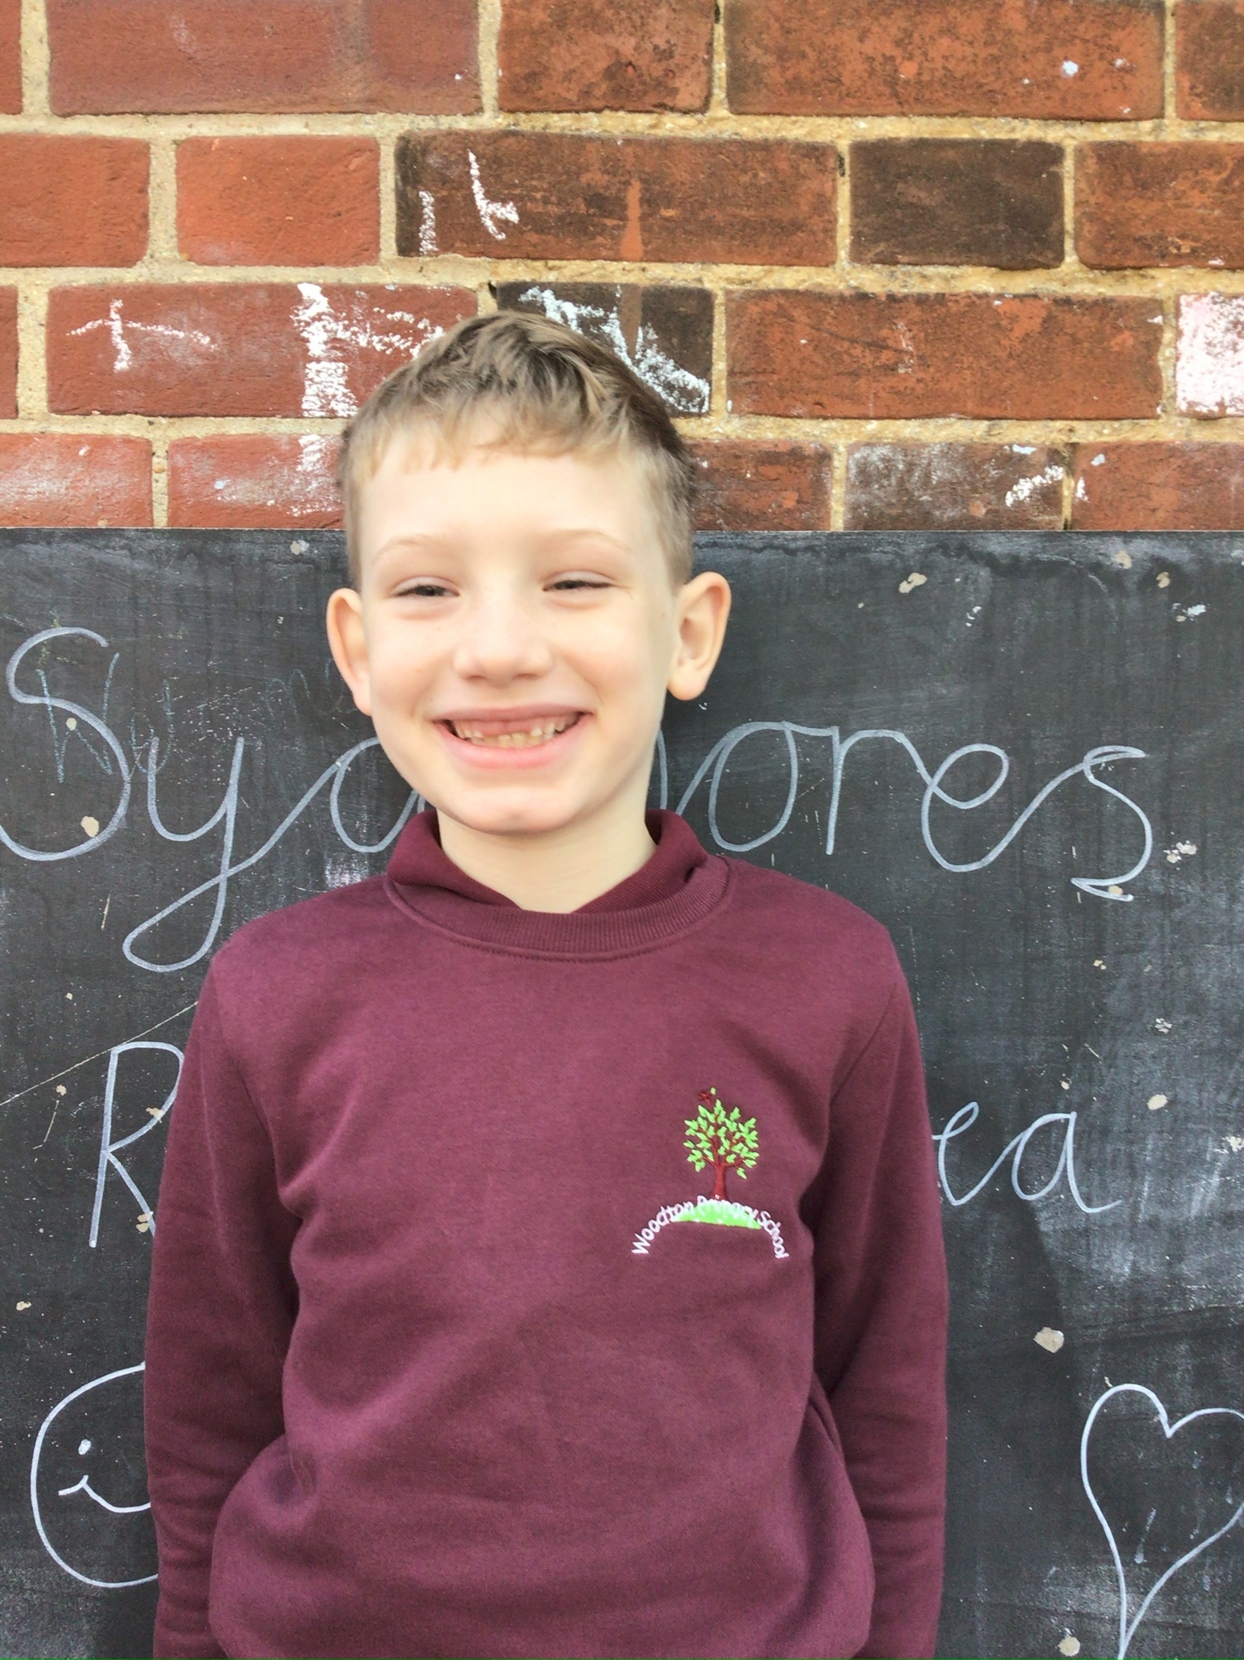

**Willows Star of the Week**

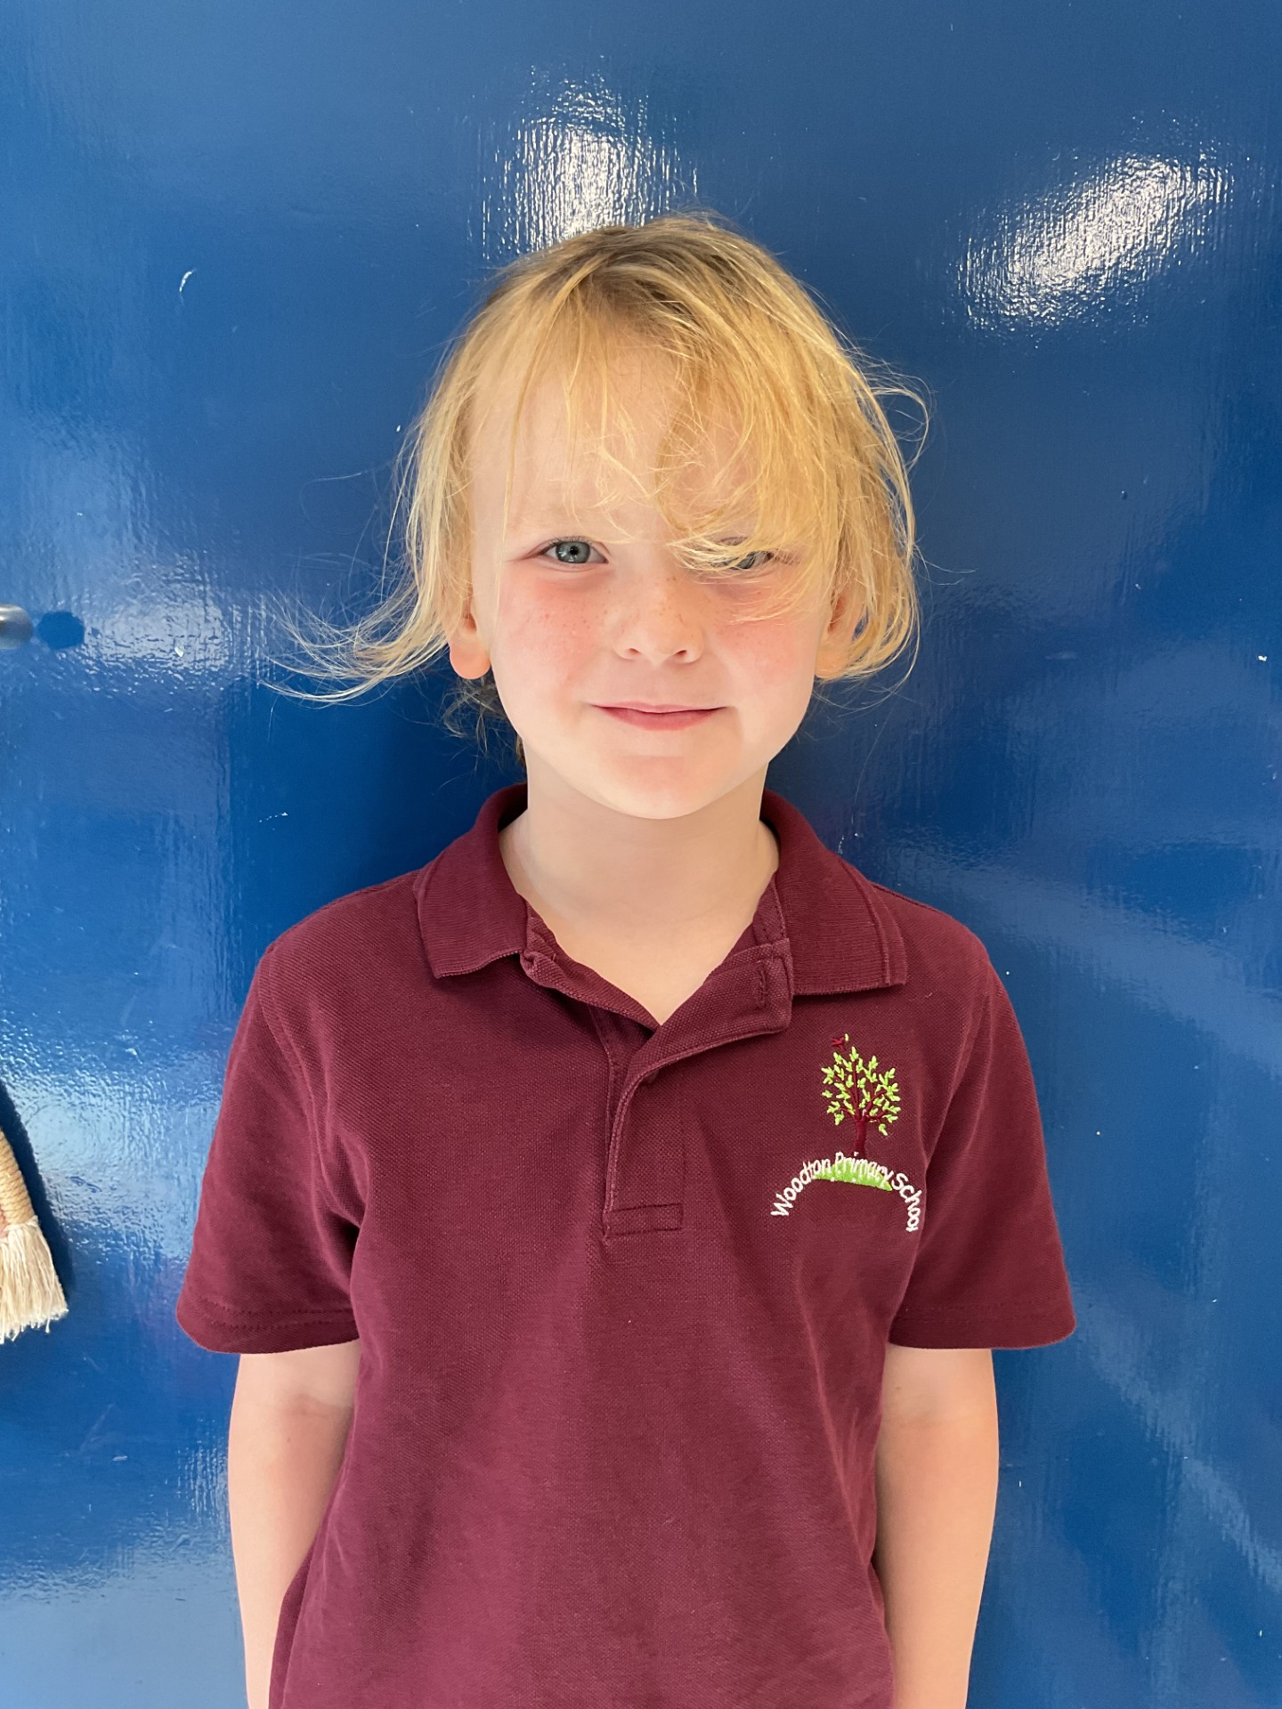

Arlo working hard and demonstrating being his best.

For doing amazingly in his writing this week.

For being resilient and a great role model in Willows this week.

**Class Attendance**

Willows – 100%

Sycamores – 98.04%

Oaks – 98.33%

CHALLENGE

NURTURE

INSPIRE

CHALLENGE

NURTURE

INSPIRE

**Oaks Star of the Week**

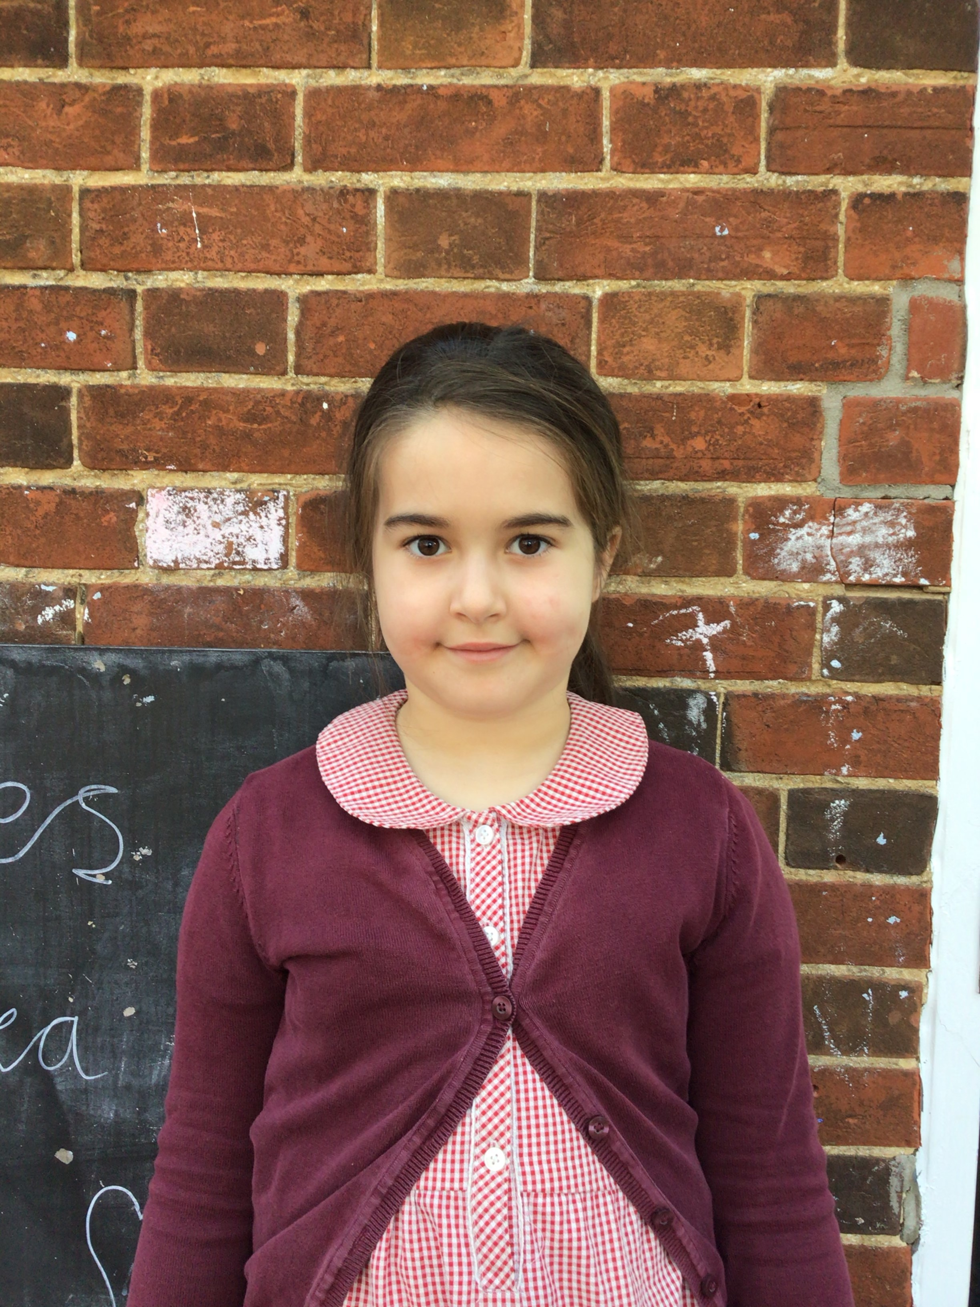

**House Points for this week**

Stephen Hawkings – 249

Beatrix Potter – 331

Benjamin Britten – 409

Kelly Holmes – 299

For having a great attitude to her learning all week and for fantastic progress in swimming.



Sycamores: 1st Arlo

2nd Ned

3rd Phoebe

Oaks: 1st Molly

2nd Theo

3rd Ada



No Rock Legends this week!



No Numbots this week!



**Morning Drop Off**

Please may we ask that children are at school to join their class line for 8.40 for when the doors open.

Willows are lining up in front of the new fenced rain garden, Sycamores and Oaks will line up at the other side of the rain garden.

For the safety of other children, please may we ask that no parents enter the school. Thank you



**Reminders forTerm:**

**Oaks Class** – PE Mondays, Swimming on Wednesdays

**Sycamores Class** – PE Wednesdays & Thursdays

**Willows Class** – PE Mondays & Fridays

**Forest School lessons** **this term** – Sycamores & Willows

**Monday – Friday** (8 till 8.40) Breakfast Club

**Monday – Friday** (3.15 till 5pm) Little Legends after-school club

**Mondays** – Fidgets Art Club (yrs 2,3 & 4) – 3.15pm – 4.15pm

**Mondays** – Football Club (KS2) – 3.15pm – 4.15pm

**Tuesdays** – Fidgets Art Club (yrs 5 & 6) – 3.15pm – 4.15pm

**Wednesdays** – Gardening Club – 3.15pm – 4.15pm

**Wednesdays** – Funky Feet Dance Club – 3.15pm – 4.15pm

**Fridays** – Forest School Club – 3.15pm – 4.15pm

**Summer Fete**

The PTA would like to say a massive thank you to everyone who supported the summer fete on Saturday.

They raised an amazing £2321

**Jeans for Genes Day**

Friday 19th September

There is still time to donate to our JustGiving page for the Jeans for Genes non-uniform day that was on Friday.

<https://www.justgiving.com/page/ellingham-vc-and-woodton-primary-school-federation-6>

**After-school Clubs**

We still have spaces in some of our after-school clubs, if you would like to sign your child up, please speak to the school office.

Fidgets Art Club – Mondays (for years 2,3 & 4)

Football Club – Mondays (for years 3,4,5 & 6)

Gardening Club – Wednesdays (for years 1,2,3,4,5 & 6)

Dance Club – Wednesdays (for all years)

**Dates for the Diary**

**Monday 15th/ 22nd/29th September** – Football tournament for selected yrs 5&6

**Wednesday 1st October** – Yrs 3 & 4 Cross Country at Langley

**Thursday 2nd October** – Special Lunch – Street Food

**Friday 10th October** – Hello Yellow Day

**Wed 15th, Thurs 16th, Fri 17th October** – Oaks Residential Trip

**Friday 24th October** - Tempest Individual & Sibling photos

**Friday 24th October** – Whole School Flu Vaccinations (details to follow)

**Thursday 6th November** – Sycamores school trip to Norwich Cathedral

Website – <http://www.ellinghamandwoodton.co.uk/>