
Issue No: 01 7 Date: Friday 5th Sept 2025

Our Newsletter comes out every Friday with updates about what the children have been up to during the week, information, things to celebrate and important dates for the diary. Please take the time to read through and if you have any questions, please speak to Mrs Taylor in the office.

This Week’s Achievements

All achievement notifications will start again next week.
Although we would like to say a massive WELL DONE to everyone for settling back into school.

CHALLENGE
NURTURE
INSPIRE
CHALLENGE
NURTURE
INSPIRE

Reminders for Next Term:
Oaks Class – PE Mondays, Swimming on Wednesdays
Sycamores Class – PE Wednesdays & Thursdays
Willows Class – PE Mondays & Fridays

Forest School lessons this term – Sycamores & Willows

Monday – Friday (8 till 8.40) Breakfast Club
Monday – Friday (3.15 till 5pm) Little Legends after-school club
Mondays – Fidgets Art Club (yrs 2,3 & 4) – 3.15pm – 4.15pm
Tuesdays – Fidgets Art Club (yrs 5 & 6) – 3.15pm – 4.15pm
Tuesdays – Gardening Club – 3.15pm – 4.15pm (starting the 17th Sept)
Wednesdays – Funky Feet Dance Club – 3.15pm – 4.15pm
Fridays – Forest School Club – 3.15pm – 4.15pm (starting the 19th Sept)

Dates for the Diary

Friday 12th September – Non-Uniform Day for PTA Tombola Prizes
Friday 19th September – Jeans 4 Genes Day
Saturday 20th September – Woodton Primary Summer Fete – from 12pm
Wednesday 1st October – Yrs 3 & 4 Cross Country at Langley
Friday 24th October - Tempest Individual & Sibling photos
Friday 24th October – Whole School Flu Vaccinations (details to follow)
Website – http://www.ellinghamandwoodton.co.uk/

Forest School Lessons
From Friday 12th September

Sycamores and Willows classes will be having Forest school lessons this term, every Friday.
A change of clothes will need to be brought in, which are suitable for the weather on that day i.e raincoat, trousers, boots etc
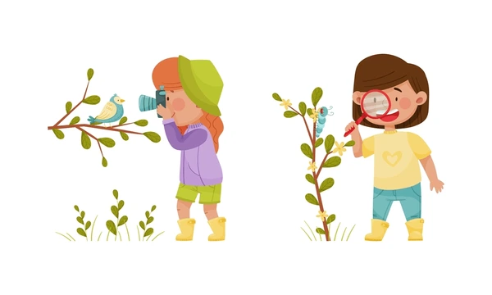

Oaks Swimming
Oaks start their swimming lessons next week, every Wednesday until the 10th of December.
Please make sure they have suitable swimwear (No bikinis), a towel and a swimming hat. They will not be allowed to swim if they do not have a swimming hat or if any earrings cannot be removed.
