

*Issue No: 33 7 Date: Friday 27th June 2025*

*Our Newsletter comes out every Friday with updates about what the children have been up to during the week, information, things to celebrate and important dates for the diary. Please take the time to read through and if you have any questions, please speak to Mrs Taylor in the office.*

**This Week’s Achievements**

**Stars of the Week**

We would like to make all three classes stars of the week, as they were all so amazing at the Norfolk Show. As a whole school treat, they will all have an ice lolly at the end of today, in place of hot chocolate club on Monday.

**WELL DONE**

**Willows, Sycamores and Oaks!!**

For working really hard in her learning this week and demonstrating all our schools expectations. Keep it up!

Millie for showing perseverance in reading and great determination in Forest school.

CHALLENGE

NURTURE

INSPIRE

CHALLENGE

NURTURE

INSPIRE

**House Points for this week**

Stephen Hawkings – 269

Beatrix Potter – 191

Benjamin Britten – 409

Kelly Holmes – 300

**Class Attendance**

Willows – 97.78%

Sycamores – 93.75%

Oaks – 93.75%



Willows: 1st Jude

2nd Phoebe

3rd Arlo

Sycamores: 1st Molly

2nd Evie

3rd Maisy

Oaks: 1st Flo

2nd Sienna

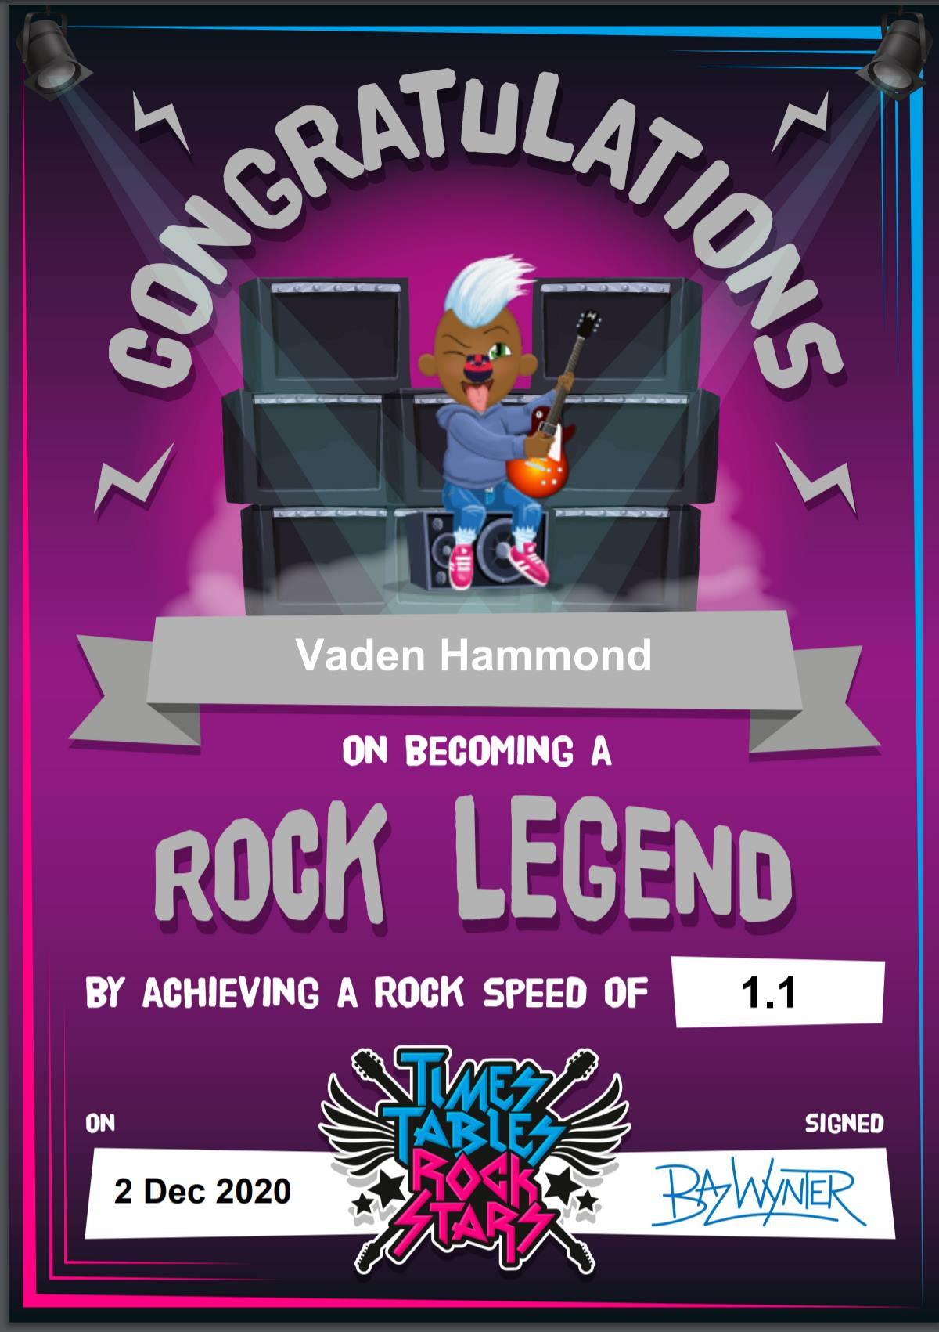

Busker – Maci

ROCK HERO – Molly!!



No Numbot stages completed this week.



Congratulations to Molly for achieving the ‘ROCK HERO’ award in TTRS.

**Playground Gate**

Following the recent incidents along the main road, the playground gate will be unlocked by staff at the beginning and at the end of the day.

**Reminders for this Term:**

**Oaks Class** – PE Mondays & Tuesdays

**Sycamores Class** – PE Wednesdays & Thursdays

**Willows Class** – PE Tuesdays & Fridays

**Fridays Forest School lessons**– Yr 2’s & Oaks

**Monday – Friday** (3.15 till 4.30) Little Legends after-school club

**Monday – Friday** (8 till 8.40) Breakfast Club

**Mondays** – Football Club (3.15 till 4.15)

**Mondays** – Fidgets Art Club (yrs 2,3 &4)

**Mondays** – Gardening Club (3.15 till 4.15)

**Tuesdays** – Fidgets Art Club (yrs 5 & 6)

**Wednesdays** – Street Dance Club (3.15 till 4.15)

**Fridays** – Forest School club (3.15 till 4.15)

**Dates for the Diary**

**Monday 30th June** – Year 6 Forensic Science Day at Hobart High

**Tuesday 1st July** – KS1 Transition morning

**Thursday 3rd July** – Woodton Sports Day – Parents welcome from 1.30pm

**Wednesday 9th July** – Whole School Transition afternoon

**Friday 18th July** – Oaks ‘Treasure Island’ Performance 1.45pm

**Thursday 17th July** – Year 6 Leavers Treat Day – Details to follow

**Tuesday 22nd July** – Year 6 Leavers assembly – 2pm

Website – <http://www.ellinghamandwoodton.co.uk/>

**Year 6**

**Forensic Science Day**

**Hobart High School**

All of our year 6’s will be attending the Forensic Science day at Hobart High School on Monday.

Please remember they will need a home packed lunch for this day.

**Tempest Photo Orders**

To qualify for free delivery direct to the school, any orders must be placed before Sunday the 29th of June.

Links were sent out last week via email.

**Sports Day 2025**

We would like to invite parents to join us for our Sports day races on Thursday 3rd July. The field gates will open at 1.30pm, giving enough time for everyone to sit down ready for the races to start at 1.45pm.

We look forward to seeing you there!

**‘Treasure Island’**

Oaks will be showing their summer performance on Friday the 18th of July, starting at 1.45pm. Oak’s children will need to be dropped off at the village hall in the morning, and they will require a packed lunch for the day.

Willows and Sycamores will be walking up in the afternoon to watch the performance but will walk back to school to be collected as normal.

**Norfolk Show 2025**

It was so much fun at the Royal Norfolk Show!

